Pocket Genealogist ™
Version
3.30
Northern Hills Software LLC

Pocket Genealogist
User Guide

Note: Some screen prints in this document show versions of Pocket Genealogist older than the current 3.30 release. This is just an indication that the screen in question did not change so a new screen print was not necessary.

Most examples in this user guide use the sample data from Legacy Family Tree (Millennia) and The Master Genealogist™ (Wholly Genes). There are differences between devices so what you see will be similar but may not be exactly the same.

Note: Colors on the 3-gen screen are user configurable.

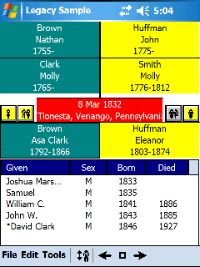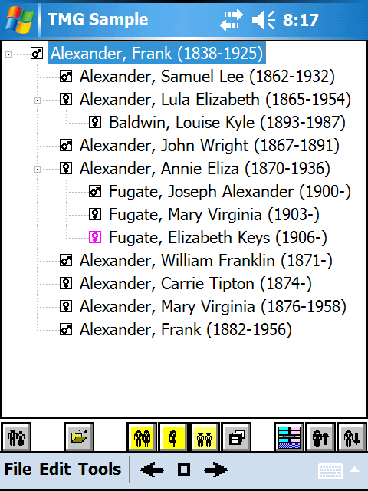

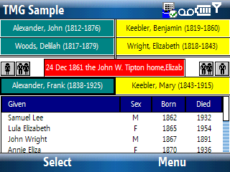
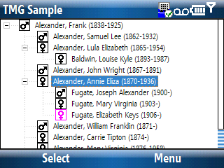

Northern Hills Software LLC
7750 SW 600 Rd., El Dorado Springs, Missouri 64744
Fax: 417-876-3819

http://www.NorthernHillsSoftware.com
http://www.PocketGenealogist.com
mailto:Support@NorthernHillsSoftware.com

Revised September 24, 2008

Table of Contents
Chapter 1 11
Installation 11
Before Installation 11
New User 11
Current Version 3 User 11
Current Version 2 User 11
Installation of 3.30 11
Running the Installation program 12
Devices prior to Windows Mobile 5 19
Windows Mobile 5 and newer devices 20
Final Installation Steps 24
Desktop Setup 26
Location of Databases 26
Registration Code 27
Options 29
File Locations 29
Sound to Play at completion 29
Miscellaneous Defaults 30
Lock Data (View Only) 30
Save Column Width and Position 30
Advanced Options 30
Advanced Options 31
Use TCP/IP for communications 31
Code Page 31
Use ‘Mounted’ for memory databases 31
Synchronize to location with most free space 32
Synchronize Pocket Genealogist device configuration values 32
Import Images as ‘BMP’ files 32
Languages 32
Chapter 2 33
Getting Started (Desktop) 33
Getting your data to the device 33
Overview 33
Creating a Pocket Genealogist Database 36
Importing data into the Pocket Genealogist database 39
Customizing the Import 39
Customizing GEDCOM imports 39
Customizing Legacy Family Tree “Direct” Imports 41
Customizing The Master Genealogist “Direct” Imports 42
Customizing Genbox Imports 44
Customizing Other “Direct” Imports (AQ, RootsMagic) 45
Customizing PAF/FTM add-on Imports 46
Other Import Options 47
GEDCOM Import Options 47
Legacy Family Tree Import Options 48
The Master Genealogist Import Options 50
Other “Direct” Import Options (AQ, Genbox, RootsMagic) 51
PAF/FTM add-on Import Options 52
Synchronizing the data to the device 53
Chapter 3 55
Getting Started (Device) 55
Screen “Print” examples 55
Registration (unlock) code 55
Open your database 56
3-Generation View 57
Descendant and Ancestor Tree View 59
Icon Bar buttons (PocketPC) 60
Individual View 61
Meaning of Icon Buttons in Pocket Genealogist 62
Individual Information 64
Main tab (Individual) 64
Names tab (Individual) 65
Events tab (Individual) 66
Notes tab (Individual) 67
Sources tab (Individual) 68
LDS tab (Individual) 69
To Do tab (Individual) 69
Field Notes tab (Individual) 70
DNA tab (Individual) 70
Identifiers tab (Individual) 71
Relationships tab (Individual) 71
Misc tab (Individual) 72
Family Information 73
Main tab (Family) 73
Misc Tab (Family) 74
Chapter 4 75
How to (Desktop) 75
Create a new Pocket Genealogist database 75
Delete a desktop Pocket Genealogist database 75
Perform 2-way Legacy Family Tree Synchronization 75
Synchronize changes made in your desktop program 76
Re-import a database 76
Retrieve changes made on the device 77
Export device changes to GEDCOM 77
Retrieve “Orphan” databases from the device 79
Set the sound to play after an event 79
Change the display language 80
Select language(s) for device 81
Process Field Notes 81
Process Research Lists 82
Remove customization values 83
Set the default path for an Import 83
Resize a list column 84
Change the column order of lists 84
Save List Column Widths and Position 84
Set “View Only” as the default 84
Enter your registration (unlock) code 84
Change the code page 85
Use TCP/IP as the synchronization method 85
Set “Mounted” databases as the default 85
Select type of data to import 85
Set the database to “View Only” 85
Enabling 2-way Synchronizations 85
Create a GEDCOM file for Import 86
View a Pocket Genealogist Log 86
Search for your Desktop Genealogy data (Import) 86
Synchronize multimedia (images) to device in BMP format 86
Chapter 5 87
How to (Device) 87
Interacting with device: Smartphone vs. PocketPC 87
PocketPC (touch screen) Interaction 87
Smartphone (non-touch screen) Interaction 88
“Tab” display 88
Displaying Individual Information 89
Displaying Family Information 90
Displaying “General” Information 90
Editing data 91
Add a new Person 92
PocketPC 92
Smartphone 92
Add an Event 93
PocketPC 93
Smartphone 94
Add a Source Citation 95
PocketPC 95
Smartphone 95
Add a Source 96
PocketPC 96
Smartphone 96
Add a Note 97
PocketPC 97
Smartphone 97
Add an Address 98
PocketPC 98
Smartphone 98
Add a To Do 99
PocketPC 99
Smartphone 100
Add an item to a Research List 100
Add a Field Note 100
Add a Secondary (AKA) Name 101
PocketPC 101
Smartphone 101
Swap a Secondary name with the Primary 102
PocketPC 102
Smartphone 102
Add a DNA Test 103
PocketPC 103
Smartphone 103
Add a new Location 104
PocketPC 104
Smartphone 105
Add a new Surname 106
PocketPC 106
Smartphone 106
Add a new Prefix 107
PocketPC 107
Smartphone 107
Add a new Suffix 107
Link an existing Individual as a spouse 108
PocketPC 108
Smartphone 108
Link an existing Individual as a child 109
PocketPC 109
Smartphone 109
Link an existing Individual as a parent 110
Delete a spouse 110
PocketPC 110
Smartphone 110
Delete a Parent 110
Delete a child 111
PocketPC 111
Smartphone 111
Unlink a spouse 112
PocketPC 112
Smartphone 112
Unlink a parent 113
PocketPC 113
Unlinking both parents 113
Smartphone 113
Unlinking both parents 113
Unlinking one parent 113
Unlink a child 114
PocketPC 114
Smartphone 114
Change Order of Children 115
PocketPC 115
Smartphone 115
Setting a Spouse as Preferred 116
PocketPC 116
Smartphone 116
Setting a Child as Preferred 117
PocketPC 117
Smartphone 117
Setting Parents as Preferred 118
PocketPC 118
Smartphone 118
Viewing TMG “Relationship” information 119
PocketPC 119
Smartphone 119
Setting Couple as “Not Married” 120
Setting an Individual to “Never Married” 120
Setting Husband Phrase 120
Setting Wife Phrase 120
Setting the Child Status 121
PocketPC 121
Smartphone 121
Setting the Child Relationship to Parents 121
Setting User Reference ID 122
Setting AFN 122
Setting RFN 122
Finding the number of Individuals in a database 122
Finding the number of Families in a database 122
Finding the number of Field Notes 122
Set the Sex of an Individual 123
Set an Individual as “Private” 123
Set Living indicator 123
Set Anc/Des Interest 123
Sort the Event List 124
PocketPC 124
Smartphone 124
Setting an Event as Preferred 124
PocketPC 124
Smartphone 124
Swapping Primary Events 125
PocketPC 125
Smartphone 125
Changing the order of Events 125
Setting Cause of Death 126
Add a source citation to Cause of Death 126
Smartphone 126
Citation “Applies To” 127
Legacy specific Source Citations 127
Smartphone 127
Go To Individual 128
Go To Family 128
Set “Home” Family 129
Go To “Home” Family 129
Find “Last Edited” date for an Individual or Family 129
Find by Name 130
PocketPC 130
Smartphone 131
Find by Location 132
PocketPC 132
Smartphone 133
Find by To Do Task 134
PocketPC 134
Smartphone 135
Find by To Do Repository 136
PocketPC 136
Smartphone 137
Find Multimedia 138
PocketPC 138
Smartphone 139
Displaying all To Do’s 140
Setting the display Language 140
The Master Genealogist Flags 140
Turning off “View Only” 141
Turning off 2-way synchronizing 141
Change to a different View 141
Configure use of a GPS 142
GPS intermediary driver 142
Using Serial Communications (COM) 142
Retrieve GPS Coordinates 143
Switch to Landscape Orientation 144
Displaying Multimedia 145
Configuring the Device 146
Database to open at Program Start 146
Home Family at Program Start 146
Set Default View 146
3 Generation 146
Tree Views 146
Set 3-Gen Colors 147
Set Miscellaneous Colors 148
Set Miscellaneous Colors 148
Misc 149
Misc 149
Uppercase Surnames 149
Display Given Name First 149
Smart Minimize 149
Save Column width and position 149
GPS 149
Prompts 150
Disable Surname Prompts 150
Disable Given name Prompts 150
Disable Location Prompts 150
Disable Find Prompts 150
Edit 150
Capitalize first letter of first word 150
Hide Format Codes 150
Field Selection 150
Change Font size 151
Tab order (Individual or Family) 152
Keys 152
Databases List 153
Deleting a database 153
Opening a database 154
Backup/Restore of your database 154
Backup 154
Restore 155
Closing Pocket Genealogist 155
View/Edit Master Lists 155
Relationship list 156
Status Area 156
Date Calculator 157
PocketPC 157
Smartphone 157
Soundex Calculator 158
Coordinates Calculator 158
Using the Relationship Calculator 159
PocketPC 159
Smartphone 159
History List 160
PocketPC 160
Smartphone 160
Soft Reset Device 161
Hard Reset Device 161
Format a Storage Card 161
Working with Dates 162
Date Qualifier 162
Date Entry 163
Calendar 163
Calculator 164
Chapter 6 165
2-Way Synchronizing 165
Overview 165
Before the initial Import 165
1. Backup your database 165
2. Check/Repair 165
3. Master Lists Cleanup 166
After the initial Import 166
Updating Legacy with changes from the device 167
Updating the device with changes in Legacy 169
Changes in both Legacy and Device 169
Chapter 7 171
Field Notes 171
Overview 171
Adding note on Device 171
PocketPC 171
Smartphone 172
Field Notes list (Reports) 173
Field Note Display 174
Field Note Print 175
Chapter 8 177
Research Lists 177
Overview 177
Adding an item to a Research List 177
Viewing Research List 179
PocketPC 179
Smartphone 179
Working with items in a List 180
PocketPC 180
Smartphone 180
Research List Report 181
Appendix A 183
Uninstalling Pocket Genealogist 183
Desktop uninstall 183
Device Uninstall 185
Appendix B 189
GEDCOM creation 189
Family Origins v10 189
Family Tree Maker v11 189
For all individuals in the Database 189
For some individuals in the Database 190
Generations v8.5 190
Personal Ancestral File v5 190
Ultimate Family Tree v3 190
Appendix C 191
Import Limitations 191
GEDCOM 191
GenBridge PAF imports 191
GenBridge FTM imports (Prior to FTM 2008) 191
GenBridge FTM 2008 imports 191
Legacy Version 5 through 7 “Direct” imports 191
TMG “Direct” imports 192
Ancestral Quest “Direct” imports 192
RootsMagic “Direct” imports 192
Genbox “Direct” imports 192
Appendix D 193
PocketPC VGA Support 193
“Real VGA” 193
“Native” VGA 193
“Native” VGA 194
Appendix E 195
FreeImage License 195
Index 200
Copyright and Terms of Use 204
Changes to this Document 205
Version 3.00 (July 1, 2006) 205
Version 3.00 (July 2, 2006) 205
Version 3.02 (August 2nd, 2006) 205
Version 3.10 (July 1st, 2007) 205
Version 3.20 (June 4th, 2008) 205
Version 3.30 (September 22th, 2008) 205

Installation
Chapter
1

Before Installation

New User
Microsoft ActiveSync (XP and older) or Windows Mobile Device Center (Windows Vista) must be installed and a connection established between your primary computer and device prior to installation of Pocket Genealogist. ActiveSync is provided on a CD that came with your device or Windows Mobile Device Center can be found online at the Microsoft website.

Current Version 3 User
All Pocket Genealogist Version 3 releases can always be installed “overtop” your current release and no “manual” uninstall needs to occur first. With Windows Mobile 5 or newer devices, you will be prompted regarding the “automatic” uninstall of the program on the device prior to the installation of the new version.

Databases created prior to 3.30 are not compatible and will need to be re-imported.

Current Version 2 User
Pocket Genealogist Version 3 will not overwrite Version 2 when you install. You may run both versions if you wish, they don’t share anything in common. See Appendix A for more details regarding uninstall.

Installation of 3.30
Start by downloading the installation program from the Northern Hills Software website. There are several different downloads. Choose the one that’s correct for your device, the website has details on how to make that distinction.

You should close any running copies of Pocket Genealogist on the desktop or the device prior to running the installation. Make sure your device is connected before you run the Pocket Genealogist installation program. You must have administrator privileges during installation although that is not required when you use the program.

There are two distinct steps to the installation which are invoked by running the installation program that you downloaded. The first step will install the desktop side of Pocket Genealogist. The second step will install Pocket Genealogist on your device. Both steps are accomplished by running the single installation program.

Note: If you need to re-install Pocket Genealogist on the device only, you still need to run the full install. You should never need to uninstall a copy of Version 3 before re-installing.

Running the Installation program
Start the installation by clicking on the program setup file that you downloaded from the Northern Hills Software website.

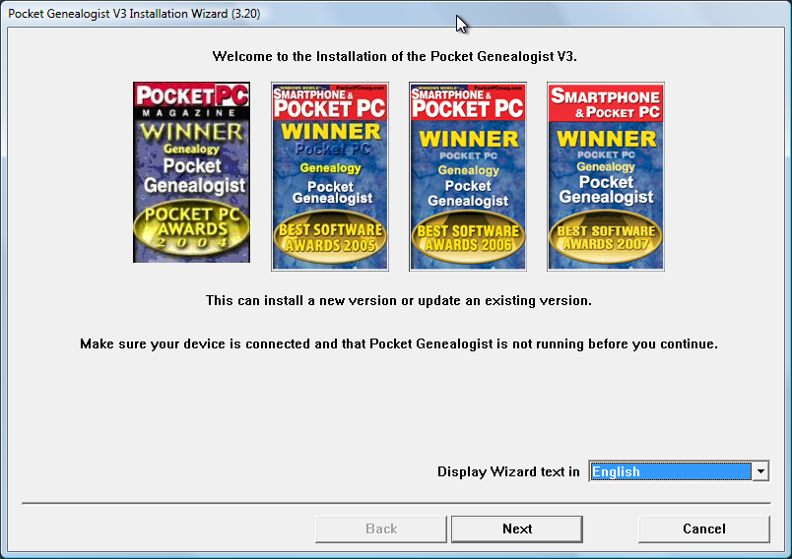

The first panel allows you to select which language you wish to use for the installation wizard display. The installation program will automatically try to select the correct language based on the value set in “Regional Settings” on your computer.

Press “Next” to continue.
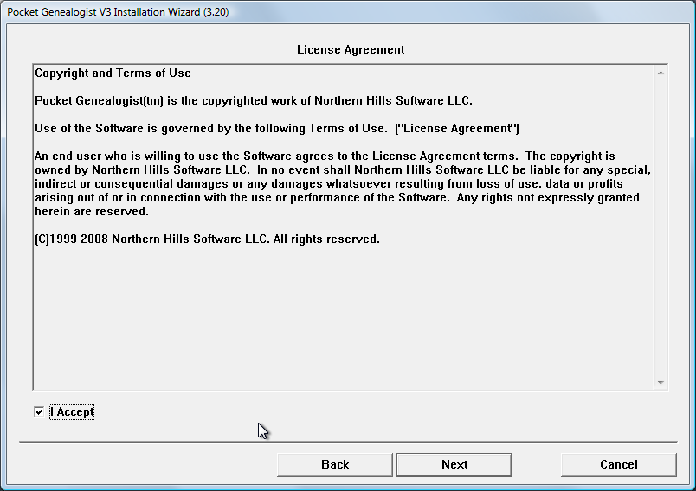

Select “I Accept” if you agree to the terms of the License Agreement. You cannot continue the install without accepting the License Agreement.

Press “Next” to continue.

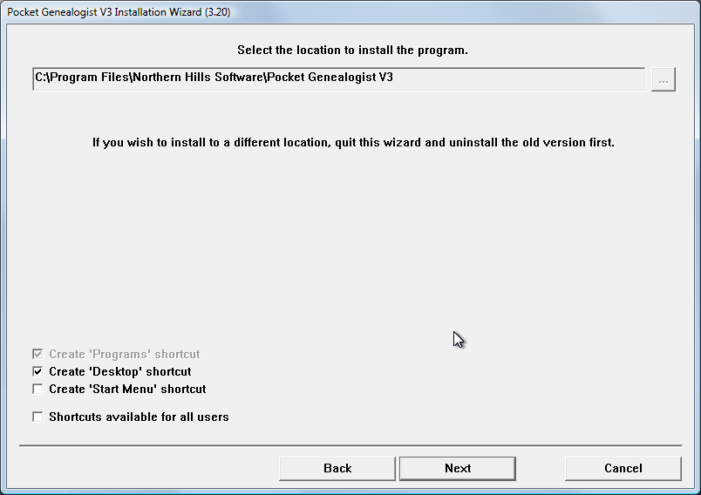

If this is a new installation you can select where to install the program. Use the button to select the location using the standard windows “Browse for Folder” dialog. A shortcut for Pocket Genealogist is always placed in the Programs menu. You may also select to have a shortcut placed on your desktop or on the start menu. Shortcuts can be defined as available for all users or just for the installation user.

Press “Next” to continue.

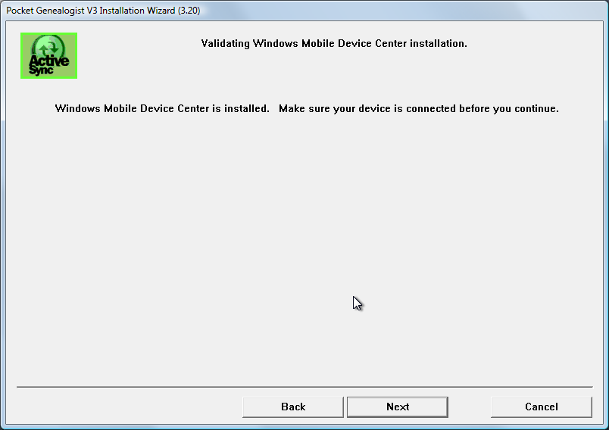

The next panel verifies that ActiveSync (or Windows Mobile Device Center) is installed. If it is not you will be shown a “Web” button which can be pressed to take you to the appropriate Microsoft website for download. (An internet connection must be present for the button to work.) You can continue to install without ActiveSync or Windows Mobile Device Center present BUT the device side of Pocket Genealogist will not be installed.

Press “Next” to continue.

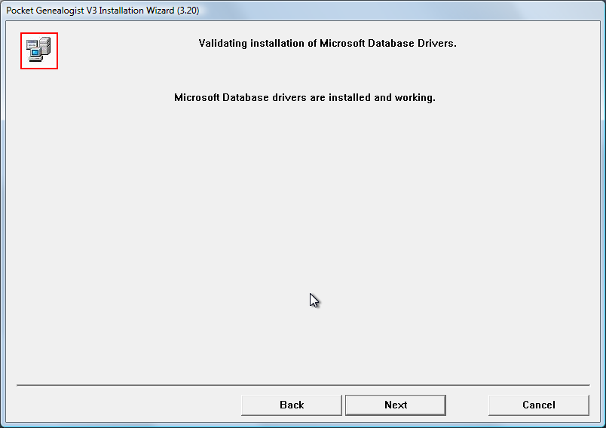

The next panel verifies that the Microsoft database drivers needed for Pocket Genealogist operation are present and working. There are two different set of drivers, one of which is mandatory for all imports and the other only necessary if you are doing “Direct” RootsMagic or The Master Genealogist imports. The messages will let you know if either are missing. A “Web” button will be displayed to allow download of the driver if necessary.

Press “Next” to continue.

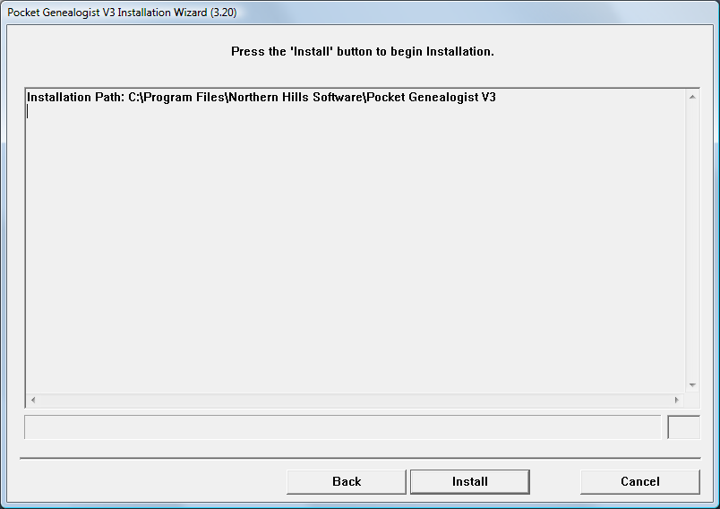

The next panel will show you where the program will be installed and gives you one last chance to change options before installation. (Use the “Back” button to change installation options)

Press “Install” to start the installation.

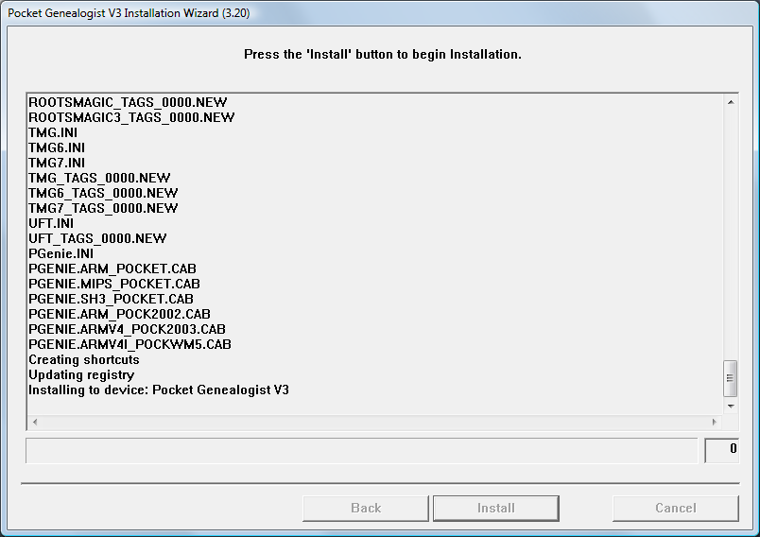

The next panel shows the progress of the installation and displays the files that are copied to your computer. After the desktop side is complete, you’ll receive the ActiveSync or Windows Mobile Device Center installation panel for the device install. (as shown on the next page).

Devices prior to Windows Mobile 5
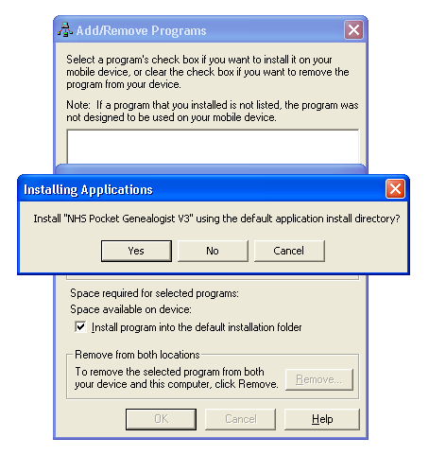

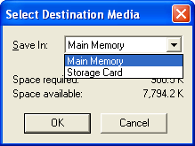
If you wish to install Pocket Genealogist to device “memory”, select “Yes”. If you wish to install Pocket Genealogist to an external storage card (if available), select “No”. Selecting “No” gives you a “Select Destination Media” screen similar to the illustration to the right. (The arrow in the drop down list has been selected for this screen print)

Note: If this is a re-install of Version 3, you may see the following screen.

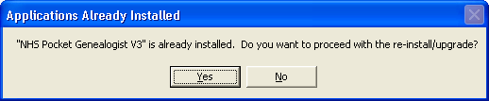

Windows Mobile 5 and newer devices
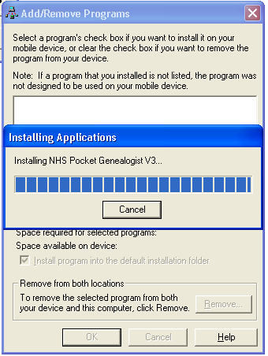
You do not select where you want the program to be installed from the desktop. The device installer (shown to the right) will automatically copy the install program to the device and you will be prompted on the device to continue the install.

Note: If this is a re-install of Version 3, you may see the following screen.

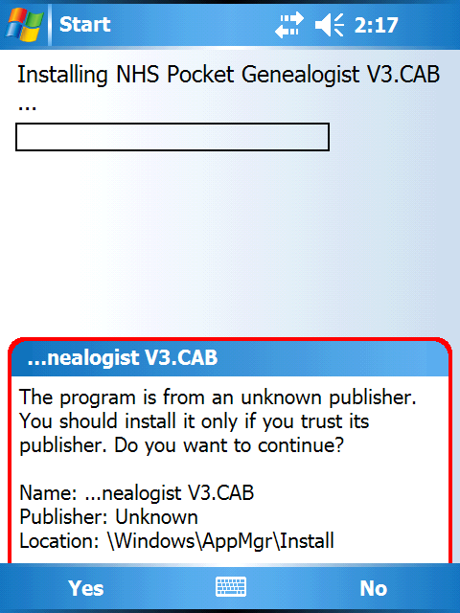
The first prompt you should see on the device is the “unknown publisher” confirmation. The Pocket Genealogist install is not a “signed” application so you will need to select “Yes” to continue.

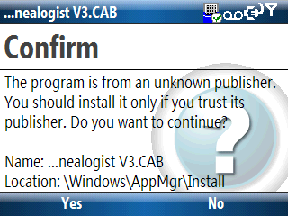

or

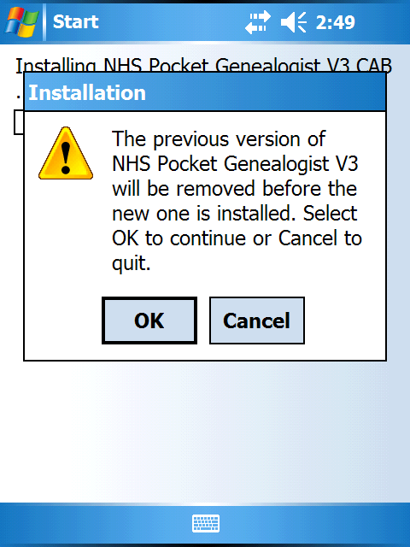
Note: If this is a re-install of Version 3, you will first be prompted to remove the prior version. The un-install will also give you the choice of removing the old databases and configuration settings. (In most cases, you would probably remove neither.)
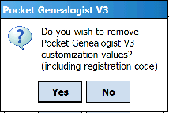

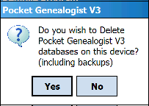

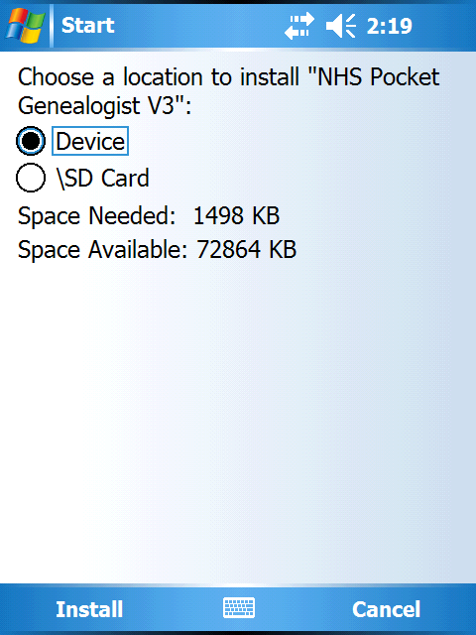
Next you will get the prompt that will allow you to choose the location on the device to install the program. Press “Install” on the menu to continue.

Note: You may not see this prompt if you do not have any storage cards in the device.

You may get a prompt if the current settings on the device will prevent Pocket Genealogist from performing synchronizations from the desktop. You should select “Yes” if you get this prompt.
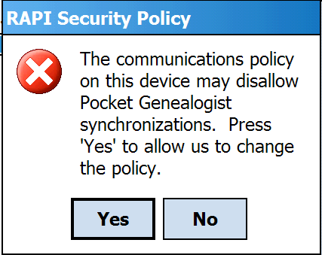

And finally you will be shown a screen indicating success or failure. Press “OK” or “Done” to dismiss this dialog.

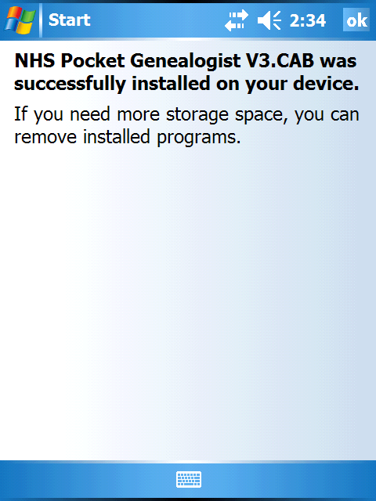

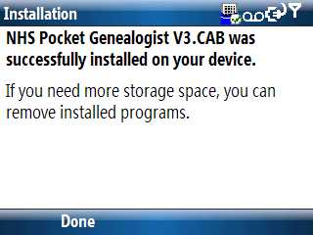

or

You may now continue with the installation on the desktop.

Final Installation Steps

After device installation, you will receive the following message on the desktop:

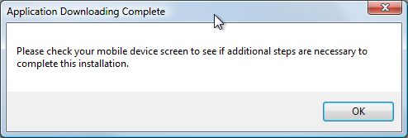

Note: Version 3.10 and higher of Pocket Genealogist no longer use separate installs for the various Languages. If you are upgrading from a previous Version 3 release, you can uninstall any references to the languages found under “Remove Programs” as they will not be needed with this version.

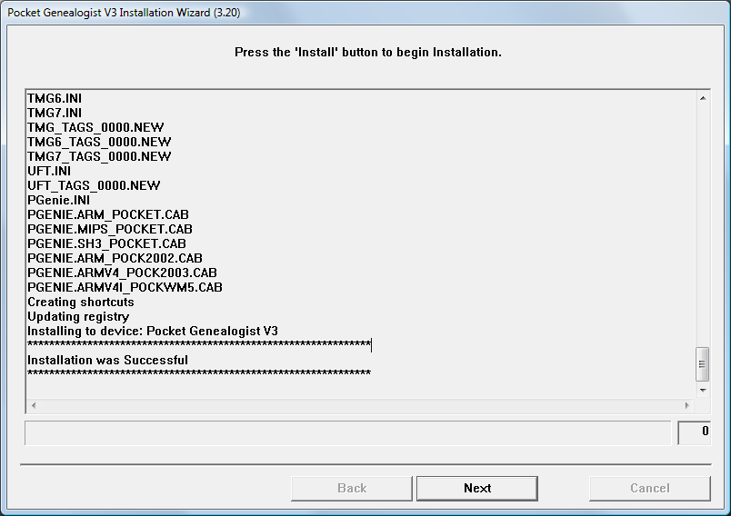

When the installation is complete, a success or failure message will be displayed in the window.

Press “Next” to continue.

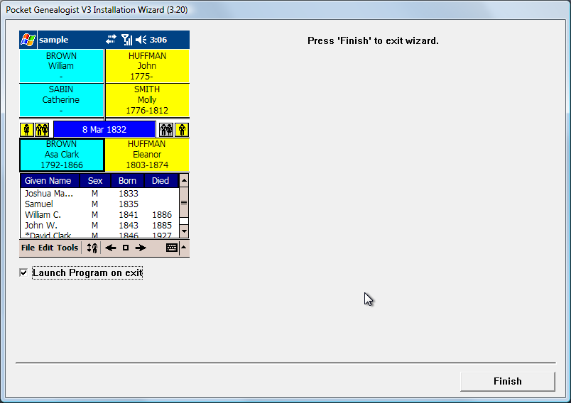

This is the final panel that will be displayed. Pocket Genealogist will automatically start unless you uncheck the “Launch Program on exit” option.

Press “Finish” to exit the wizard.

Desktop Setup
The first time you run the Pocket Genealogist program on the desktop there are a couple of things to set.

Location of Databases
You will be asked to select the location for the Pocket Genealogist databases and other common files. This prompt will only occur the first time you run Pocket Genealogist.

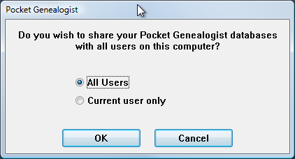

Note: You can reset this later by removing the Pocket Genealogist customization values. See “Remove Customization Values” for more detail.

Registration Code
You will be prompted to enter your registration code. You can use the program without a registration code by pressing “OK” but some features will be disabled.

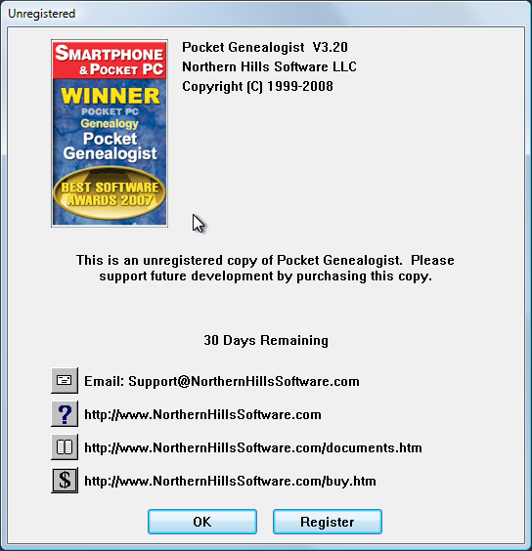

If you have already purchased Pocket Genealogist, press the “Register” button to enter your unlock code.

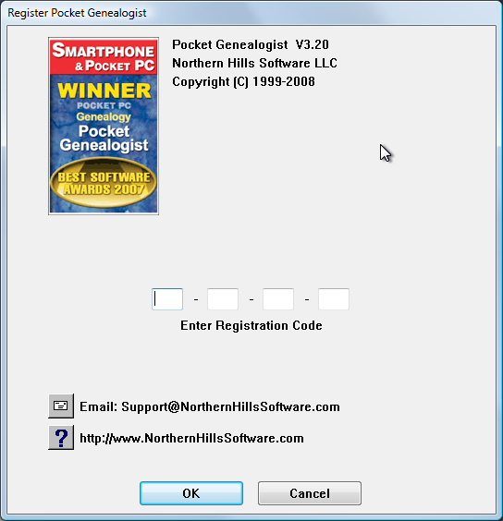

Enter your registration/unlock code provided in the email received from the vendor from which you purchased Pocket Genealogist. The first time you synchronize a database it will also automatically enter the code for you on the device.

Options
You may want to select the “Options” button on the main Pocket Genealogist screen to set some values to improve the Pocket Genealogist experience. Most of these options can be set during operation of Pocket Genealogist although you may wish to preset these values before you begin.

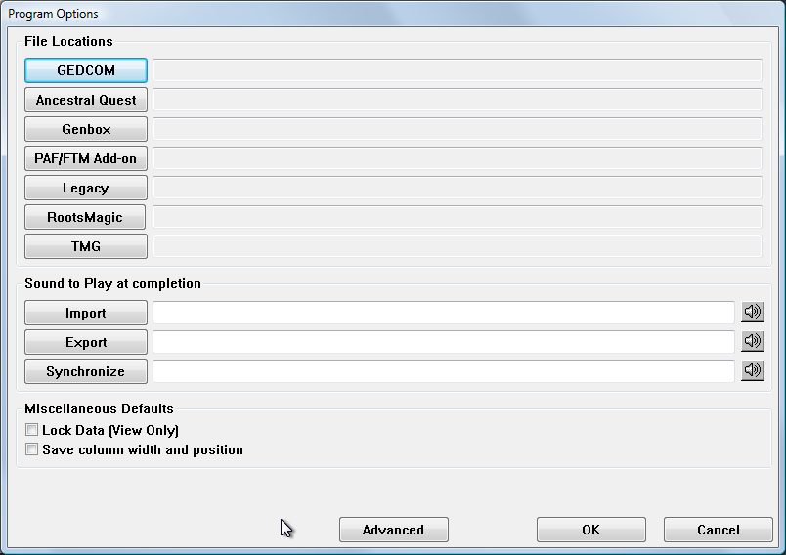

File Locations
You can set the “default” location to look for your import files when you do a “Create”. Press the appropriate button to bring up a “Browse” dialog so you can select the folder on your desktop to use as the default location for that type of import.

Sound to Play at completion
With large amounts of data, it may take some time to perform an import, export or synchronization. You can set a sound to play when these operations complete as a means to notify you that the operation is complete. Pressing the appropriate button (import, export, sync) invokes an “open” dialog so you can select the “WAV” file. (Look in C:\windows\media for some “WAV” files that may come with your operating system.)

Miscellaneous Defaults

Lock Data (View Only)
If you do not want to do data entry on the device, you can “lock” the data to prevent accidental changes to the data. Setting this value will set this as the default for when you do imports. (Changing this after you do an import does nothing for any databases you’ve already created without this value set.) This value is selectable at import time, but the selection you have on this screen will be used as the default when you do an import so that you don’t have to remember to set it every time an import occurs.

Save Column Width and Position
Selecting this option allows you to save the width and position of columns for the various “lists” found in the desktop Pocket Genealogist program. If this is not selected, you can still change the width and position of the columns but they won’t be saved when you exit Pocket Genealogist.

Advanced Options
The “Advanced” button is used to display the Advanced program options.

Advanced Options
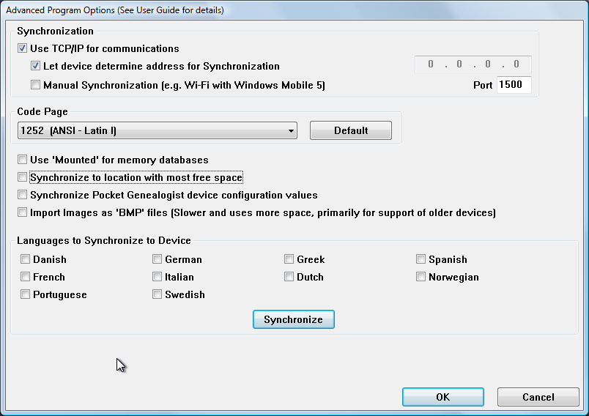

Use TCP/IP for communications
With 3.20 and higher, you generally do not need to set this option in order to make synchronization work. If normal ActiveSync communications is unsuccessful, the program will automatically try the “TCP/IP” option and if successful will automatically set this option on.

“Let device determine address for Synchronization” should always be selected and “Manual Synchronization” not selected unless you have specific needs which have been previously discussed with Northern Hills Software. (For example, these can be used to establish a Wi-Fi connection with Windows Mobile 5 and later devices)

Code Page
Except in rare situations (Vietnamese for example), the Code Page should always be set to 1252 (ANSI – Latin I). You can use the “default” button to set the value back to this value.

Use ‘Mounted’ for memory databases
Prior to Windows Mobile 5, memory databases could either be “Object Store” or “Mounted”. “Object Store” databases can be faster and use less space but only “Mounted” databases are eligible for use with the backup feature of Pocket Genealogist.

Synchronize to location with most free space
Most devices have multiple locations available for synchronizing databases. (Memory, File Store and Storage Cards for example) If you have this option selected, the location with the most free space will be automatically selected on the synchronization screen when you first sync a database. (although you can change the value to any location you wish before starting the sync)

Synchronize Pocket Genealogist device configuration values
Configuration options you select on the device can be synchronized to the desktop for “safe keeping” so that if you should have a “hard reset” on the device they can be restored. Select this option to retrieve and save these values on your desktop computer.

Import Images as ‘BMP’ files
If you select multimedia on the Customization screen during import of your database, the images are automatically converted to JPEG for synchronization to your device. (Your original images are of course not modified) However, some older Windows CE devices do not support display of JPEG images. If you find that to be the case, turn on this option so that subsequent imports will create BMP (Bitmap) files instead. Most Windows CE devices should be able to display these types of images. The downside is that BMP images tend to be much larger than JPEG images and therefore will take up more space on your device and will be slower to synchronize.

Languages
Selecting or de-selecting the languages you wish to synchronize to the device is accomplished on this screen. You can either synchronize these languages using the “Synchronize” button or automatically when you synchronize a database. If you previously synchronized a language but then de-select it on this screen, the next synchronization will remove that language from the device.

Getting Started (Desktop)
Chapter
2

Getting your data to the device

Overview
Your genealogy data is not directly copied to the device. Instead, you import your genealogy data into a Pocket Genealogist database which is then synchronized to the device. This is all accomplished with the desktop portion of the Pocket Genealogist program. Pocket Genealogist can read your data in a number of ways.

- GEDCOM file – GEDCOM, or GEnealogical Data COMmunication, is the data transfer “standard” for exchanging information between genealogy programs. It was developed by the Church of Jesus Christ of Latter Day Saints. All modern desktop genealogy programs can create a GEDCOM file. See Appendix B for examples on how to create a GEDCOM file from some popular genealogy programs. Pocket Genealogist supports ANSI, ANSEL, UTF-8 and Unicode based GEDCOM files.
- “Advanced” Pocket Genealogist only: You can bypass GEDCOM and directly read databases created with Ancestral Quest, Genbox Family History Version 3, Legacy Family Tree Version 5 and 6, RootsMagic Version 2 and 3, and The Master Genealogist Versions 4 through 6. Pocket Genealogist also supports updating changes made on the device directly back into Legacy when the 2-way synchronization option is turned on.
- “Basic” or “Advanced” with the PAF/FTM add-on: The Pocket Genealogist PAF/FTM add-on available from Wholly Genes Software allows you to directly read PAF Version 5 or Family Tree Maker databases. (Import only, not 2-way Synchronization)

When you create a new Pocket Genealogist database to go onto the device, it first stores your information in a Pocket Genealogist database on the desktop then synchronizes it to the device. If you make changes to the data on the device and synchronize it back to the desktop, it puts the changes back into the Pocket Genealogist database it created there. If you are doing 2-way Synchronizing with Legacy Family Tree, it will then update Legacy using that Pocket Genealogist database. If you are doing any other type of import, you can use the “Export” feature of Pocket Genealogist to create a GEDCOM for merging back into your original genealogy database.

The steps for getting your data to the device, which will be covered in detail in this chapter, are as follows:

- Create. This starts the process of creating a Pocket Genealogist database on the desktop which will be synchronized to the device.
- Import. This step reads your genealogy data and puts it in the Pocket Genealogist database on the desktop. When you do your first import you will need to set some “customization” options for what type of data you wish to import. This allows you to selectively pick the data you wish to import in case you wish to conserve space on the device.
- Synchronize. This step takes the Pocket Genealogist database on the desktop and copies it to the device.

When you first start the program and before you create any new databases, you will have a “blank slate” showing no Pocket Genealogist databases as illustrated on the following screen.

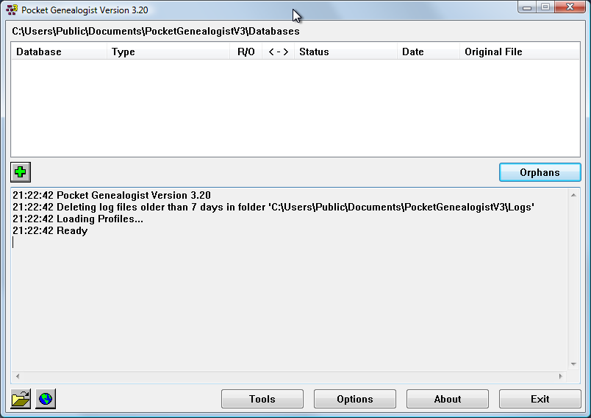

Tip: Most buttons in Pocket Genealogist have “Tips” associated with them. Hover your mouse pointer over the button to display more information.

Tip: Most Pocket Genealogist screens can be resized both vertically and horizontally. The size and position of the screen will automatically be saved.

The layout of the main Pocket Genealogist screen is divided into roughly four areas from top to bottom:

- Database List. This list shows the Pocket Genealogist databases that have been created and information about that database. This information includes the database name, the type of import, whether the database is “locked” as read/only, whether 2-way synchronization is in effect, the status of the last action against the database, the date the database was lasted acted upon using the action buttons, and the original location of the imported data.
- Action Buttons. This contains buttons that allow you to perform actions against the databases in the list. (in the previous example most of the action buttons are invisible since no databases have been created yet)
- Log Window. The “Log” window contains information about the actions you have taken since starting Pocket Genealogist.
- Additional Options. These buttons are other actions you can take that are not specific to a database.

Tip: Use the “About” button to enter your registration (unlock) code before you create your first Pocket Genealogist database.

Creating a Pocket Genealogist Database
The first step in getting your genealogy data to the device is to create a new Pocket Genealogist database. Use the “Create” button on the main desktop screen to start the process.

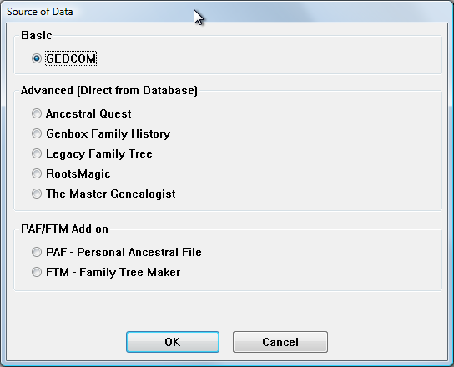

The first thing you must select is how you are getting the data into the Pocket Genealogist database. The import types are grouped by the level of Pocket Genealogist you have purchased. All “Basic” features are also available if you have the “Advanced” level of Pocket Genealogist. If you are using the “Trial” level the only available option is “GEDCOM”.

The use of the PAF/FTM add-on requires the additional purchase of the item from Wholly Genes Software.

Select the import type and press the “OK” button to continue.

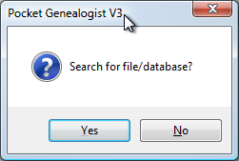
When you do an import and no files are found in the “default” location or that type of import, you will be prompted if you wish to search your computer for files that qualify for that type of import.

This is useful if you don’t know where your genealogy data is stored on your computer. Be aware that the search may take some time to run if you have a lot of folders and files on your computer although you do have the option of aborting the search at any time. For illustration purposes, we will assume that “No” is selected.

The “file selection” screen is shown next. The current default path for the type of import selected will be displayed in the edit field at the top of the screen and any files/databases that match for this location will be displayed in the list. (In this example there are no matches) If the file/database you wanted to import was in the list, you could simply select that item then press the “OK” button to continue.

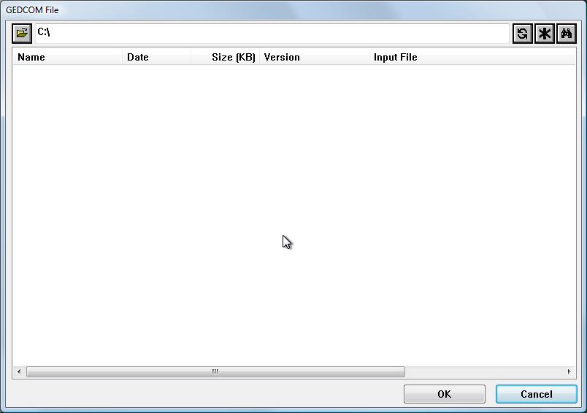

Since there are no items in the list, you must “navigate” to the location containing the data. Here are the options for selecting data from this screen:

- Select from the list. If the file you want to import is in the list, simply select that item in the list using a single left mouse click.
- Open dialog. Press the “Open” button to invoke the Windows file selection dialog which can be used to navigate to the file you wish to import.
- Enter the Location. If you know the location of the data, enter the full path in the edit field (path only) and press the “Refresh” button to display a list of files at that location.
- Search. Press the “Search” button to display the search screen.

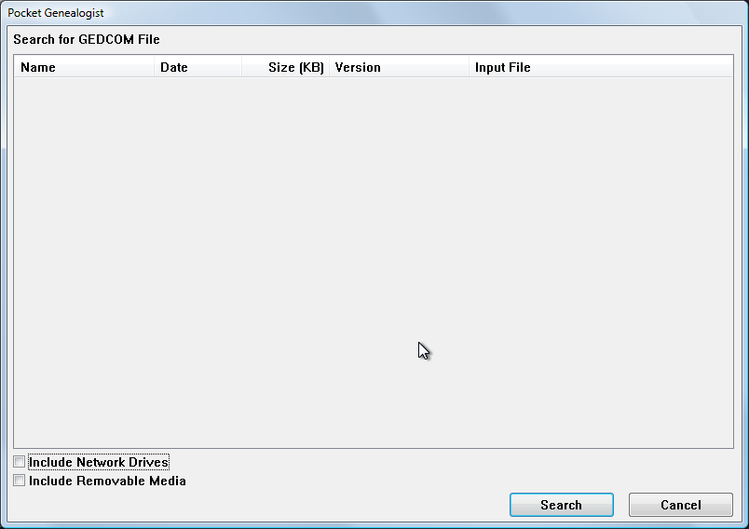

If you are on a network and wish to have network drives searched along with local drives, select the “Include Network Drives” option. You can also search removable media such as floppy drives, Zip disks, and memory drives.

The search can take some time depending on the number of files and folders and hard drives you have in your system. At times it may appear to be “hung” if there are lots of files in any particular folder. If the file you are searching for appears in the search list you can press “Stop” to stop the search. Selecting an item from the search list and pressing “OK” will select that file for import.

Importing data into the Pocket Genealogist database

Customizing the Import
The second step in getting your genealogy data to the device is importing the data selected in the “Create” step into the desktop Pocket Genealogist database. The first time you import a database of a particular type (GEDCOM for example), you will be prompted to set the customization values for that import.

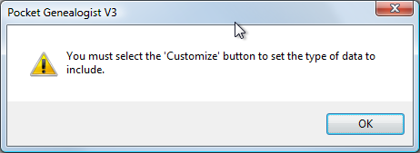

Press the “Customize” button on the import screen to set the options you wish to use for that type of import.

Customizing GEDCOM imports
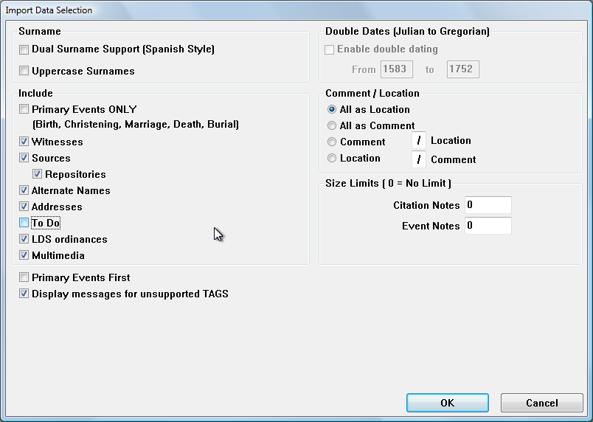

Note: Not all options are applicable for every type of GEDCOM import. The availability of that type of data depends on your desktop genealogy program. However, selecting an option that is not applicable will do no harm.

Dual Surname Support (Spanish Style) – Select this option when both the mother’s and father’s surnames are used as part of the full name for the children of that couple.

Uppercase Surnames – Converts surnames to all uppercase during import.

Include section -- This section contains options for selecting the data you wish to include as part of the import. Some of these options may not be applicable for all GEDCOM imports. Warning: Selecting “Primary Events Only” will discard all events other than “primary” events. (Birth, Christening, Marriage, Death and Burial)

Multimedia – This option allows the importation of images (photos for example) and is only available in the Advanced version of Pocket Genealogist.

Primary Events First -- “Primary” events (birth, christening, death, burial, marriage) will appear first in the event list on the device. If not selected, events are strictly sorted by date.

Display messages for unsupported TAGS – Some GEDCOM tags are not supported during import. If you wish to see messages when these tags are encountered, select this option.

Double Dating – Allows you to select the beginning and ending date to use for double dating (Julian to Gregorian calendar switch). This option may not be available for all GEDCOM imports.

Comment / Location – For some import types, you are allowed to define how the comment and location is imported. For example, Family Tree Maker and Brother’s Keeper allow a location and a comment in the same data field. With the third and fourth option, you can specify the character that is used to separate the two values.

Size Limits – If you have a large number of source citation or event notes, you may want to limit the maximum size (in characters) of imported notes so the database doesn’t get too large to synchronize to the device. The default value is 0 which means that the entire note will be imported. The minimum value you can specify is 20. If during the import a note larger than the limit is encountered, it will only import the indicated amount and discard the rest. If you do “limit” the size of the note, it is recommended that you also turn on “View Only”.

Customizing Legacy Family Tree “Direct” Imports
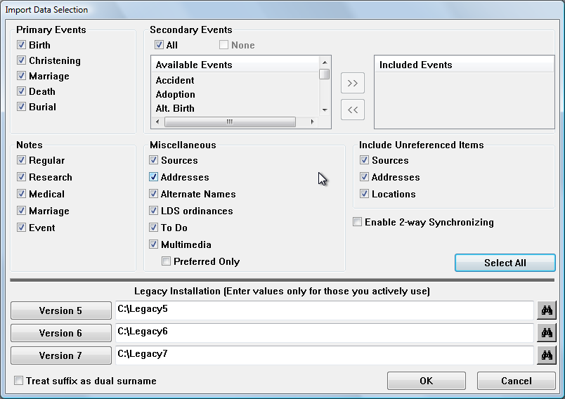

On this screen you can select which events, notes, and other items to include during import of the Legacy data. If you are doing 2-way synchronizations, you must select all options. (Use the “Select All” button.) The only exception is Multimedia which you can leave unselected but still enable 2-way synchronizing.

The “Legacy Installation” value is used to retrieve configuration options set in Legacy. You can either manually enter the path where Legacy is installed or press the “Version” button to select the path. You can also press the “Search” button if you do not know where Legacy is installed.

Note: If you use the “Search” button it will search all hard drives on your system. If during the search it finds the location and displays it in the list, you can press the cancel button to stop the search and pick that location.

Treat suffix as dual surname
This option is similar to “Dual Surname (Spanish Style)” found on GEDCOM imports and allows you to use the suffix field in Legacy as the second surname.

Customizing The Master Genealogist “Direct” Imports 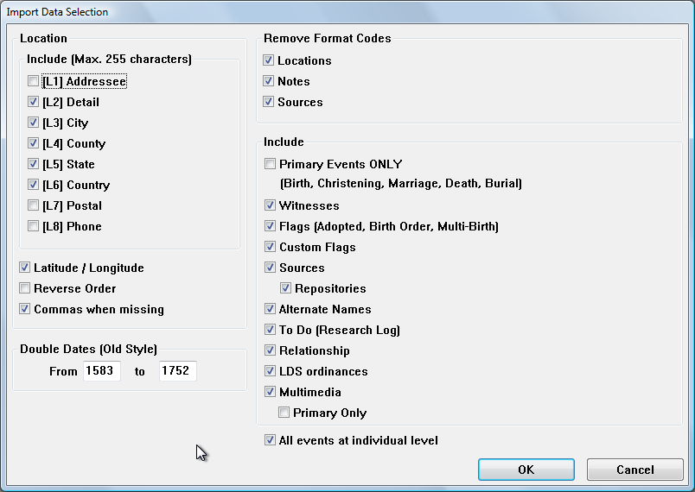
Location – Select which location elements you would like to include during import.

Latitude / Longitude – Select this option if you wish to include the latitude and longitude value associated with the location.

Reverse Order – Reverses the “order” of the location that is built using the elements selected. (For example, builds the location string as [L8], [L7], [L6], etc.)

Commas when missing – When building the location string, if an “element” is missing in the data, this option will retain the space for that element by putting in a comma.

Double Dates (Old Style Dates) – Allows you to set the first and last date used for old style dates.

Remove Format Codes – Select these options to remove any formatting codes that may be included in the original data.

Include – Various options for selecting what data types you want to include with your import. You can use this to decrease the amount of space needed for your database.

Primary Events Only - This selection will cause non-Primary events to be discarded during import. If selected, only Birth, Christening, Marriage, Death and Burial events are honored. This allows you to limit the amount of data sent to the device if you are trying to conserve space.

Witnesses – Roles and Witnesses can be transferred to the device although they cannot be edited on the device as The Master Genealogist does not allow for this information to be transferred via GEDCOM.

Custom Flags - If you select “Custom Flags”, you will be presented with a “flag selection” screen during import. (TMG Version 5 and higher databases only.) This will allow you to pick the flags to import since they can take up a lot of space in the Pocket Genealogist database.

To Do (Research Log) – The Research Log can be transferred to the device although it cannot be edited on the device as The Master Genealogist does not allow for this information to be transferred via GEDCOM.

Multimedia – This option if enabled allows the transfer of images (photos for example) to the device. If you wish to limit the amount of images for space or increased synchronization speed, you can select “Primary Only”.

All events at individual level – Events with a principal 1 and 2 that match the same principals in a marriage can be displayed at the “Individual” level instead of the “Family” level in Pocket Genealogist. This option more closely matches how data is displayed in The Master Genealogist.

Customizing Genbox Imports
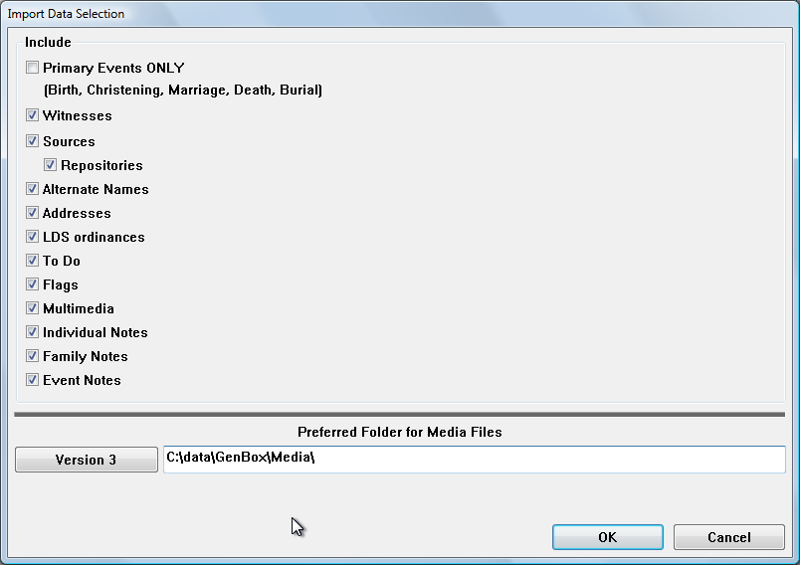

Note: The options which are not applicable for the import will be disabled. Repositories will be enabled for selection when you select “Sources”.

Primary Events ONLY: This selection will cause non-Primary events to be discarded during import. If selected, only Birth, Christening, Marriage, Death and Burial events are honored. This allows you to limit the amount of data sent to the device if you are trying to conserve space.

The rest of the items in the “Include” section allow you to pick the type of data you wish to synchronize to the device.

Preferred Folder for Media Files – If importing multimedia files, this field defines the preferred media file location as specified in Genbox. This field will automatically be filled in with the value used in Genbox, but you can override it if incorrect. (This value is the “Preferred Folder for Media Files (“pref”) value found under “View”, “Preferences”, “Operation” tab in Genbox)

Customizing Other “Direct” Imports (AQ, RootsMagic)
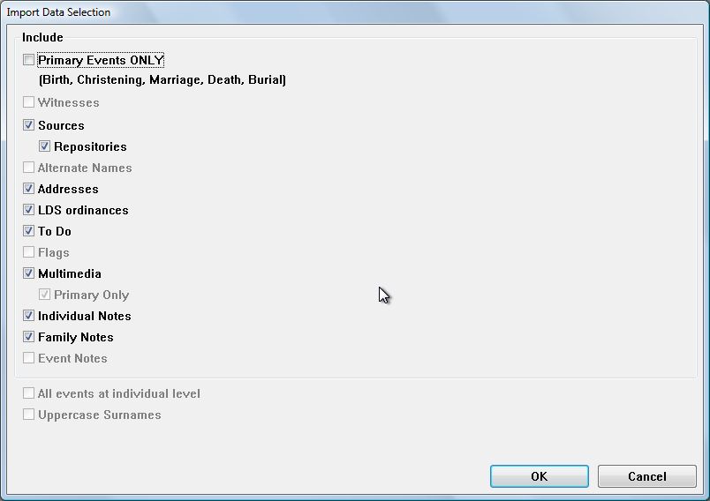

Note: The options which are not applicable for the import will be disabled. Repositories will be enabled for selection when you select “Sources”.

Primary Events ONLY: This selection will cause non-Primary events to be discarded during import. If selected, only Birth, Christening, Marriage, Death and Burial events are honored. This allows you to limit the amount of data sent to the device if you are trying to conserve space.

The rest of the items in the “Include” section allow you to pick the type of data you wish to synchronize to the device.

Multimedia – This option if enabled allows the transfer of images (photos for example) to the device. If you wish to limit the amount of images for space or increased synchronization speed, you can select “Primary Only”. (not applicable for all imports)

All events at individual level – “Family” events such as marriage can be displayed at the “Individual” level if this option is selected. Both spouses will show the same event when viewing “Individual” information for that person.

Uppercase Surnames – Converts surnames to all uppercase during import.

Customizing PAF/FTM add-on Imports
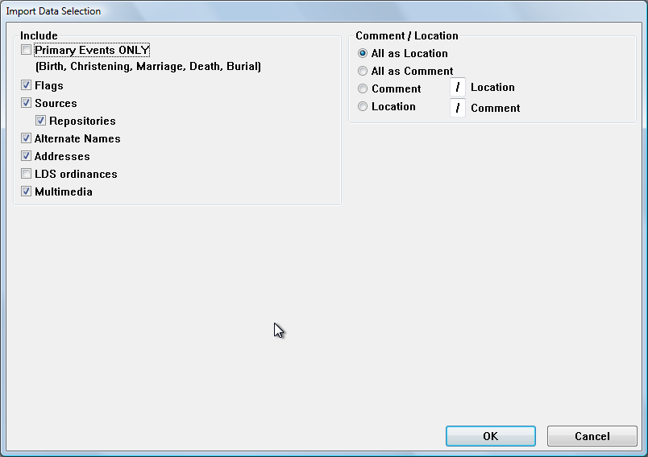

Note: Not all options are available for both PAF and FTM.

Include – Various options for selecting what data types you want to include with your import. You can use this to decrease the amount of space needed for your database.

Primary Events Only -- This selection will cause non-Primary events to be discarded during import. If selected, only Birth, Christening, Marriage, Death and Burial events are honored. This allows you to limit the amount of data sent to the device if you are trying to conserve space.

Multimedia – This option if enabled allows the transfer of images (photos for example) to the device. This option is only applicable for PAF and Family Tree Maker 2008 (or newer) imports.

Comment / Location – Family Tree Maker allows a location and a comment in the same data field. This allows you to pick how you want to process that field as it is imported from FTM. With the third and fourth option, you can specify the character that is used to separate the two values.

Note: As of Family Tree Maker Version 2006, this “Comment” field appears to be solely a “Place” field.

Other Import Options
Now that you have customized your import and saved those values for future use, you have other options you can choose before you start the actual import of your genealogy data. After selecting those options, press “Start” to begin the import.

GEDCOM Import Options
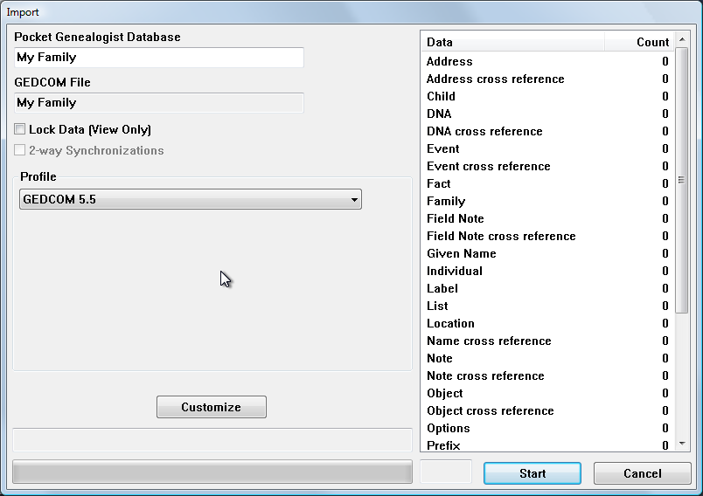

Pocket Genealogist Database - The name of the Pocket Genealogist database will automatically be selected based on the name of the original file. However, you can change the name to whatever you wish. If a database by that name already exists on the device, it will be overwritten.

Lock data (View only) – If you don’t want to allow data entry for this database on the device, you can turn on this option to prevent accidental changes.

Profile – This will automatically be selected based on the GEDCOM file you are using in the import. Profiles are used to select the proper options needed to ensure a correct import of the data. They also provide information to the device side of Pocket Genealogist so that the program matches the capabilities of the genealogy program that created the GEDCOM file.

Legacy Family Tree Import Options
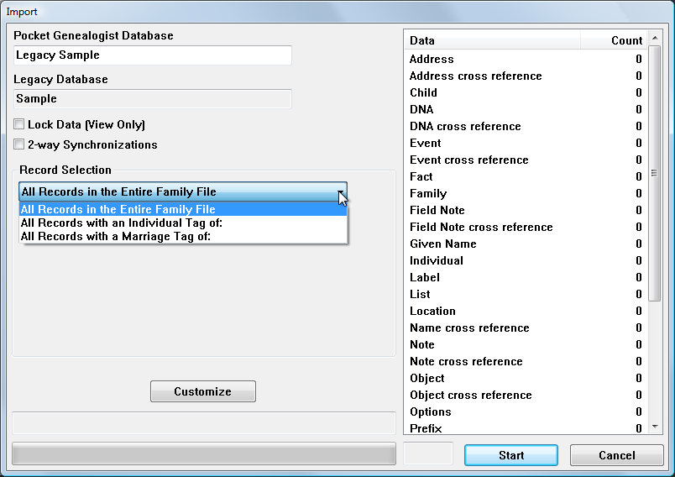

Pocket Genealogist Database - The name of the Pocket Genealogist database will automatically be selected based on the name of the original database. However, you can change the name to whatever you wish. If a database by that name already exists on the device, it will be overwritten.

Lock data (View only) – If you don’t want to allow data entry for this database on the device, you can turn on this option to prevent accidental changes.

Enable 2-way Synchronizing – Use this option if you wish to enable the ability to synchronize changes made on the device directly back to your Legacy database, or changes made in Legacy to your device. When using this option, you can only change Legacy or Pocket Genealogist between synchronizations. (Either side can be changed but not both.) After changing either the device database or the Legacy database, do a “Synchronize” in order to get the databases back in sync. Afterwards, you can then change either side again but only one side at a time.

Note: All options available on the “Customize” screen and “All Records in the Entire Family File” will also be selected if you pick the “Enable 2-way Synchronizing” option.

Note: It is recommended that you do a “Check/Repair” of your Legacy database before you do the initial import. See Chapter 6 for more details.

Note: If you wish to not make changes on the device but still want to retrieve changes in Legacy and synchronize them with the device, select both “Lock Data” and “Enable 2-way Synchronizing”.

Record Selection – Use the following options to pick the individuals you would like to import.

All Records in the Entire Family File – All individuals in the Legacy database will be imported. No other options are available or will be shown.

All Records with an Individual Tag of – All individuals in the Legacy database with the tag specified will be imported. (You have to set this tag from within the Legacy program.) You can optionally select spouses, children and parents of the tagged individuals even if they are not tagged.

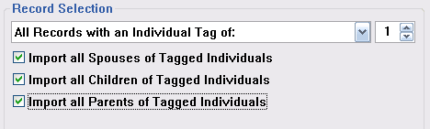

All Records with a Marriage Tag of – All individuals in the Legacy database associated with the family record with the tag specified will be imported. (You have to set this tag from within the Legacy program.) You can optionally select the children of the tagged individuals even if they are not tagged.

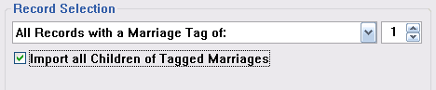

The Master Genealogist Import Options

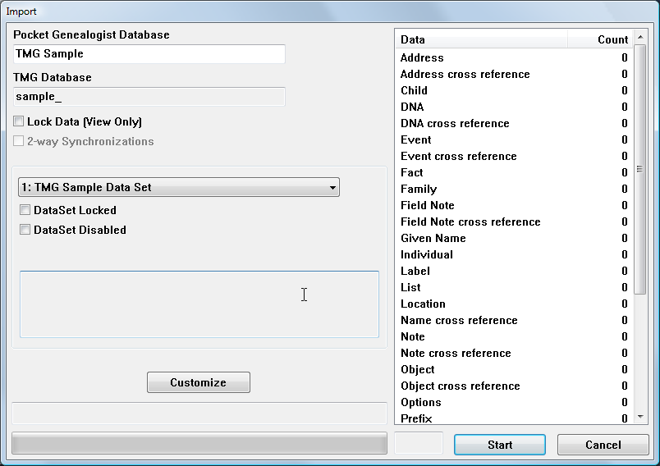

Pocket Genealogist Database - The name of the Pocket Genealogist database will automatically be selected based on the name of the original database. However, you can change the name to whatever you wish. If a database by that name already exists on the device, it will be overwritten.

Lock data (View only) – If you don’t want to allow data entry for this database on the device, you can turn on this option to prevent accidental changes.

Dataset dropdown list – Use the “drop down list” to pick which dataset you would like to import from the TMG project. (Version 5 or higher of TMG.)

Note: The “DataSet Locked” and “DataSet Disabled” indicate the value as set in TMG, not something you can change prior to import.

Other “Direct” Import Options (AQ, Genbox, RootsMagic)
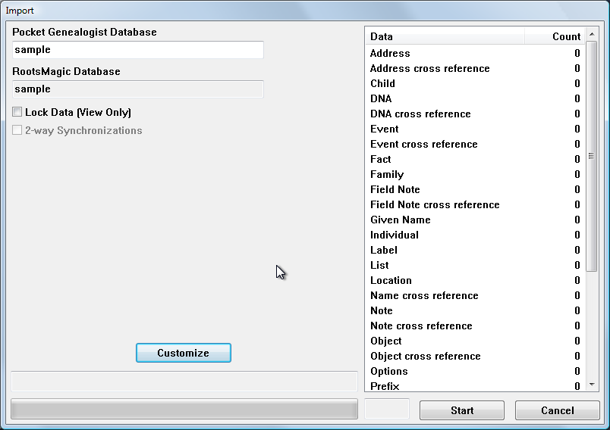

Pocket Genealogist Database - The name of the Pocket Genealogist database will automatically be selected based on the name of the original database. However, you can change the name to whatever you wish. If a database by that name already exists on the device, it will be overwritten.

Lock data (View only) – If you don’t want to allow data entry for this database on the device, you can turn on this option to prevent accidental changes.

PAF/FTM add-on Import Options
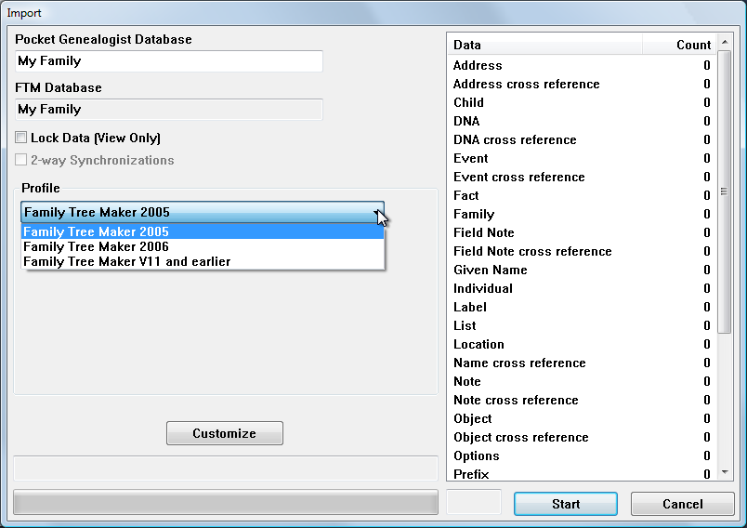

Pocket Genealogist Database - The name of the Pocket Genealogist database will automatically be selected based on the name of the original database. However, you can change the name to whatever you wish. If a database by that name already exists on the device, it will be overwritten.

Lock data (View only) – If you don’t want to allow data entry for this database on the device, you can turn on this option to prevent accidental changes.

Profile – You may have the choice of picking a profile that matches the genealogy program you are using. (PAF will only show “PAF v5” in the list.) Pick the profile that best matches the version of the desktop genealogy program you are using. It will remember which value you select for future imports.

Synchronizing the data to the device
The third step in getting your genealogy data to the device is synchronizing the Pocket Genealogist database to the device.

Note: If there were errors during the import step, the synchronization screen will not be shown.

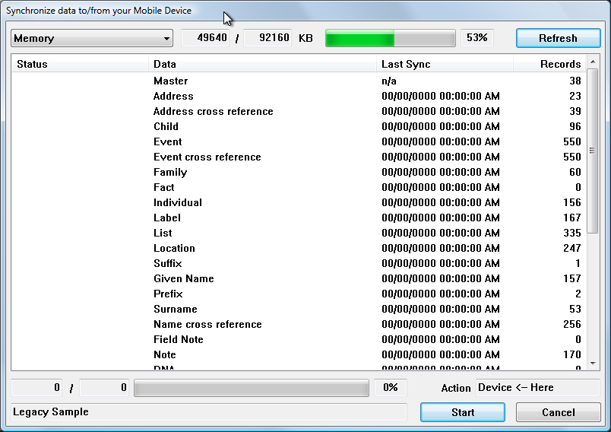

You must have your device turned on and connected to your desktop/laptop computer and an active ActiveSync (or Windows Mobile Device Center) session in order to synchronize. If you do not, you will see the following screen.

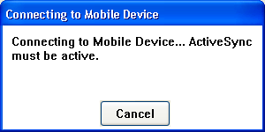

Once you have a connection, the above screen will automatically disappear.
Prior to starting the synchronization, you can select where you want your Pocket Genealogist database stored on the device. Use the drop down list at the top left of the synchronization screen to pick the location.

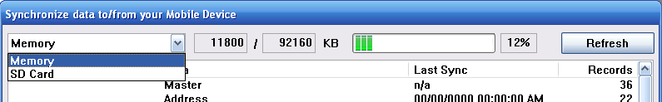

The amount of space already used for that location will be shown to the right and will be updated automatically to show current space utilization while synchronization progresses. In the above example, there is about 92MB of memory of which 12MB is already in use. (12% utilized)

The above is an example for Windows Mobile 5. Prior versions of the Windows Mobile operating system have two memory options:

 | Memory | Memory databases (referred as “Mounted”) are similar to databases stored on storage cards and can be used with the backup function on the device with the Advanced level of Pocket Genealogist.
 | Memory (Object Store) | Object Store databases are similar to the internal Outlook databases such as “Contacts”. Object Store databases are the fastest and most memory efficient type of database on the device. However, they can’t be used with the backup function in Pocket Genealogist, nor can they be stored on a storage card.

Note: Synchronizing to storage cards is slower and the process of creating the database on the card temporarily requires a lot of device memory. If you should get an “out of memory” message during synchronization to a storage card, restart the synchronization (using the synchronization button) to pick up where it left off.

Note: If you want to edit your data, it is recommended that you put the database in memory. Editing the database on a storage card can be significantly slower. Never do a soft reset when you are updating a database to a storage card even if you think the program is “hung”. (It can be that slow at times!) Doing a soft reset during a database update will corrupt the database.

After selecting the location to store the database on the device, press “Start” to perform the synchronization. When it completes, barring any errors, you are now ready to use your database on the device.

Getting Started (Device)
Chapter
3

Screen “Print” examples
Pocket Genealogist supports a wide range of devices with different types of screen resolutions and orientations. Most of the examples in this user guide are for “Portrait” PocketPC devices although “Landscape” PocketPC and smartphone examples will also be shown as necessary.

Some devices support the ability to switch the orientation and Pocket Genealogist will automatically adjust to the new layout “on the fly” if the orientation switch is done using the Pocket Genealogist menus.

Registration (unlock) code
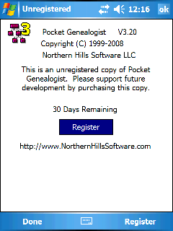
The first time you synchronize a database, it will automatically enter your registration code from the desktop to the device. You can also use the “Register” button or menu item to enter your code.

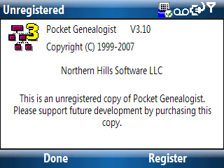

or

Note: The example screen prints have color customization already set. You can set your own preferences by selecting “Edit”, “Configuration” from the menu.

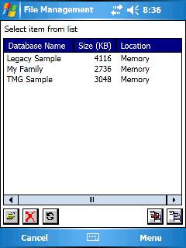
Open your database
By default when you start Pocket Genealogist, it will display a list of databases you have synchronized to the device. If you have not synchronized any databases, refer back to Chapter 2.
Select the database you wish to open by using a single tap of the stylus on the database name in the list, then press the Open button. Double tapping the name in the list will also open the database.

You can also use the “Directional Pad” button to “scroll” down in the list to select the database, then press the “D-Pad” to open it.

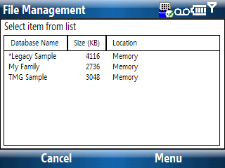

Note: Smartphones do not have buttons for selecting the actions. All actions are accomplished by using the 5-way directional button (d-pad) or using the menus at the bottom of the screen. (Which can be selected using the two menu buttons on the device) Throughout this document the references to the iconic buttons to perform an action are substituted with menu items. The same menus, in most cases, will also be available on PocketPC devices.

3-Generation View
The 3-Generation view is the default “view” of your database. The layout of the screen is divided into 4 areas.
- Current Couple – In the middle of the screen are the male and female “couple” that are currently selected. All other information on the screen relates to this “Current Couple”.
- Children – The list below the current couple is the children of that union.
- Marriage – Above the current couple is the marriage or union information for that couple. To the left are buttons to select other spouses or parents for the male and to the right for the female.
- Parents – Above the marriage box are the parents of the current couple.

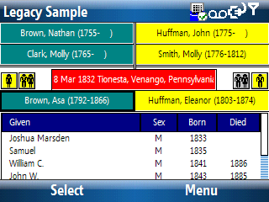
The 3-gen screen is used to both navigate through the database as well as viewing the information about the current couple. Using your stylus, if you tap on one of the parent boxes, that person will become the “Current Couple” and the other information on the screen will change relative to that person. The same is also true for the child list.

Tapping on either person of the “Current Couple” will display more information about that person. Tapping on the marriage box will display family information about the “Current Couple”. Tapping on the spouse and parent icons will display a selection dialog where you can choose a different spouse or set of parents to display. If the icon is in color, that indicates that additional spouses or parents already exist for that person.

Tip: The item on the screen that is “selected” will have a darker border.

Tip: (PocketPC) Use the icon on the menu next to “Tools” to expand/collapse the child window in order to show additional action icons above the menu bar. You can set “collapse child window” from the “Edit”, “Configuration”, “View” tab if you wish to make this the default.

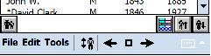

Tip: (PocketPC) You can get a “tip” as to the meaning of each icon by tapping and holding on that icon. To “cancel” the operation, drag the stylus off the icon before releasing.

Tip: You can navigate around the 3-gen screen using the “D-Pad” button or the Action “rocker” switch. (It depends on your device which type you may have. The D-Pad button is the 4-way button found on the bottom front of the device. The Action “rocker” switch is usually found on the left side of the device.) Either acts like a joystick so that you can move around and select individuals from the 3-gen screen. You can tell which person is selected as a darker border will appear around the name. If you “navigate” off the top of the screen, the 3-gen screen will change and you will traverse up one generational level. The D-Pad button is actually a 5-way switch. Pressing the button is similar to pressing the “Enter” key on a keyboard. It is the same as tapping the screen with a stylus for the person who is selected on the 3-gen.

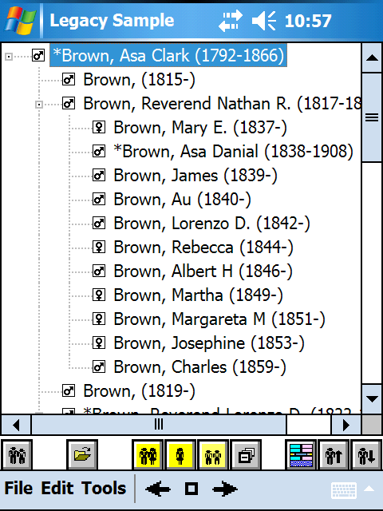
Descendant and Ancestor Tree View
The Descendant Tree View (shown) shows the descendants of the current couple. The Ancestor Tree shows the ancestors of the current couple. By default, only the first generation is expanded. Press the “+” button to expand or the “-“ button to contract a branch.
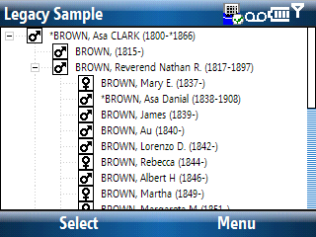

There are 4 pieces of information displayed on each line of the tree.

- The name of the person.
- The birth/death date of the individual.
- The sex of the individual is represented by the “Male” or “Female” symbol. Unknown is represented as a question mark.
- The living indicator. If the person is marked as living, the sex icon will be in color. (No living individuals are shown in this example.)

Note: The “Basic” level of Pocket Genealogist allows up to 3 generations per tree. The “Advanced” level can have up to 255 generations.

Note: You can also highlight the branch you wish to expand/contract and press the “enter” button on the “D-Pad” to perform that action.

Tip: You can set the default “view” shown at startup and the number of levels displayed from the “Edit”, “Configuration”, “View” tab.

If you wish to view or edit the individual information from a Tree View, select the person in the list and press the “Edit” button. To view/edit the family information, select the individual from the Tree View then press the “Spouse List” button. From that list select the spouse for the family in question, then press the “Edit” icon.

Note: (PocketPC and smartphone) You can also highlight the individual in the tree and press the “Select” menu item to view/edit that individual.

Icon Bar buttons (PocketPC)
Button | Use
 | “Find Name by Relationship List” – this is a quick entry into the “Find”, “by Name List” function found on the “Tools” menu. Selecting this button will show all the immediate relations to the selected individual in the list. Selecting a person that the relationship list then takes you to the “Find”, “by Name List” function with that person selected.
 | “Edit” – this is used to edit/view the individual selected in the tree.
 | “Parents list” – this icon will show a list of parents for the selected person in the tree. If more than one set of parents exist, the icon will be in color. If you select a person from the parent list, they become the new “root” person in the tree. (Male person by default.)
   | “Spouse list” – this icon, either female or male, will show a list of spouses for the selected person in the tree. If more than one spouse exists, then the icon will be in color. If you select a person from the spouse list, they become the new “root” person in the tree.
 | “Children list” – this icon will show a list of children for the selected person in the tree. If you select a person from the children list, they become the new “root” person in the tree.
 | “Expand All” – this icon will expand all levels for the selected individual. If you select the “root” person in the list and press this button, all branches of the tree at all levels will be expanded. Use this with caution as sorting occurs for the children of each level the first time they are expanded. If you expand all at once, it may take some time to expand depending on the number of individuals and levels.
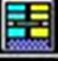 | “3 Generation View” – this icon will switch to the “3 Generation” view for the selected person in the tree.
 | “Ancestor Tree View” – this icon is used to switch to the Ancestor tree view. If you are already in either tree, the selected individual in the tree becomes the root for the view. This is handy for quickly navigating up and down a tree.
 | “Descendant Tree View” – this icon is used to switch to the Descendant tree view. If you are already in either tree, the selected individual in the tree becomes the root for the view. This is handy for quickly navigating up and down a tree.

Individual View
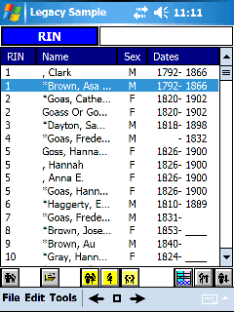
The Individual View is new with Version 3. Unlike the other views that only show a limited number of individuals at a time, the Individual View must read information about all individuals in your database in order to show the display. Therefore, because of speed considerations, the Individual View is only suitable for small databases.

Note: The Individual View is not currently supported on smartphones. (non-touch screen devices)

Both primary and alternate (AKA) names are shown in the view. Primary names are noted by the use of an asterisk preceding the name.

Note: An asterisk preceding the date indicates that an alternative date was used to signify the birth or death. (Such as a christening or burial event) This is true on all views.

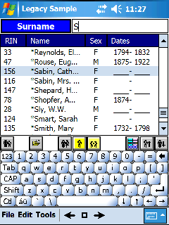
The button and edit field at the top of the view is a means to change the sort order of the view as well as navigate (find) the first occurrence of the text that you enter. Pressing the button will toggle between the fields that are available. When switching between the fields, the view won’t automatically sort until you tap on the edit field. (which would indicate the intent to enter data.) Sorting can take from a few seconds to several minutes depending on the size of your database.

You can sort/find on RIN, Surname, Given name, birth or death. To find the first name in the list with a surname beginning with an “S”, tap on the button until “Surname” appears, then tap on the edit field (which will cause a sort to occur), then enter “S” into the edit field. If you continue to type, the selected individual in the list will continue to change to match the value entered. (Typing in “Sma” would position the selection to “*Smart, Sarah” in the example to the right)

Meaning of Icon Buttons in Pocket Genealogist
Button | Use (Not all functions are available for all imports)
 | “Address” - used to invoke the address screen. If the icon is in color, address information exists for this item.
 | “Add a source citation” – this is used to add a source citation to the current item. This button is always in color.
 | “List of Source Citations” – this button display a list of source citations for the current item. If the book icon is red, source citations exist for the item.
 | “Note” – this is used to display the note screen. If the icon is in color, a note exists for this item.
 | “Add” – this is used to add an item.
 | “Edit” or “Open” – this is used to edit/view/open an item.
 | “Delete” – this is used to delete an item.
 | “Set to preferred” – this is used to set the selected item to either “primary” or “preferred” (depends on context).
 | “Link to existing Individual” – this is used to link to an existing person such as linking a new child to a set of parents.
 | “Unlink the individual” – this is used to unlink a person such as unlinking a child from a set of parents but not deleting that person.
 | Used to display a relationship list for the current individual. (Shows parents, spouses, and children of that person).
 | Part of the menu and is used to navigate through the “history” list. The square box brings up the history list for selection. The backward and forward buttons move to the previous or next person in the “history” list.
 | “Clear” – this is used to clear the text in the edit field.
 | “Undo” – this is used to reverse the last action or to reset the text (Generally on edit screens).
 | “Find/Lookup” – this is used to lookup information in the database such as Surnames or Locations.
 | “Save” – this is used to “save” the sort order (Legacy events for example).
 | “Sort the List” – this is used to “re-order” the list back to its original sequence. (Legacy events, for example)
 | This set of buttons is used to change the order in a list. (Legacy events for example)
 | “Sort Date” – this is used to display the Sort Date. (TMG Events for example). When the icon is in color, this indicates a sort date exists for the current item.
 | “2nd Date” – depending on import, could be an End Date or a Status Date (such as marriage ending status date). If the icon is in color, a date exists for the event.
 | “To Do” – this is used to display the To Do list. If the icon is in color, To Do’s exist for the current item.
 | “Latitude / Longitude” – this is used to display latitude and longitude information. If the icon has a blue background, latitude and longitude values exist for the current item.
 | Used with the “Find by” function to change the character set.
 | “Parents list” – this icon will show a list of parents for the selected person in the tree. If more than one set of parents exist, the icon will be in color. A person selected from the parent list becomes the new “root” person in the tree.
 | “Spouse list” – this icon, either female or male, will show a list of spouses for the selected person in the tree. If more than one spouse exists, then the icon will be in color. A person selected from the spouse list becomes the new “root” person in the tree.
 | “Children list” – this icon will show a list of children for the selected person in the tree. If you select a person from the children list, they become the new “root” person in the tree.
 | “Expand All” – this icon which is found when in “Tree” view, will expand all levels for the selected individual. If you select the “root” person in the list and press this button, all branches of the tree at all levels will be expanded. Use this with caution as sorting occurs for the children of each level the first time they are expanded. If you expand all at once, it may take some time to expand depending on the number of individuals and levels.
 | “3 Generation View” – this icon will switch to the “3 Generation” view for the selected person in the tree.
 | “Ancestor Tree View” – this icon is used to switch to the Ancestor tree view. If you are already in either tree, the selected individual in the tree becomes the root for the view. This is handy for quickly navigating up and down a tree.
 | “Descendant Tree View” – this icon is used to switch to the Descendant tree view. If you are already in either tree, the selected individual in the tree becomes the root for the view. This is handy for quickly navigating up and down a tree.
 | “Refresh” – this icon is used refresh the display. (For example, the “Databases” lists)
 | “Close” – this icon is used to close the currently open database.
 | “Backup” – this icon is used to create a backup of the selected database. This is only available in the “Advanced” version of Pocket Genealogist.
 | “Restore” – this icon is used to restore a backup. This will overwrite the database with the same name on the device. This is only available in the “Advanced” version of Pocket Genealogist.
 | “Add item to Research List” – found on Individual, Family, Source, and Repository screens and allows you to add that “Item” to a Research List.
 | “Multimedia” – this icon is used to display a list of multimedia objects for the current object. (Individual, event, etc.) Multimedia Objects are only available in the “Advanced” version of Pocket Genealogist

Individual Information
When you “tap” on either member of the “current couple” in the 3-gen View or press the edit button in one of the other views, you will display a series of tabs with information for that individual. Depending on the source of the import, since Pocket Genealogist attempts to mirror the capabilities of the desktop genealogy program, you may have a different set of tabs and the information displayed on each tab may have different information.

Main tab (Individual)
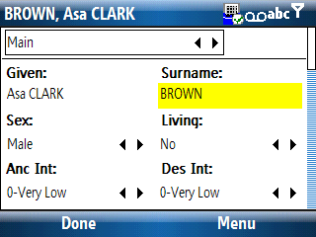
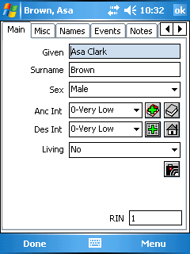
The “Main” tab is used to display the main information about the individual. This would include the primary name, sex, a living indicator and other items. Some or all of these values may be disabled or hidden depending on the source of the import.

or

For some imports, if the database is locked as “View Only”, the date the individual was last edited on the desktop will be displayed.

For sex and living fields, only the values that can be selected for the particular import will be shown in the list. (You may only see a single item if the value cannot be changed)

As with most Pocket Genealogist screens, the data displayed and the options available may differ greatly depending on the genealogy program you use on the desktop.
The “How To” section of this guide goes into much more information.

Names tab (Individual)
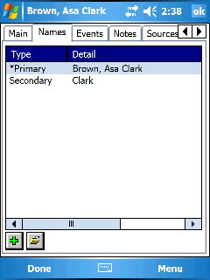
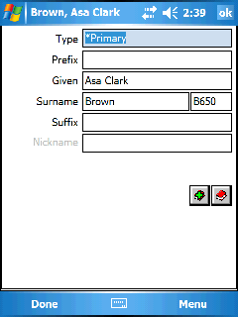

The names tab is used to work with the primary and secondary names for the individual. Selecting a name in the list then pressing the “edit” button will display the information for that name. Tapping on any of the name fields will display an edit/view dialog for that name element.
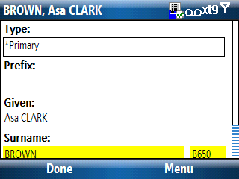
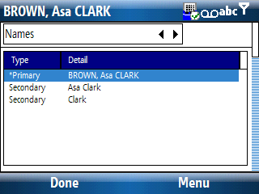

Events tab (Individual)
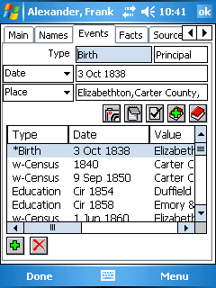
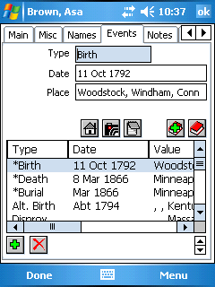

The events tab, as with most Pocket Genealogist screens, can be greatly different depending on the source of the import. Some imports may have a drop down list next to a detail field which can be used to change what is displayed in the field. Depending on the import, you may have roles (witnesses), sort date, address, notes, To Do’s and other fields. Pocket Genealogist uses “profiles” to control this behavior and also will only allow the types of events applicable for the desktop genealogy program you are using.
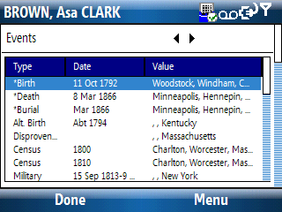
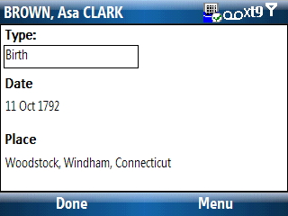

Note: Primary Events (Birth, Christening, Marriage, Death and Burial) may appear either at the top of the list or be interspersed (usually sorted by date) and will be indicated by an asterisk. For Family Tree Maker imports, the Asterisk indicates the “Preferred” event.

Note: If your desktop program supports witnesses, the events for which the person is a witness will be marked in the list preceded with a “w-“.

Notes tab (Individual)
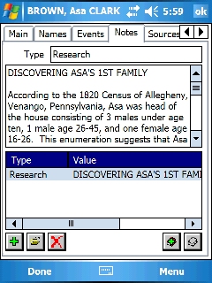
The notes tab is for displaying notes about the individual. Depending on the capabilities of the desktop genealogy program you are using, you may have from zero to many notes.

On the devices that show both the list and the note, the note area may only display partial information. (Approximately 500 characters) Tap on the note (or “Edit” from the menu) to display the complete note.

Other devices may show only a list of notes but the entire note can be displayed using the menu.

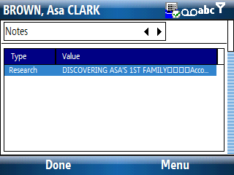
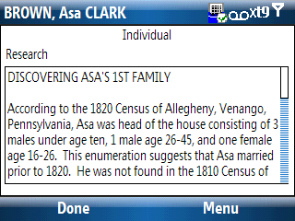

Sources tab (Individual)
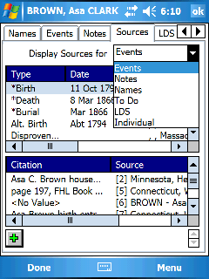
The sources tab allows you to see all the citations that are attached to all items at the individual level. The drop down list allows you to pick the type of citations you wish to see in the lists.

After selecting the item from the first list, the citations for that item will be displayed in the second list.

On some devices only the first list will be shown and you will need to select an item from the list in order to see a subsequent list with the citations.

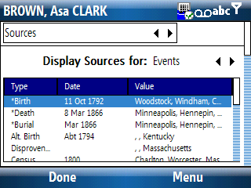
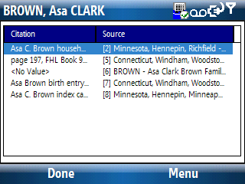

Note: The type of items that appear in the drop down list depends on the capabilities of your desktop genealogy program.

LDS tab (Individual)
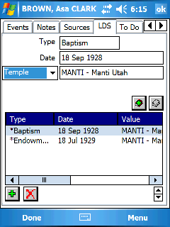
The LDS Tab is similar to the events tab but is used to display the LDS Ordinances for the individual. This tab may be hidden if you disable this option from the desktop during import. In the case of Legacy Family Tree direct imports, the display of the tab depends on the options you have set in Legacy.

As with the events tab, you may a drop down list next to a display field which is used to toggle between different types of fields. In the above example the “Temple” field will toggle between “Temple” and “Place”.

To Do tab (Individual)
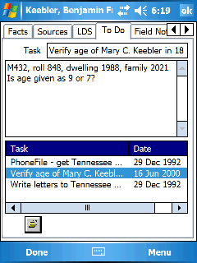
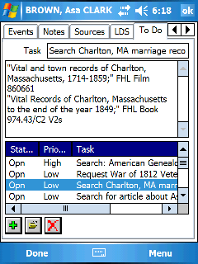

The To Do tab will be displayed if your desktop genealogy program supports that type of information. Some desktop programs may support To Do’s but not via GEDCOM in which case they will not appear on the device. As with other screens in Pocket Genealogist, the display will look different based on the import type as in the Legacy and TMG examples above.

Field Notes tab (Individual)
Field Notes are available for all imports since they are not specific to a desktop genealogy program. In fact, information entered here is never transferred back into your desktop program. Any information you enter can be displayed using the Field Note reporting feature found in the Desktop side of Pocket Genealogist. How you process the Field Notes is entirely up to you, you may decide to enter them as notes into your desktop program or simply print them for later reference. See Chapter 7 for additional details on Field Notes.

Note: Since Field Notes have no direct tie to your desktop genealogy program, every time you import a new database the Field Note tab will always be empty.

DNA tab (Individual)
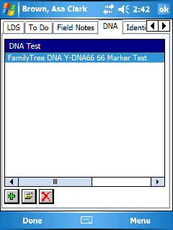
The DNA tab provides a means to view/edit DNA information for the individual. This feature is only available if supported by your desktop genealogy program. The type of markers and tests that are displayed depends on the tests supported by your program.

Selecting an item in the list and pressing the “Edit” button will display details for that DNA test. The “Markers” tab is used to display/edit the DNA markers for the test.
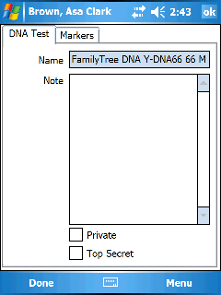

Identifiers tab (Individual)
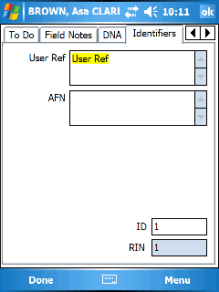
The Identifiers tab shows some additional ID fields that may be available for your desktop genealogy program.

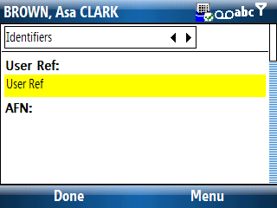

Tip: You can set the background color for “Changed data” to one color and editable fields to another. This can be accomplished from the “Misc Color” tab under “Edit”, “Configuration”.

Relationships tab (Individual)
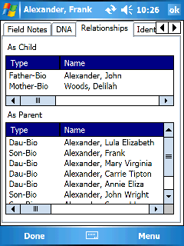
The Relationships tab is only available for The Master Genealogist imports. This tab shows the relationship information for the individual both backwards (as a child) and forwards (as a parent).

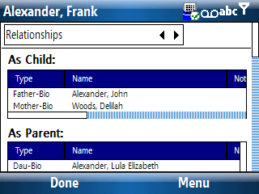

Misc tab (Individual)
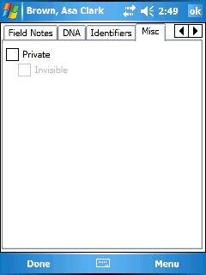
The “Misc” tab contains miscellaneous information such as the Private indicator. The availability of the “Misc” tab depends on the features supported by your desktop genealogy program.

Family Information
When you “tap” on the “Marriage” box in the 3-gen View or select the appropriate edit button or menu item in one of the other views, you will display a series of tabs with information for the “Current Couple”. The tabs that are displayed are very similar to the tabs found for the Individual. (See Individual tabs for examples.)

Main tab (Family)
The “Main” tab is used to display details about the union such as the individuals’ names. It may also have other options and buttons for accessing information attached to the Family record.
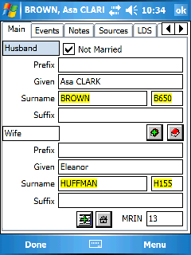
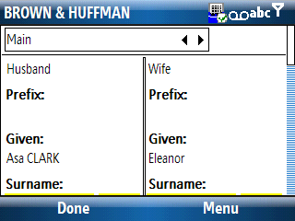

Note: Some imports have the option “All events at individual level” which can be found on the “Customize” screen for the import. If selected, the family events will not appear at this level but will be shown on the event tab for both individuals that make up the family.

Misc Tab (Family)
The “Misc” tab is used to display miscellaneous information about the family such as “Private” or “Not Married” or married name options. (Married Name is applicable to Legacy Family Tree only)

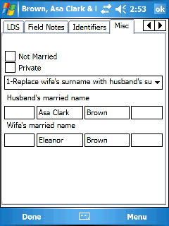

How to (Desktop)
Chapter
4
This chapter goes into detail on how to accomplish various tasks in the desktop side of Pocket Genealogist.

Create a new Pocket Genealogist database
Pocket Genealogist is a companion product for desktop genealogy databases. You cannot use Pocket Genealogist as a stand-alone genealogy program. You need to have a desktop program where you keep your genealogy data. To create a new Pocket Genealogist database with the data from your desktop program, use the “Create” Button. See “Getting Started (Desktop)” for more details on how to create a new database and synchronize it to the device.

Note: You can have as many Pocket Genealogist databases as you wish from as many different desktop genealogy programs as you use.

Delete a desktop Pocket Genealogist database
If you have a Pocket Genealogist database that you no longer need, you can delete it from the desktop. This does not automatically delete it from the device so you may want to do the same on the device. To delete the desktop Pocket Genealogist database do the following:

- Start Pocket Genealogist on the desktop.
- Select the database in the list you wish to delete.
- Press the Delete button.

Perform 2-way Legacy Family Tree Synchronization
See Chapter 6 for more details.

Synchronize changes made in your desktop program
With the exception of Legacy Family Tree (with 2-way Synchronization enabled), all other imports require a complete re-import of your database when changes are made in your desktop genealogy program. Please note that all changes made to the database on the device will be replaced with a fresh copy of the database from the desktop. If you have made changes on the device, always synchronize your database and export the changes to GEDCOM before doing a re-import. See “Re-Import a database” for more details on how to “refresh” your device database with changes made on the desktop.

Re-import a database
If you make changes in your desktop genealogy program and want to “Refresh” the device database to reflect these changes, you have to re-import the entire database. The only current exception is 2-way synchronizations with Legacy Family Tree. Keep in mind that when you re-import a database, any changes you may have made to the database on the device will be replaced by the database on the desktop. (Think of it as deleting the device database, then creating a new one.) To re-import your database, do the following steps:

- Turn on your device and make sure Pocket Genealogist is closed.
- Connect your device to the desktop and establish an ActiveSync connection.
- Start Pocket Genealogist on the desktop.
- Select the database you want to re-import from the list.
- Press the Import Button.
- You will get the following warning. Select “Yes”

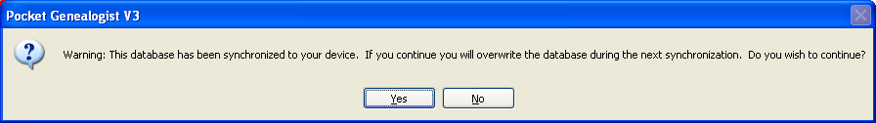

- A 2nd warning will be displayed verifying you want to overlay the database. Press “OK”.

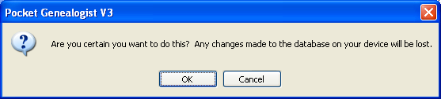

- An import screen like the one you originally used for the initial import will be displayed. You should not need to “Customize” again unless you want to use different options for the type of data that is imported. Select any options you wish to use such as “2-way Synchronization” (Legacy only) or “Lock Data (View Only)” and then press “Start”.
- If no errors occurred during import and a synchronization session is established with the device, you will see the “Synchronization” screen. Don’t forget to pick the location you want to put the database on the device using the drop down list at the top left. Press “Start” to perform the synchronization. Press “Start” to perform the synchronization.

The database has now been “Refreshed” on the device with the new changes made in your desktop genealogy program.

Retrieve changes made on the device
You need to do a synchronization in order to retrieve changes made on the device back to the desktop Pocket Genealogist database. This can be done using the following steps:

- Turn on your device and make sure Pocket Genealogist is closed.
- Connect your device to the desktop and establish an ActiveSync connection.
- Start Pocket Genealogist on the desktop.
- Select the database you want to synchronize from the list.
- Press the Synchronize Button.
- A synchronization session will be established to the device. You will see the synchronization screen both on the desktop and on the device.
- Press “Start” to perform the synchronization.
- If you are doing 2-way Legacy Synchronizations, additional steps will occur. See Chapter 6 for more details.

The changes made on the device will now be in the Pocket Genealogist database on the desktop ready for exporting to GEDCOM or Field Note/Research List processing.

Export device changes to GEDCOM
After performing a synchronization to retrieve changes made on the device (see “Retrieve (Synchronize) Changes made on the device”), you can export the data to a GEDCOM file which can be used by your desktop genealogy program. You may wish to load the GEDCOM as a new database or “merge” the data with your current database. (See your desktop genealogy programs’ help file for more information on how to accomplish that.) To create a GEDCOM do the following steps:
- Make sure you’ve synchronized the changes from the device first.
- Select the database from the list in Pocket Genealogist on the desktop.
- Press the Export button.
- If the import for this database was a GEDCOM file, you will be prompted if you wish to replace the original GEDCOM.

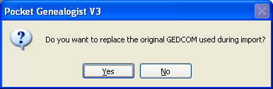

Warning: For Family Historian, which uses GEDCOM as its “database”, replacing the original GEDCOM would be replacing your FH database. You should probably not use this option.

- The Export to GEDCOM screen will be displayed. If the name and location of the GEDCOM file is blank, you will need to press the “Select” button to pick a location and name you wish to use.
- If you want to keep the size of the GEDCOM file to a minimum, which may be a good idea if you plan on doing a “merge” with your desktop program, select the “Only Individuals with changes”. All information for that Individual will be exported, but only for those individuals where a change has occurred. If it would be helpful during “merge”, you can also include spouses, children and parents of Individuals with changes.
- Press “Start” to export the GEDCOM.

You can now use the GEDCOM file as input into your desktop genealogy program.

Note: GEDCOM files that were originally imported as “ANSI”, “UTF-8”, or UNICODE will be exported in the same format. “ANSEL” coded GEDCOM files will be exported as “ANSI”.

Note: You can create GEDCOM files for direct Legacy, The Master Genealogist or for the “PAF/FTM add-on” data although not all information may be eligible for output to GEDCOM (for example, TMG Roles).

Note: It is recommended that you import the GEDCOM file into a new database in your desktop genealogy program until you get comfortable with the process of merging data into your original database.

Note: Objects such as photos are not transferred to the device during import. However, the links to the objects are stored in the Pocket Genealogist database created on the desktop so that they can be put back into the GEDCOM file on export.

Retrieve “Orphan” databases from the device
When you delete a Pocket Genealogist database on the desktop, it does not automatically delete the database from the device (and Vice Versa). You can retrieve the database from the device and export the information to GEDCOM if you wish. (VERY handy if you should have a desktop crash and lose your database and backups.) Databases left on the device but not on the desktop are called “Orphan” databases. To retrieve an orphan database, do the following:

- Turn on your device and make sure Pocket Genealogist is closed.
- Connect your device to the desktop and establish an ActiveSync connection.
- Start Pocket Genealogist on the desktop.
- Press the “Orphans” button. If a connection is successful to the device, any “orphaned” databases will now appear in your database lists and the status will indicate if they can be recovered. If they can, press the Synchronize button to retrieve the database.

You can now use the Export button to create a GEDCOM of your data.

Note: If this was a Legacy database where 2-way synchronizing was enabled, the 2-way synchronizing option will no longer be available.

Set the sound to play after an event
If you are working with large databases, you may wish to set a “sound prompt” that will play after selected events such as Import, Export, or Synchronize. This prompt provides a handy notification when that event is done so you can work on other items. To set this “sound prompt”, go to the “Options” screen in Pocket Genealogist.

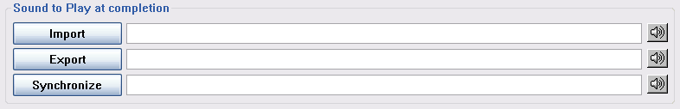

Pocket Genealogist does not come with any sample sounds, but you can find Windows sounds usually in “C:\windows\media”. Press the button for the event you wish to set to display a dialog for picking the sound file to play. Use the “Speaker” button to play the sound for verification.

Change the display language
- Press the “Language” button.
- Select the language you want to use from the list. “Default” will use the current regional settings to select from the available installed languages.

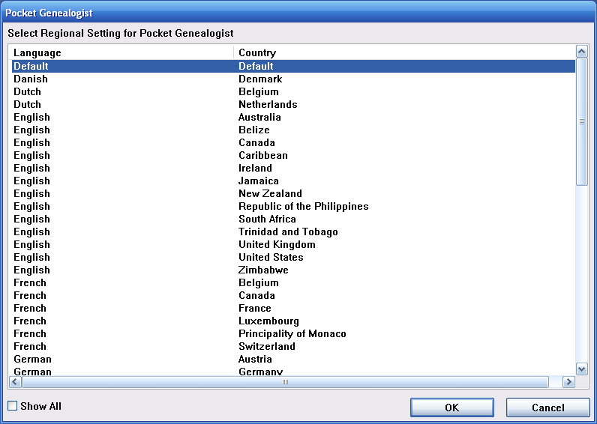

“Show All” shows all regional setting values available for the desktop. Even though you may not have that language available with Pocket Genealogist, the other regional settings such as date format will still be honored.

If you select a language that has not been selected to synchronize to the device, you will get the following prompt:

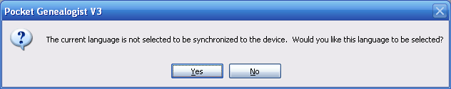

You will also be given the option to synchronize the language immediately to the device. If you decline, the next time you do a database synchronization the language will also be synchronized to the device.

Select language(s) for device
You can manually select which languages you want to have synchronized to the device from the “Options”, “Advanced” screen. Selecting a check box and pressing the “Synchronize” button will add a language to the device. De-selecting a check box and synchronizing will remove the language from the device.

If you do not explicitly synchronize the languages from this screen, they will automatically be synchronized during database synchronization.

Process Field Notes
If you have entered Field Notes on the device and are now ready to retrieve and “process” them, do the following:

- Make sure you’ve synchronized the changes from the device first.
- Select the database and press the Reports button.
- Select “Field Notes” from the prompt.

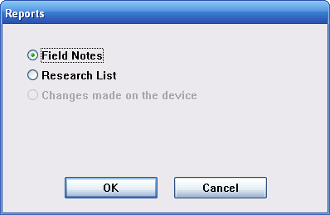

- See Chapter 7 for additional details on what you can do with the Field Notes.

Note: The “Changes Report” is not yet available in the production release. If you wish to try this report, see the “Public Beta” on the website.

Process Research Lists
If you have added items to Research Lists on the device and want to see this information on the desktop, do the following:

- Make sure you’ve synchronized the changes from the device first.
- Select the database and press the Reports button.
- Select “Research List” from the prompt.

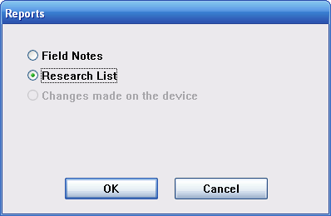

- See Chapter 8 for additional details on what you can do with the Research List display.

Note: The “Changes Report” is not yet available in the production release. If you wish to try this report, see the “Public Beta” on the website.

Remove customization values
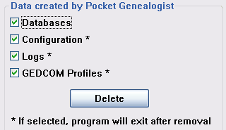
There are times when you may wish to reset the customization values or delete all databases on the desktop side of Pocket Genealogist. Start Pocket Genealogist on the desktop and press the “Tools” button. There are four types of data that can be removed.

- Databases – selecting this option will delete all Pocket Genealogist databases on the desktop. It does not delete databases on the device.
- Configuration – this removes all customization values such as the type of data you’ve selected for import, your registration/unlock code, the size and position of columns in lists and other customization information. Removing these values will allow you to re-select the location where databases are stored.
- Logs – this will remove all Pocket Genealogist log files.
- GEDCOM Profiles – if you have modified GEDCOM Profiles (not generally recommended), selecting this option will remove the customized profiles and reset the system back to the default profiles.

After selecting the options to remove, press the “Remove” button. Pocket Genealogist will exit after you press this button.

Set the default path for an Import
When you do imports of a particular type (for example GEDCOM), the default location on your computer where it will look for this type of file is saved within Pocket Genealogist. If you change the location at import time, you will be prompted if you want to set the new location as the default path.

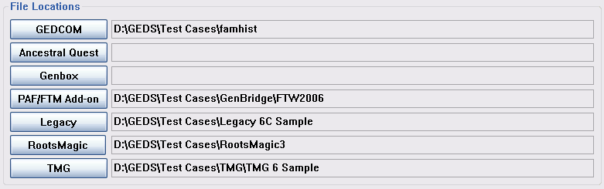

Press the button for the path you wish to set and a Windows selection dialog will be displayed to allow you to pick the path.

Resize a list column
Most lists in Pocket Genealogist will allow you to resize the columns in the list. Move your mouse over the vertical bar that separates the column header for the column you wish to resize, then hold down the left mouse button and move the mouse to resize the column. Double clicking on the vertical bar between columns will automatically resize the column to the width of the header text.

Change the column order of lists
Most lists in Pocket Genealogist will allow you to change the order of the columns. Using the mouse, single left click on the column header you wish to move and hold down the mouse. Then drag the column to the location in the list where you wish to place it.

Save List Column Widths and Position
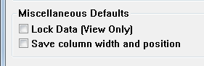
Most of the lists in Pocket Genealogist allow you to resize the columns and set the order of the columns as you choose. If you want to automatically save the changes you make so that each time you start Pocket Genealogist, turn on this default from the “Options” button. See “Resize a list column” and “Change the column order of lists” for details on how to make those changes.

Tip: Change the lists to how you like them then turn off this option so that you don’t accidentally change the list later.

Tip: You can reset the column width and order for all lists by first turning on this option, then turning it off. The prompt will ask if you want to reset to the default.

Set “View Only” as the default

If you want the majority of your Pocket Genealogist databases to be “View Only”, you can set this as the default from the “Options” Screen. You can still override this value during import.

Note: Setting this option has no effect on previously imported/synchronized databases.

Enter your registration (unlock) code
When you run Pocket Genealogist for the first time, you will be prompted for your registration code. If you didn’t enter it at that time or need to re-enter the code later, for example when you upgrade from “Basic” to “Advanced”, you can enter it from the “About” screen.

Change the code page
In rare cases you may need to change the code page used during imports. (For example if you are using the Greek alphabet or the Vietnamese character set.) You can change the default code page from the “Advanced” screen found under “Options”. Use the “Default” button to set the code page back to the default.

Note: It is recommended that you do not change this value without first talking to Pocket Genealogist support.

Use TCP/IP as the synchronization method
If you are having firewall problems and are unable to get synchronization working with Pocket Genealogist (“Unable to Communicate” message) or are using Wi-Fi or an Ethernet connection with a Windows Mobile 5 device, you may need to turn on the “Use TCP/IP for communications” option. You can find this on the “Advanced” screen under “Options”. Smartphone devices (non-touch screen devices) may also need to have this option turned on in order to synchronize.

Set “Mounted” databases as the default
Prior to Windows Mobile 5 there were two types of memory databases, “Object Store” and “Mounted”. “Object Store” databases are the default and are faster and use less space. However, “Mounted” databases are eligible for backup with the backup feature in the “Advanced” version of Pocket Genealogist. You can select the type of database when you initially synchronize the database to the device. However, if you want to make “Mounted” databases the default so that you don’t forget during synchronization, you can set it on the “Advanced” screen under “Options”.

Select type of data to import
When you import a database, you have options on the type of data that you can send to the device. You can use this to minimize the sync time to the device or to conserve space. Use the “Customize” button found on the import screen to set the options.

Set the database to “View Only”
When you do an import from your genealogy database, you can set the Pocket Genealogist database to “View Only”. You may wish to do this if you aren’t planning on making changes on the device as it will prevent accidental changes. You can set this option on the import screen during synchronization.

Enabling 2-way Synchronizations
With Legacy Family Tree databases, you may want to enable 2-way Synchronizations. This will allow you to make changes on the device, then directly update your Legacy database during synchronization. You can enable this option from the import screen. See Chapter 6 for more details.

Create a GEDCOM file for Import
If you are using a GEDCOM file as input into Pocket Genealogist, you must first create the file from your desktop genealogy program. See Appendix B for some examples on how to create this file.

View a Pocket Genealogist Log
The bottom half of the Pocket Genealogist “main” window contains information about actions you have taken during the current Pocket Genealogist session. You can also see the last 7 days worth of sessions by opening the Pocket Genealogist log window.
Press the “Logs” button to open a window where you can select any of the last 7 days of logged sessions. Select an item in the list and press “Open”. A separate window (generally Windows Notepad) will open with the log information.

Search for your Desktop Genealogy data (Import)
See the “Getting Started (Desktop)” chapter for information on how to search for your desktop genealogy data when creating a new Pocket Genealogist database.

Synchronize multimedia (images) to device in BMP format
Pocket Genealogist (“Advanced” only) will import images in JPEG format for synchronization to your device. The images attached to your desktop database can be in the format of BMP, GIF, JPEG, TIFF or PNG. Pocket Genealogist automatically converts to JPEG and resizes the images to display better on the device. (Your original images are left untouched) However, some older devices may not support the display of JPEG images, so you can indicate that images sent to the device be converted to bitmap (BMP) format. BMP files will be quite a bit larger than JPEG which will use more space on the device plus take longer to synchronize. Only use this option if necessary.

Go to “Options”, “Advanced” in the desktop Pocket Genealogist program to select “Import Images as ‘BMP’ files”. After changing this option, you must import and synchronize your database to reflect the change.

How to (Device)
Chapter
5
This chapter goes into detail on how to accomplish various tasks on the device side of Pocket Genealogist.

Interacting with device: Smartphone vs. PocketPC
Pocket Genealogist supports a wide range of devices including smartphones and PocketPC’s. A PocketPC may also include a phone, but references to “smartphone” in this document indicate a non-touch screen device.

PocketPC (touch screen) Interaction
The common method of interacting with touch screen devices is with the included stylus. However, there are other ways to interact that bypass the use of the stylus.
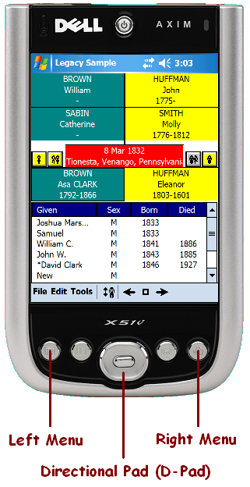
- Directional Pad (D-Pad): This is a 5-way “rocker” button and acts similar to a joystick. You can move around on the screen by pressing the button up, down, right or left. Pressing the center of the button acts like an ‘Enter’ key or the equivalent of a “tap”.
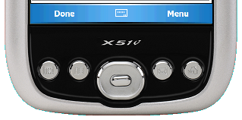
- Menu Buttons: On all screens except the main “views” (3-gen View for example) there will be a two item menu at the bottom of the screen. Pressing the left or right menu button will invoke the left or right menu item. You may need to enable this on your device at “Start”, “Settings”, “Buttons”. (Assign “Left Softkey” to button 1 and “Right Softkey” to button 4)

Smartphone (non-touch screen) Interaction
Smartphones are devices that do not have a touch screen. They depend heavily on the use of the directional pad (D-Pad), menu buttons and keypad.

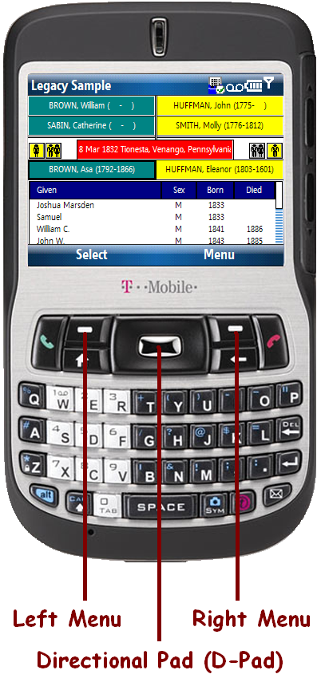
- Directional Pad (D-Pad): This is a 5-way “rocker” button and acts similar to a joystick. You can move around on the screen by pressing the button up, down, right or left. Pressing the center of the button acts like an ‘Enter’ key or the equivalent of a “tap” on the screen. You can use the D-Pad to move to other items on the display such as the parents or children. Pressing the D-Pad (“Enter”) will cause the parent or child to move to the “Current Couple” position.
- Menu Buttons: On all screens there will be a two item menu at the bottom of the screen. Pressing the left or right menu button will invoke the left or right menu item. On the 3-gen example to the left, the detail information for the left “current couple” person (Asa Brown) will be displayed if you press the left menu button. (That position is “highlighted” indicated by the darker border) Additionally, if you move to a parent or child and press the left menu button (“Select”), you can view that individuals details without making them the “Current Couple”.

“Tab” display
Smartphones do not support the “tab” display like what you see on PocketPC’s. Instead, there will be a selection field at the top of each detail screen that allows you to switch between the various “tabs”.

Whenever you display a “tab” screen, the “focus” (cursor) will always be on the “switch” field. You can use the left and right button of the D-pad to change which “tab” is shown or you can press the D-Pad “Enter” on the field to display a list of all “tabs” that you can select from. The ability to show a list of available values is true for all fields that show a left and right arrow. Pressing “Enter” on fields that don’t have the arrows will invoke the Pocket Genealogist “edit” screen applicable for that field.

Tip: The field that is currently selected on the screen will have a border around it to help distinguish that it has the “focus”. When you move off the field the border will disappear.

Most Pocket Genealogist smartphone screens are larger than what can be displayed at once and will have a scroll bar to the right. Use the D-Pad up/down button to move between the fields which will automatically scroll as necessary. Even when more than one field is shown on a single line, you always use the up/down button to move between fields. The left/right button is used to move within a single field or to change the selection of fields that have the arrow buttons. One exception are “lists” such as the event list. When you move the selection up or down in the list to find the item you wish to have selected, use the left and right button to move away from the list and keep the selection.

Displaying Individual Information
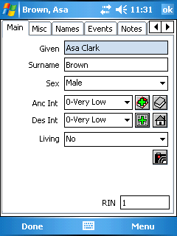
PocketPC: From the 3-gen screen, tap the left or right “Current Couple” person to display more information about that individual. From the other views, select the person in the list or tree and press the “Edit” button.

Smartphone: Use the “Select” menu item once you highlight an individual on the view.

Displaying Family Information
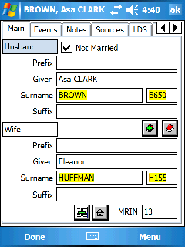
PocketPC: From the 3-gen screen, tap the marriage box to display more information about that Family. From the tree views or the Individual list, select the person, press the spouse button, then select the spouse in the list and press “Edit”.

Smartphone: Use the “Select” menu item after you highlight the marriage box on the 3-Gen view. From the other views use the “menu” button to find the means to view the family information.

Displaying “General” Information
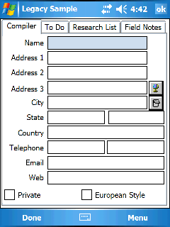
Information that is not attached to an Individual or a Family, for example “General” To Do’s in Legacy, can be found from “Edit”, “General Details”. This is also the location where general Field Notes and all Research List items can be found.

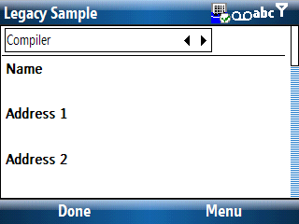

Editing data
The data in Pocket Genealogist is never edited “in place”. When you see a screen displayed with information, tapping on the data field, using the D-Pad “Enter”, or using the space bar (if you have a keyboard) will bring up a view/edit screen that will allow you to change the information. This allows the program to customize how fields are edited, depending on the type of field and the capabilities of the desktop genealogy program. The view/edit screen may have additional features such as the ability to look up information in the database or to reset the field to an empty value.

In this PocketPC example, tapping on the date field will bring up the view/edit screen for dates.
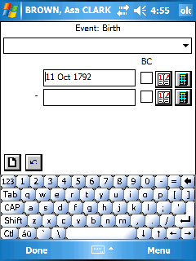
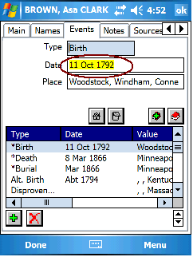

In this smartphone example, use the up/down button to “highlight” the field you wish to edit, then press the D-Pad “Enter” to invoke the edit screen for that field.
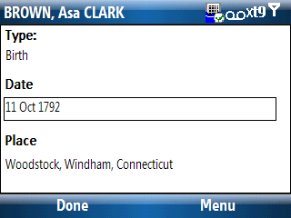
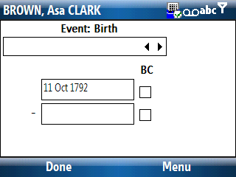

Add a new Person

PocketPC
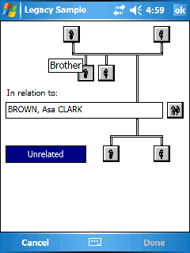
The “Add Person” screen greatly simplifies adding new individuals by displaying a graphical representation of individuals related to the selected person. To access this screen use the menu item “Edit’, “Add Person”.

Tip: On Pocket PC devices, use “Tap and Hold” on the buttons to get more information about the icon. This example shows a “Tap and Hold” on the Brother button.

There are buttons for adding parents, siblings, spouses, children or an unrelated individual.

You can also add individuals from the spouses, parents, and children screens.

Children | On the “Edit”, “Children” screen, use the “Add” button to add a new child.
Spouses | Use the icons on the 3-gen screen to display all spouses for an individual or use the “Edit”, “Spouses” menu item to display the spouse list. Use the “Add” button to add a new spouse. You can also Link an existing person in the database as a spouse instead of creating a new person.
Parents | Use the icons on the 3-gen screen to display all parents for an individual or use the “Edit”, “Parents” menu item to display the spouse list. Use the “Add” button to add a new parent set.

Smartphone
The “Add Person” screen is found from “Menu”, “Edit”, “Add Person”. Select the type of person you wish to add from the selection list.
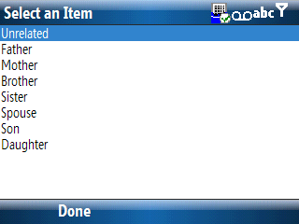
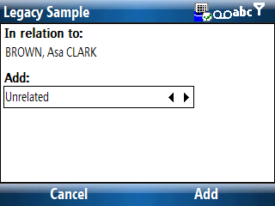

Add an Event

PocketPC
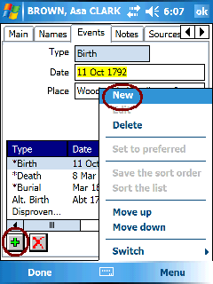
Press the ‘Add’ button on the “Events” tab or “New” from the menu to add a new event. A list of available events will be displayed. (The list will differ depending on the desktop genealogy program you use.) Primary events will appear at the top of the list followed by all other events in alphabetical order. Select the event in the list that you wish to add and press “OK”.
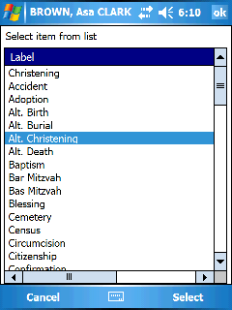

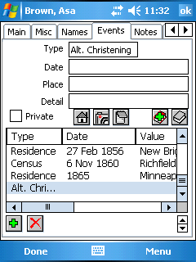

The event will be added to your database and you can then add a date, place, memo, etc. to the event. (As with most fields in Pocket Genealogist, you edit/view individual fields by tapping on the field or by pressing the space bar if you have a keyboard.)

See “Working with Dates” for an example of what happens when you tap on the date field.

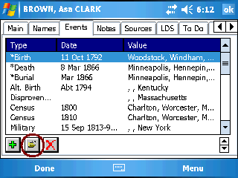
Square screen and Landscape devices do not show the event details on the event tab. Select the event you wish to edit/view and press the “Edit” button.

Smartphone
Add a new event using the menu. Select the type of event from the list and it will be added to the event list and you will be automatically taken to the detail screen for editing.

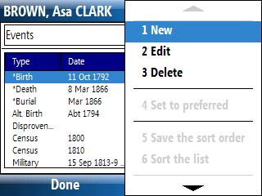
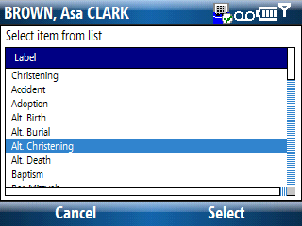

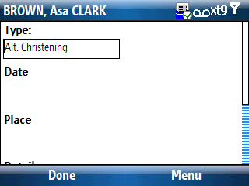

Add a Source Citation

PocketPC
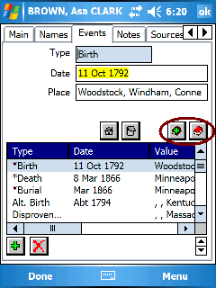
You’ll find source buttons on screens where citations are allowed for the type of item you are looking at. There are always two buttons:
Source Citation Add – use this button to add a source citation. The tabbed dialogs that appear will allow you to enter the citation information as well as select the source to go with the citation. You can also add an entire new source from these screens.
Source Citation List – this button is used to display the source citation list for the item you are viewing (such as an event). The button is gray which indicates that no citations are currently attached to this item. You can add a new Citation using the “Add” button.
OR
Source Citation List – the button is “Red” indicating that there is already at least one source citation in the list for this item.

Smartphone
You will find menu items on the screens that allow source citations.
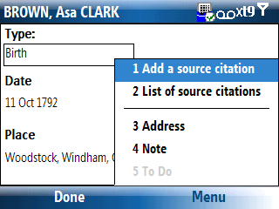

Note: See also “Add a Source” which goes hand in hand with adding a citation.

Add a Source

PocketPC
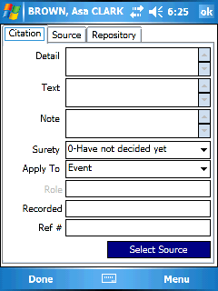
When adding a Source Citation, either tap on the “Source” tab or use the “Select Source” button to select a source. The “Select source” screen can be used to pick an existing source or to add an entirely new source by pressing the “Add” button.

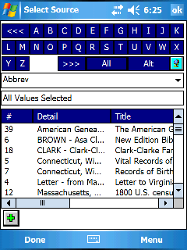

After the new source is created, all fields will be empty except for the “Abbrev” field which will have the value “<< New >>”.

Smartphone
You can either switch to the source “tab”, or use the menu to select the source when creating a new citation. You can use the list to select an existing source or create a new one from the menu.

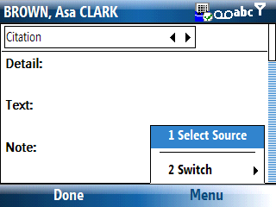
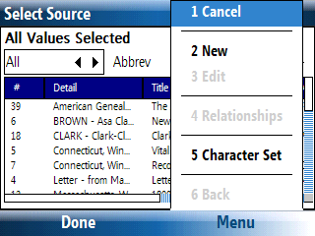

Add a Note

PocketPC
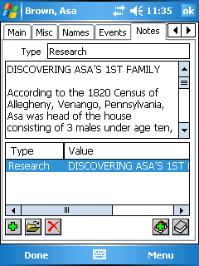
If notes are allowed for an Individual or Family, a “Notes” tab will be displayed when viewing the Individual or Family information.

Other items such as Events will have a “Note” button for accessing the note. (A gray icon means there is no note and a red icon indicates the presence of a note.)

With devices that show both a list and a note area, the note may only partially be displayed. Tap on the note area or use the “Edit” icon to display the entire note.

Add another Note.
View/Edit the complete note.
Delete the note.

Smartphone
If notes are allowed for an individual or Family, a “Notes” tab will be available for display. Other items such as events will have a “Notes” menu item that will be enabled if notes are allowable.

Note: When viewing the entire note, if the note is larger than 30,000 characters you will be asked if you wish to view it in “Read Only” mode. Large notes can be very slow to display and read only mode can make things faster.

Add an Address

PocketPC
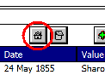
The “Address” button will be displayed for items that allow addresses. Pressing the button will display a screen where you can enter the address information. As with most icons, if the button is in color it represents the presence of an address. If gray it indicates the absence.

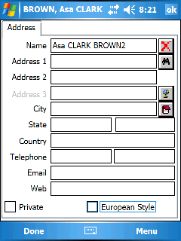
The Address screen may look vastly different depending on the capabilities of your desktop genealogy program.

Use this button to delete the entire address.
Use this button to find and use an existing address.
Use this button, if supported by your desktop genealogy program, to enter latitude/longitude information.
Use this button to enter the address note.

Tip: For Individual and Family addresses, look for the address button on the “Main” tab.

Smartphone
If addresses are allowed for an item such as an individual, family or event, the “Address” menu item will be enabled.

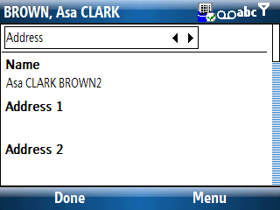
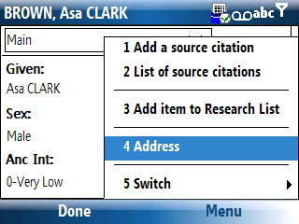

Add a To Do

PocketPC
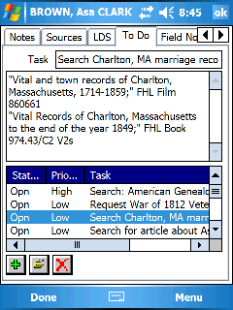
A To Do can be attached to Individuals, Families, Events, Sources, etc. The To Do tab will appear for Individuals and Families if supported by your desktop program. You may also see a To Do button on screens such as the Event tab.

Invoke the To Do screen for the selected item – There are no To Do’s currently defined for this item.
Invoke the To Do screen for the selected item – To Do’s already exist.

To Do’s already defined for the item will be in the list and selecting that To Do will allow you to view/edit or delete it. Pressing the Add button allows you to create a new To Do. The type of data fields shown on the To Do edit screens will greatly differ depending on your desktop program. For those imports that allow a single To Do to be attached to multiple items, such as The Master Genealogist, the “Reference” tab will give you those details.

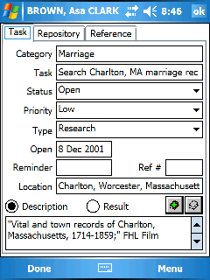
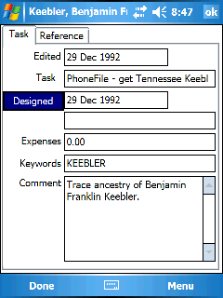

Smartphone
A To Do can be attached to Individuals, Families, Events, Sources, etc. The To Do “tab” will appear for Individuals and Families if supported by your desktop program. For items that support To Do’s such as events, a “To Do” menu item will be enabled if supported by your desktop program.

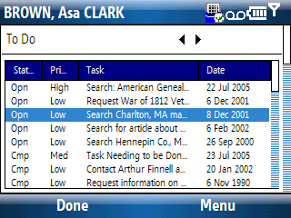
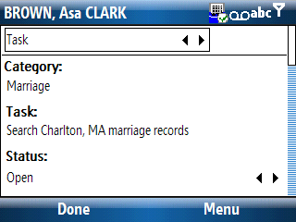

Add an item to a Research List
Research Lists can be viewed from the “General Details” display. See Chapter 8 for more details on working with Research Lists.

Add a Field Note
Field Notes are very similar to notes transferred from your desktop genealogy program. However, Field Notes are not part of your original data and they cannot be transferred back to your original data via 2-way synchronizing or GEDCOM. Field Notes entered on the device can be synchronized back to the desktop then “processed” using the Report function. See Chapter 7 for more details.

Add a Secondary (AKA) Name

PocketPC
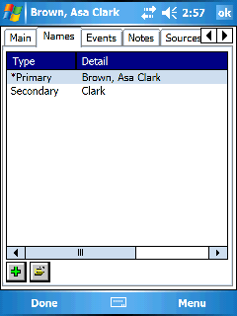
The desktop genealogy programs use different terms for “Secondary Names” but the concept is the same in Pocket Genealogist. Go to the “Names” tab for the Individual and press the “Add” button to add a new Secondary name.

Add a name
Delete a name

Smartphone
The desktop genealogy programs use different terms for “Secondary Names” but the concept is the same in Pocket Genealogist. Go to the “Names” tab for the Individual and use the menu to add or delete names.

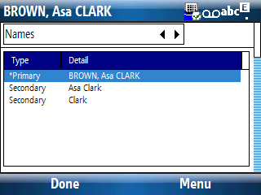
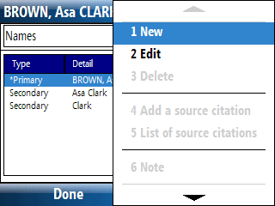

Note: You cannot delete the Primary name from the list.

Note: Not all desktop genealogy programs allow secondary names.

Swap a Secondary name with the Primary

PocketPC
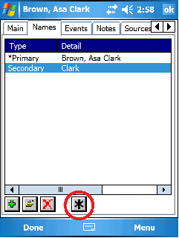
You can “swap” a secondary name with the primary name in Pocket Genealogist. Select the secondary name you wish to become the primary name and press the “Set to Preferred” button.

Smartphone
Select the secondary name in the list to set to preferred, then use the menu to do it.
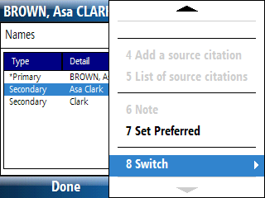

Add a DNA Test

PocketPC
If your desktop program supports DNA tests, including the ability to transfer it via GEDCOM, a DNA tab will appear as part of the Individual information. Press the “Add” button to display a list of tests that you can select. After a test has been added to the list use the “Edit” button to change the information for that test.
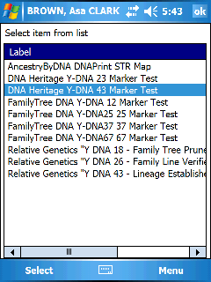
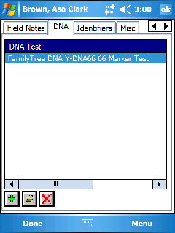

Smartphone
If your desktop program supports DNA tests, including the ability to transfer it via GEDCOM, a DNA tab will appear as part of the Individual information. You can add a new test using “New” on the menu. Selecting an item in the list and using “Edit” from the menu will display the markers which you can then edit.

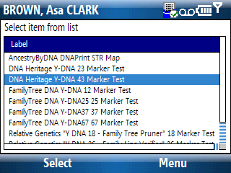
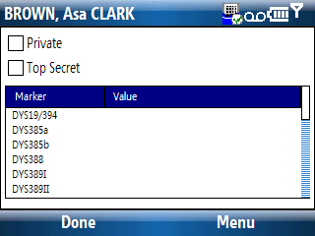

Add a new Location

PocketPC
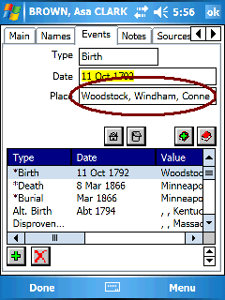
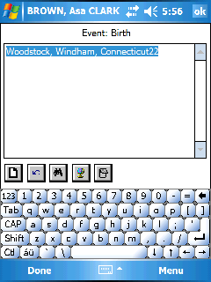
You can view/edit the location for an event by tapping on the Place field when displaying the event. The Location view/edit screen allows you to look up locations already defined in the database using the “Lookup” button. Alternately, you can type in the name of the location. If the location does not exist in the database, a prompt asks if you would like to add it.

Clear the field
Undo last change
Lookup a location
View/Edit the Latitude/Longitude
View/Edit the Location Note
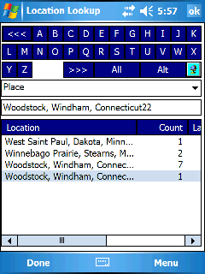

If you use the “Lookup” button, the current location will be shown in the lookup list, and you can see how many references in the database there are for that location. Use the keys at the top to find locations starting with that letter. Select an item in the list and press “OK” to select that location.

Smartphone
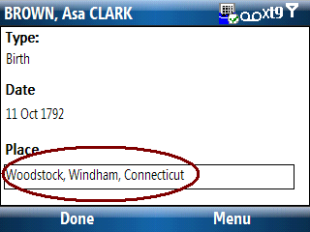
You can view/edit the location for an event by pressing the D-Pad “enter” button after scrolling down to the place field. The Location view/edit screen allows you to look up locations already defined in the database using the “Find” menu item. Alternately, you can type in the name of the location. If the location does not exist in the database, a prompt asks if you would like to add it.
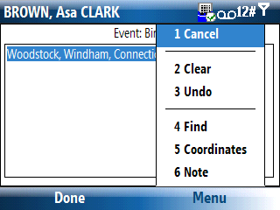

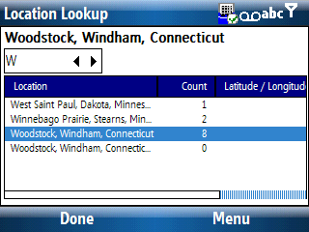
If you use the “Find” menu item, the current location will be shown in the lookup list, and you can see how many references in the database there are for that location. Use the selection list to find locations starting with the value you select. Select an item in the list and press the D-Pad “Enter” to select that location.

Add a new Surname

PocketPC
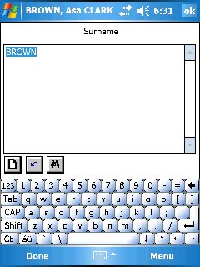
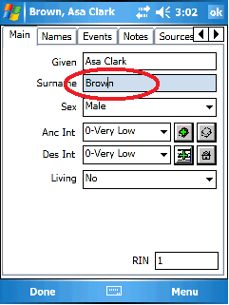
You can edit the surname of an individual by tapping on the Surname field. The Surname edit screen allows you to look up surnames already defined in the database using the “Lookup” button. If you type in a surname that does not exist in the database, a prompt asks if you would like to add it.

Clear the field
Undo last change
Lookup a surname

Smartphone
You can edit the surname of an individual by pressing the D-Pad “enter” button after scrolling down to the Surname field. The Surname edit screen allows you to look up surnames already defined in the database by using the “Find” menu item. If you type in a surname that does not exist in the database, a prompt asks if you would like to add it.
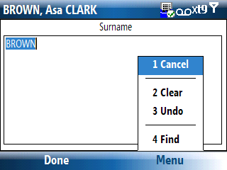
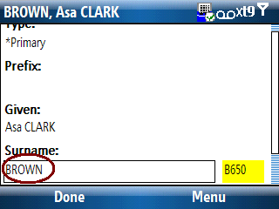

Add a new Prefix

PocketPC
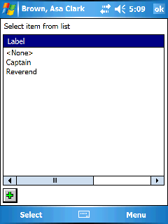
When you tap on the prefix field for a name, you will be shown a list of prefixes already defined in the database. The prefix currently selected for the name will be highlighted in the list. A new prefix can be added to the database by pressing the “Add” button.

Select from the list the prefix you want to assign to the name and press “OK”.

Smartphone
Press the D-Pad “enter” button on the prefix field for the name to display a list of prefixes defined in the database. The prefix currently selected for the name will be highlighted in the list. A new prefix can be added to the database using the “New” menu item.
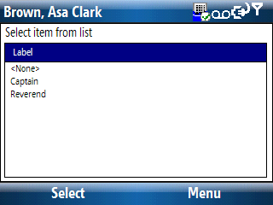

Add a new Suffix
Works the same as the prefix field.

Link an existing Individual as a spouse

PocketPC
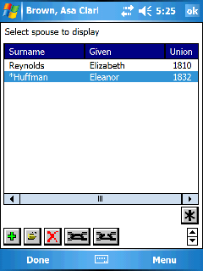
The “Add Person” screen invoked from the “Edit” menu is useful for adding new individuals but cannot be used to link an existing person as a spouse to another.

Instead use the “Spouse List” screen to work with spouses of an Individual.

or (from the 3-Gen screen for example) to invoke the “Spouse List” or use the main “Edit” menu.

to link to an existing person. A “Find” list will be displayed so you can select the person you want to link as a spouse.

Smartphone
The “Add Person” screen invoked from the “Edit” menu is useful for adding new individuals but cannot be used to link an existing person as a spouse to another.

Instead use the “Spouse List” screen to work with spouses of an Individual.

or (from the 3-Gen screen for example) to invoke the “Spouse List” or use the main “Edit” menu.

Then use the “Link to Existing…” menu item to link to an existing person. A “Find” list will be displayed so you can select the person you want to link as a spouse.

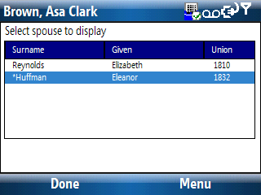
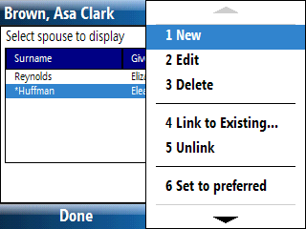

Link an existing Individual as a child

PocketPC
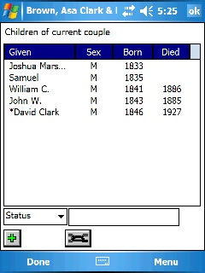
The “Add Person” screen invoked from the “Edit” menu is useful for adding new individuals but cannot be used to link an existing person as a child to parents.

Instead use the “Children List” screen to work with children for a couple.

to invoke the “Children List” or use the “Edit” menu.

to link to an existing person. A “Find” list will be displayed so you can select the person you want to link as a child.

Smartphone
The “Add Person” screen invoked from the “Edit” menu is useful for adding new individuals but cannot be used to link an existing person as a child to parents.

Instead use the “Children List” screen to work with children for a couple. Use the “Edit”, “Children” menu item to view the child list. Then use the “Link to Existing…” menu item to link to an existing person. A “Find” list will be displayed so you can select the person you want to link as a child.

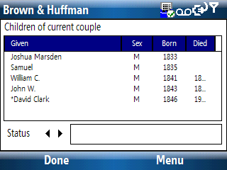
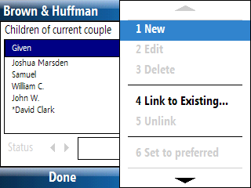

Link an existing Individual as a parent
The “Add Person” screen invoked from the “Edit” menu is useful for adding new individuals but cannot be used to link an existing person as a parent to another. You can’t link parents from the “Parents List” either. To add a new parent using an existing person in the database, go to the person who will become the parent and add the other person as a child.

Delete a spouse
When you do a deletion on a spouse, you are not only removing that person as a spouse, you are also deleting that person from the database. (See “Unlink a Spouse” if you don’t want to delete them from the database.)

or to Invoke the “Spouse List” or use the “Edit” menu.

PocketPC
Select the person in the list and press the “Delete” button. The immediate relations to that person will be displayed so you can verify first before deleting.

Smartphone
Select the person in the list and use the “Delete” menu item. The immediate relations to that person will be displayed so you can verify first before deleting.

Delete a Parent
You can’t directly delete parents from an individual, but you can “unlink” those parents from that person. (See “Unlink a parent”.) To indirectly delete one or both parents, make the parents the “Current Couple”, then delete either spouse using the “Edit” menu. Deleting an individual will remove them from the database.

Delete a child

PocketPC
Use the “Children List” to delete a child from a couple. Deleting a child will remove not only the child reference, but that individual from the database. If you only wish to remove the child reference, see “Unlink a child” instead.

to invoke the “Children List” or use the “Edit” menu.

Select the person in the list and press the “Delete” button. The immediate relations to that person will be displayed so you can verify first before deleting.

Smartphone
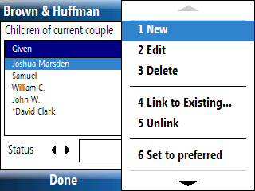
Use the “Children List” to delete a child from a couple. Deleting a child will remove not only the child reference, but that individual from the database. If you only wish to remove the child reference, see “Unlink a child” instead.

Use the “Edit”, “Children” menu item to invoke the “Children List”.

Select the person in the list then use the “Delete” menu item. The immediate relations to that person will be displayed so you can verify first before deleting.

Unlink a spouse

PocketPC
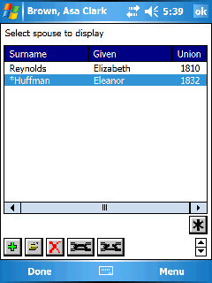
You can remove a spouse from an individual yet not delete that spouse from the database. If you with to delete the spouse, see “Delete a spouse”.

or to invoke the “Spouse List” or use the “Edit” menu.

Select the spouse you wish to remove and press the “Unlink” button. You will get a yes/no prompt before the action is performed.

Smartphone
You can remove a spouse from an individual yet not delete that spouse from the database. If you with to delete the spouse, see “Delete a spouse”.

or from the 3-Gen view to invoke the “Spouse List” or use the “Edit” menu.

Select the spouse you wish to remove then use the “Unlink” menu item. You will get a yes/no prompt before the action is performed.

Unlink a parent

PocketPC
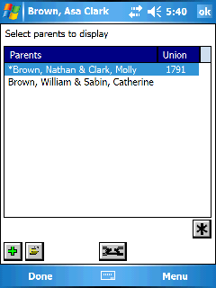
You can unlink a set of parents or an individual parent from a person without deleting them from the database. If you wish to delete the parents, see “Delete a parent”.

Unlinking both parents
to display the “Parents list” or use the “Edit” menu.

Select the parents you wish to remove and press the “Unlink” button.

Smartphone
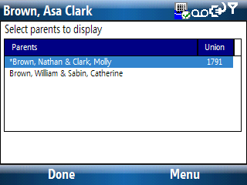
You can unlink a set of parents or an individual parent from a person without deleting them from the database. If you wish to delete the parents, see “Delete a parent”.

Unlinking both parents
Use the parents button from the 3-Gen view to display the “Parents list” or use the “Edit” menu.

Select the parents you wish to remove then use the “Unlink” menu item.

Unlinking one parent
To unlink just one parent, make the parents the current couple and unlink the parent using information found under the topic “Unlink a spouse”.

Unlink a child

PocketPC
You can remove a child from a set of parents without deleting them from the database. If you wish to delete the child, see the topic “Delete a child”.

Use this icon to go to the “Children List” or use the “Edit” menu.

Select the child from the list you wish to unlink and press the “Unlink” button. You will get a yes/no prompt before the action is performed.

Smartphone
You can remove a child from a set of parents without deleting them from the database. If you wish to delete the child, see the topic “Delete a child”.

Use the “Edit”, “Children” menu item to invoke the “Children List”.

Select the child from the list you wish to unlink and then use the “Unlink” menu item. You will get a yes/no prompt before the action is performed.

Change Order of Children

PocketPC
With some imports, you can change the order of the children.

to go to the “Children List” or use the “Edit” menu.

Select the child in the list you wish to move and press the “up/down” arrows to set the new order. If the arrows are hidden, your desktop genealogy program strictly sorts by birth date and the order cannot be changed using this method.

Smartphone
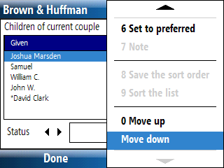
With some imports, you can change the order of the children.

Use the “Edit”, “Children” menu item to invoke the “Children List”.

Select the child in the list you wish to move then use the “Move up” or “Move down” menu item.

Setting a Spouse as Preferred

PocketPC
Some desktop genealogy programs allow you to set the “preferred” spouse. When an individual becomes the “current couple”, Pocket Genealogist will attempt to display the “preferred” spouse if multiples exist.

or to invoke the “Spouse List” or use the “Edit” menu.

Select the spouse in the list and press the “Set to Preferred” button.

Smartphone
Some desktop genealogy programs allow you to set the “preferred” spouse. When an individual becomes the “current couple”, Pocket Genealogist will attempt to display the “preferred” spouse if multiples exist.

or on the 3-Gen view to invoke the “Spouse List” or use the “Edit” menu.

Select the spouse in the list then use the “Set to Preferred” menu item.

Setting a Child as Preferred

PocketPC
Some desktop genealogy programs allow you to set the “preferred” child.

to go to the “Children List” or use the “Edit” menu.

Select the child in the list and press the “Set to Preferred” button.

Smartphone
Some desktop genealogy programs allow you to set the “preferred” child.

Use the “Edit”, “Children” menu item to invoke the “Children List”.

Select the child in the list then use the “Set to preferred” menu item.

.

Setting Parents as Preferred

PocketPC
Some desktop genealogy programs allow you to set the “preferred” parents. When an individual becomes the “current couple”, Pocket Genealogist will attempt to display the “preferred” parents if multiples exist.

to display the “Parents list” or use the “Edit” menu.

Select the parents in the list and press the “Set to Preferred” button.

Smartphone
Some desktop genealogy programs allow you to set the “preferred” parents. When an individual becomes the “current couple”, Pocket Genealogist will attempt to display the “preferred” parents if multiples exist.

Use the “Parents” button on the 3-Gen view to display the “Parents list” or use the “Edit” menu.

Select the parents in the list then use the “Set to Preferred” menu item.

Viewing TMG “Relationship” information

PocketPC
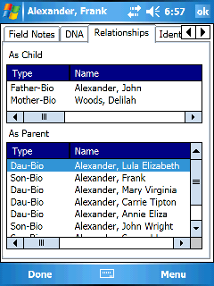
With imports from The Master Genealogist, you can view the relationship information of an individual from the perspective of a parent or as a child. This information can be found on the “Relationships” tab on the Individual screens.

Smartphone
With imports from The Master Genealogist, you can view the relationship information of an individual from the perspective of a parent or as a child. This information can be found on the “Relationships” tab on the Individual screens. Depending on the screen orientation of your smartphone, you may need to scroll down to see all the information. (D-Pad up/down button)

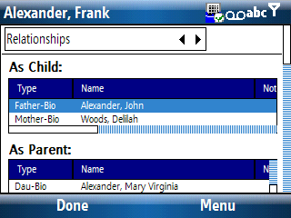
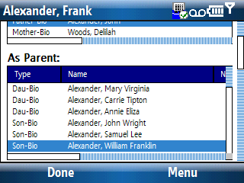

Setting Couple as “Not Married”
With Legacy Family Tree imports, you can assign a “Not Married” flag to a couple. Go to the “Misc” tab for the family information to set this flag.

Setting an Individual to “Never Married”
With Legacy Family Tree imports, you can indicate that an individual never married. Go to the “Misc” tab for the Individual information to set this flag. (This value cannot be set if the individual has a spouse)

Setting Husband Phrase
With Legacy Family Tree imports, you can set the phrase that is used to designate the “husband” in a relationship. For example, you could change it to “Partner” if that couple was never married. Go to the “Main” tab for the family information screens for that couple to set this value.

Setting Wife Phrase
With Legacy Family Tree imports, you can set the phrase that is used to designate the “wife” in a relationship. For example, you could change it to “Partner” if that couple was never married. Go to the “Main” tab for the family information screens for that couple to set this value.
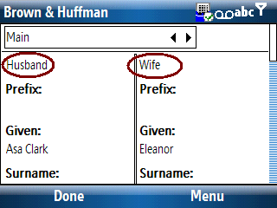
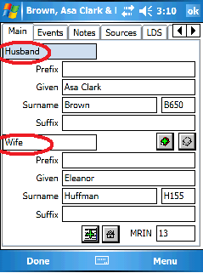

Setting the Child Status

PocketPC
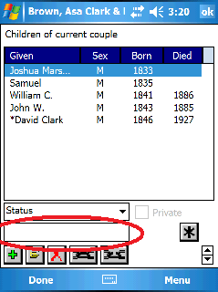
If your desktop genealogy program supports a child status field such as “Twin” or “Stillborn”, you can find this field on the “Children list” screen.

Use to invoke the “Children List” screen or use the “Edit” menu.

Select the child in list to display the status. Tapping on the field will display a list of available values.

Note: With Legacy Family Tree, either of the “Relationship to” values can be set as “Private”.

Smartphone
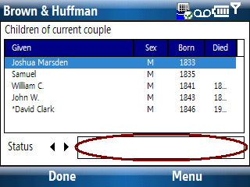
If your desktop genealogy program supports a child status field such as “Twin” or “Stillborn”, you can find this field on the “Children list” screen.

Use the “Edit”, “Children” menu item to invoke the “Children List”.

Select the child in list then use the D-Pad right button to exit the list and move to the “Status” field. Use the D-Pad “Enter” button will display a list of available values.

Setting the Child Relationship to Parents
If your desktop genealogy program supports a relationship to parents field such as “Adopted” or “Step”, you can find this field on the “Children list” screen. You can display this screen either using the button or the “Edit” menu. Select the child in the list to display the relationship to the parent(s). Tapping on the field will display a list of available values for that field. If child status is also supported, you may need to press the button next to the display field to toggle between the status and the relationship fields.

Setting User Reference ID
If your desktop program supports a User Reference ID field for Individuals or Families, go to the “Identifiers” tab when viewing the Individual or Family screens to set this value.

Setting AFN
Same as “Setting User Reference ID”.

Setting RFN
Same as “Setting User Reference ID”.

Finding the number of Individuals in a database
You can find a count of the number of individuals in your database from the “Properties” screen invoked from the “File” menu.

Finding the number of Families in a database
You can find a count of the number of families in your database from the “Properties” screen, which is invoked from the “File” menu.

Finding the number of Field Notes
You can find a count of the number of Field Notes in your database from the “Properties” screen which is invoked from the “File” menu.
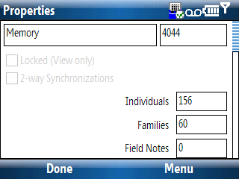
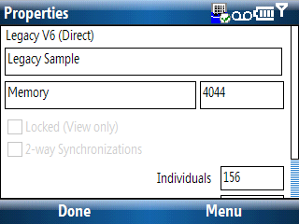
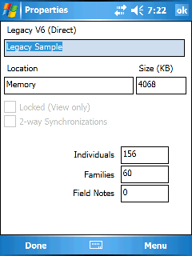

Set the Sex of an Individual
The sex of the individual can be set on the “Main” tab of the Individual screens. The drop down list will contain the values acceptable to your desktop genealogy program. If only one value is in the list, this indicates you can’t change the value for this individual. (With some programs once you have a spouse attached you can’t change the sex) As with all fields in Pocket Genealogist, what you can set will depend on the capabilities of your desktop program.

Set an Individual as “Private”
If your desktop genealogy program supports setting an individual to “private”, this flag will be available on the “Main” tab of the Individual screens.

Set Living indicator
Different desktop genealogy programs handle a “Living” indicator differently, and some programs don’t have this type of flag. Pocket Genealogist sets these flags differently based on the capabilities of your desktop program. You may be able to change this flag directly or it may be automatically set based on the existence of a Death or Burial event (or both). The living flag can be found on the “Main” tab for an Individual.

Set Anc/Des Interest
If your desktop genealogy program supports an ancestor and descendant interest field, you can find it on the “Main” tab for the Individual.
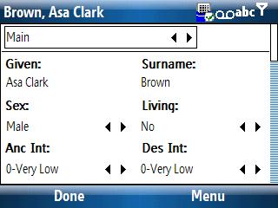
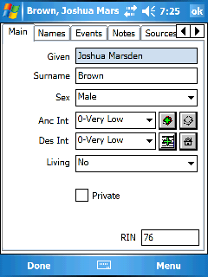
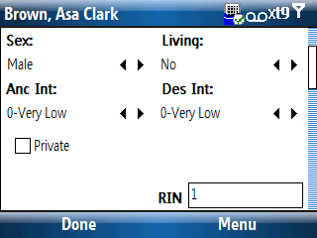

Sort the Event List

PocketPC
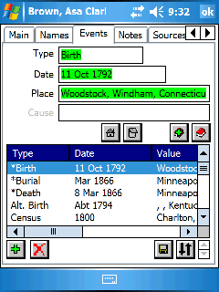
You can sort the event list by tapping on the column headers. Tapping a second time on the same column header will reverse the sort. If your desktop genealogy program allows the sorting of event, a “Save” button will be displayed. A “Sort” button will also be shown if you wish to reset the list. If you press the “Save” button to keep the new order, both buttons will disappear until the order changes again. The “up/down” arrows are another method for changing the order.

Save the sort order created by tapping on the column headers.
Sort the list back to original order before the “column header sort”.
Order the selected item in the list up or down one item per click.

Smartphone
Currently the ability to sort the lists by tapping on the list column headers is not supported. However, if your desktop genealogy program supports it, you can change the order of the events by selecting the event in the list and using the “Move up” and “Move down” menu item.

Setting an Event as Preferred

PocketPC
Some desktop genealogy programs allow you to indicate the “preferred” event when multiple events of the same type are in the list. The “preferred” event is designated in the list by an asterisk. To set an event as preferred, select the event in the list and press the “Preferred” Button.

Smartphone
Some desktop genealogy programs allow you to indicate the “preferred” event when multiple events of the same type are in the list. The “preferred” event is designated in the list by an asterisk. To set an event as preferred, select the event in the list and use the “Set to preferred” menu item.

Swapping Primary Events

PocketPC
Some desktop genealogy programs allow multiple instances of primary events such as Birth. Only one Birth will be considered the primary and will be designated with an asterisk. If you wish to swap the non-primary event with the primary, select the non-
primary event in the list and press the “Preferred” button.

Note: Primary events are always designated with an asterisk.

Smartphone
Some desktop genealogy programs allow multiple instances of primary events such as Birth. Only one Birth will be considered the primary and will be designated with an asterisk. If you wish to swap the non-primary event with the primary, select the non-primary event in the list then press the “Set to preferred” menu item.

Note: Primary events are always designated with an asterisk.

Changing the order of Events
With some imports, you can change the order of the events. See “Sort the Event list” for various ways this can be done.

Setting Cause of Death
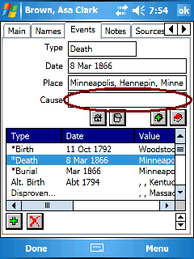
Cause of Death, if supported by your desktop genealogy program, is attached to the primary Death event for the Individual. Even if you don’t have any other information regarding the death, such as date or location, you still need to create a Death event in order to enter “Cause”.

Add a source citation to Cause of Death
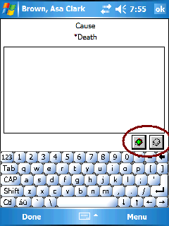
Some desktop genealogy programs allow you to attach a source citation to the Cause of Death field. This is a separate citation from the event itself. These “special” citations don’t show up on the source citation display for the event. They can be found on the view/edit screen for the item that is cited. This example shows the source citation buttons on the view/edit screen for cause of death which can be used to view/edit the citations for that field.

Smartphone
Use the menu to add or list the source citations attached to cause of death.

Citation “Applies To”
Most desktop genealogy programs only allow you to add a source citation to an entire event. However, some desktop genealogy programs, such as Family Historian or Genbox, allow more control over what the citation is applied toward. (such as only the date or the place in the event.) Use the “Apply To” drop down list on the citation screen to make this selection.

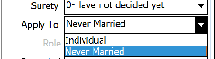
Additionally, this “Apply To” field may be available for other imports. For example, you can use this to create a source citation for the “Never Married” flag for Legacy Version 6 when adding a citation to the Individual.

Legacy specific Source Citations
The Relationship to parents, child status and Cause of Death source citations do not show up on the “Source” screen. These sources can be found from the view/edit screen for each field. This example is for Child Status. First an “Edit”, “Children” was selected from the menu from the “3-gen” screen.

In order to see the citations or to change the Status field for the selected child, “tap” on the field to bring up the Child Status list.

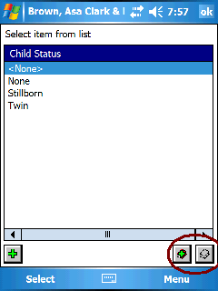

You can select the status you wish from the list or add a new one using the “Add” button. Even if you select <None> (which sets the status to an empty value), you can still assign a source citation using the sourcing buttons at the bottom right of the screen.

Smartphone
Use the menu to set source citations.

Go To Individual
If you know the RIN (Record ID Number) or the Pocket Genealogist ID of an Individual, you can “Go To” that person using the menu item under “Tools”.

After entering a number in the edit field, press this button to retrieve the information for that ID.
Used to go to the next ID # in the database.
Used to go to the previous ID # in the database.
Shows the immediate relations for the selected person.
Used to display the view/edit screens for the ID selected.

Go To Family
Works the same as “Go To Individual” but for Family ID’s.

Note: You can switch between “ID” and “RIN” using the top “List” field.

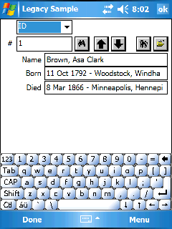
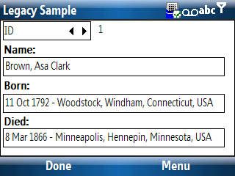

Note: Whoever is displayed on the screen when you press “OK” or “Done” will be set to the current person in the view. (Such as the 3-gen view.)

Set “Home” Family
You can set the “Current Couple” to the preferred “Home” family from the “Tools”, “Home Family”, “Set Preferred”.

Go To “Home” Family
You can make the preferred “Home” Family the “Current Couple” in the view by using the “Tools”, “Home Family”, “Goto Preferred”.

Find “Last Edited” date for an Individual or Family
If you have your database locked as “View Only” and your desktop genealogy program supports “Last Changed Date”, then that information will be available in Pocket Genealogist. The information will be found on the “Main” tab for Individuals and Families.
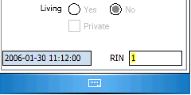
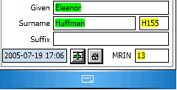

Find by Name

PocketPC
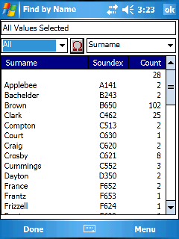
You can search for individuals in your database by references to given or surname. You can do the search from the “Tools”, “Find”, “by Name List” menu item. The “Find” display allows you to pick the first letter of the name and will display a list and how many references there are for that name. The example to the right shows the result of using the “All” selection. Select an item in the list and details of the names using that value are displayed.

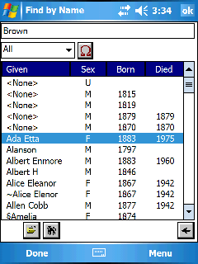

Shown are all the “Brown” individuals in the database. Select an item in that list and press “OK” to make that person the selected individual in the view you are using. Alternately, you can use the buttons at the bottom to display more information about that individual.

Used to display alternate keys in the keypad area such as numerals and diacritics.
This displays alternate character sets you can use for the “Alt” display. (Greek for example)
Allows you to return to the summary screen instead of starting over with the search.
Shows the immediate relations for the person selected in the list.
Displays the Individual screens for the person selected in the list.

Smartphone
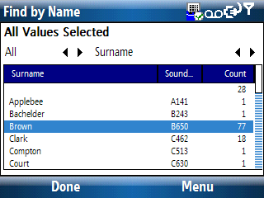
You can search for individuals in your database by references to given or surname. You can do the search from the “Tools”, “Find”, “by Name List” menu item. The “Find” display allows you to pick the first letter of the name and will display a list and how many references there are for that name. The example to the right shows the result of selecting “All” for surnames. Select an item in the list and press the D-Pad “Enter” to display the details for that item.
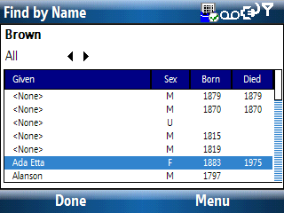

All items with that surname in the database will be displayed along with additional details. Select an item in that list and press the D-Pad “Enter” button to make that person the selected individual in the view you are using.

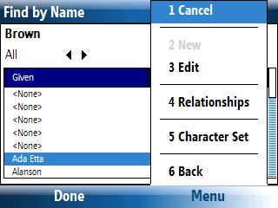

Edit | Displays the Individual “tabs” for the person selected in the list.
Relationships | Shows the immediate relations for the person selected in the list.
Character Set | Displays alternate character sets. (Greek for example)
Back | Return to the summary (1st) screen.

Tip: Both fields at the top of the screen contain a “list” of values that can be selected. Use the D-Pad left or right buttons to change the field or press the D-Pad “Enter” button to display a list of available values.
Find by Location

PocketPC
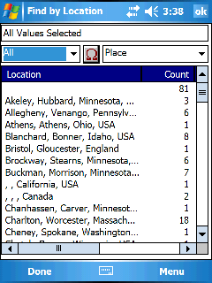
You can search for individuals in your database by references to locations that they use in Events. You can do the search from the “Tools”, “Find”, “by Location List” menu item. The “Find” display allows you to pick the first letter of the location and will display a list and how many references there are for that location. The example to the right shows the result of using the “All” selection. Select an item in the list and more details will be displayed.

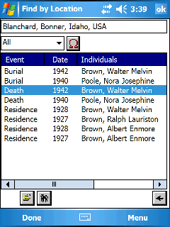

Select an item in that list and press “OK” to make that person the selected individual in the view you are using.

Used to display alternate keys in the keypad area such as numerals and diacritics.
This displays alternate character sets you can use for the “Alt” display. (Greek for example)
Allows you to return to the summary screen instead of starting over with the search.
Shows the immediate relations for the person selected in the list.
Displays the Individual screens for the person selected in the list.

Smartphone
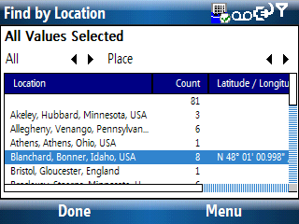
You can search for individuals in your database by references to location that they use in events. You can do the search from the “Tools”, “Find”, “by Location List” menu item. The “Find” display allows you to pick the first letter of the location and will display a list and how many references there are for that location. The example to the right shows the result of selecting “All”. Select an item in the list and press the D-Pad “Enter” to display the details for that item.

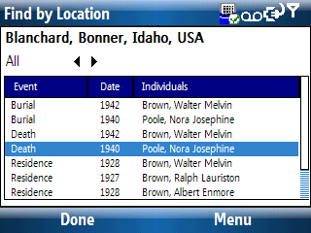

All items with that location in the database will be displayed along with additional details. Select an item in that list and press the D-Pad “Enter” button to make that person the selected individual in the view you are using.

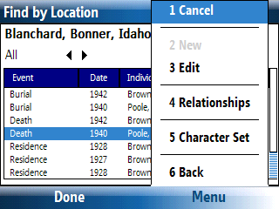

Edit | Displays the Individual “tabs” for the person selected in the list.
Relationships | Shows the immediate relations for the person selected in the list.
Character Set | Displays alternate character sets. (Greek for example)
Back | Return to the summary (1st) screen.

Tip: Both fields at the top of the screen contain a “list” of values that can be selected. Use the D-Pad left or right buttons to change the field or press the D-Pad “Enter” button to display a list of available values.

Find by To Do Task

PocketPC
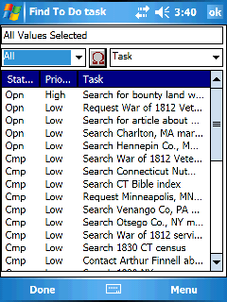
You can search for To Do’s in your database by the value assigned to the task. You can do the search from the “Tools”, “Find”, “To Do”, “by Task” menu item. The “Find” display allows you to pick the first letter of the task which will display a list of matches. The example to the right shows the result of using the “All” selection. Select an item in the list and the task information will be displayed.

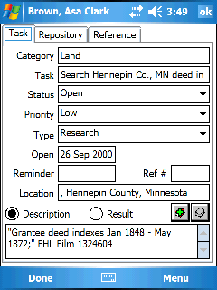

Use the “Reference” tab to see how the To Do is used.

Used to display alternate keys in the keypad area such as numerals and diacritics.
This displays alternate character sets you can use for the “Alt” display. (Greek for example)
Found on the reference tab and used to display more information about the selected item in the list.
Found on the reference tab and used to set the selected individual in the list as the “current” person in the view you are using. (also will close the Find by screen.) Note: You don’t have to be using the 3-gen view to use this button, nor will it switch you to the 3-gen screen if you are using a different view.
Smartphone
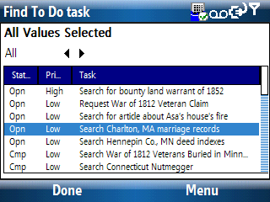
You can search for To Do’s in your database by the value assigned to the task. You can do the search from the “Tools”, “Find”, “To Do”, “by Task” menu item. The “Find” display allows you to pick the first letter of the task which will display a list of matches. The example to the right shows the result of selecting “All”. Select an item in the list and press the D-Pad “Enter” to display the task information.

Tip: Pressing “All” provides an easy way to see all To Do’s in your database.

Tip: Both fields at the top of the screen contain a “list” of values that can be selected. Use the D-Pad left or right buttons to change the field or press the D-Pad “Enter” button to display a list of available values.

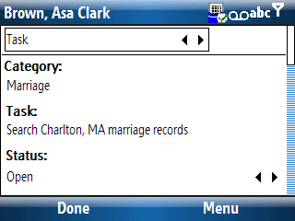

The “Switch” field at the top is used to show the other “tabs” for the To Do. The “Reference” tab is used to see what references this To Do.

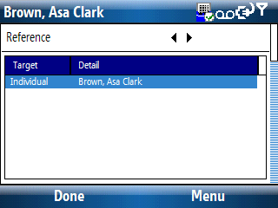

You can View/Edit the individual from the reference tab using the “Edit” menu item. The “Go to” menu item will make this individual the current selected person in the view you are using.

Find by To Do Repository

PocketPC
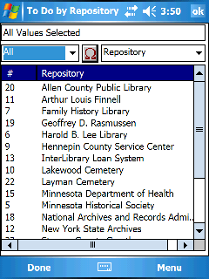
If your desktop genealogy program supports attaching a Repository to a To Do, you can search for To Do’s associated with that Repository from the “Tools”, “Find”, “To Do”, “by Repository” menu item. The “Find” display allows you to pick the first letter of the Repository name, which will display a list of matches. The example to the right shows the result of using the “All” selection. Select an item in the list and the To Do’s, if any, will be displayed.
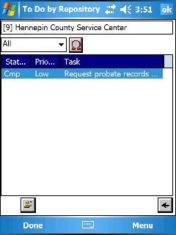

Selecting an item in the list allows you to then press the “Open” button to display information about that To Do.

Used to display alternate keys in the keypad area such as numerals and diacritics.
This displays alternate character sets you can use for the “Alt” display. (Greek for example)
Allows you to return to the summary screen instead of starting over with the search.
Displays the Individual screens for the person selected in the list.

Note: For desktop genealogy programs that allow you to attach a To Do to a Repository (instead of a Repository to a To Do), use the Master List for Repositories to find those To Do’s.

Smartphone
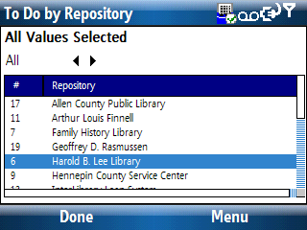
If your desktop genealogy program supports attaching a Repository to a To Do, you can search for To Do’s associated with that Repository from the “Tools”, “Find”, “To Do”, “by Repository” menu item. The “Find” display allows you to pick the first letter of the Repository name, which will display a list of matches. The example to the right shows the result of selecting “All”. Select an item in the list and press the D-Pad “Enter” to display To Do’s (if any) attached to that repository.
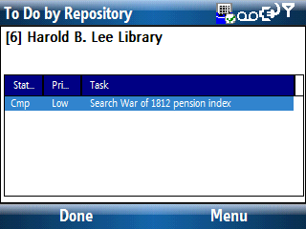

Select an item in the list then use the “Edit” menu item to display the task information.

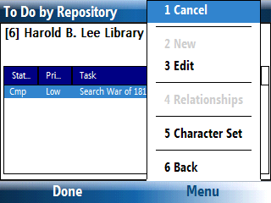

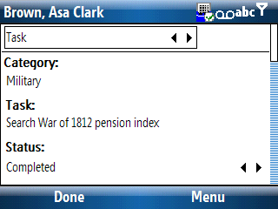

Edit | Displays the task information for the selected To Do.
Character Set | Displays alternate character sets. (Greek for example)
Back | Return to the summary (1st) screen.

Note: For desktop genealogy programs that allow you to attach a To Do to a Repository (instead of a Repository to a To Do), use the Master List for Repositories to find those To Do’s.

Find Multimedia

PocketPC
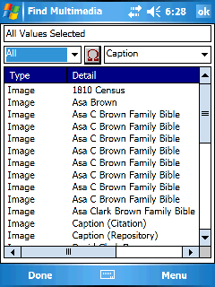
If your desktop genealogy program supports Multimedia and you have the “Advanced” version of Pocket Genealogist, you can transfer the information to the device. (Only images are synchronized, but the information about the other types of multimedia will still be shown in the list) From the menu select “Tools”, “Find”, “Multimedia”. The “Find” display allows you to pick the first letter of the Caption or Description associated with the multimedia object and will display a list of matches. The example to the right shows the result of using the “All” selection. Select an item in the list and the multimedia object will be displayed.

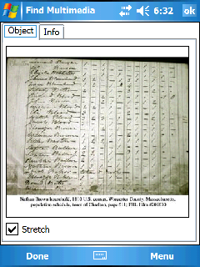

Select the “Info” tab to see information about the multimedia object such as Caption, Date, Description, etc. (Information depends on what is available in your desktop genealogy program)

Note: If the image is smaller than what can be displayed on the screen, you can select the “Stretch” option to display it larger. “Stretch” is a “sticky” option. Once you select or deselect it, that value will be used as the default for the display of subsequent images.

Smartphone
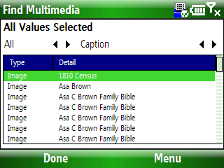
If your desktop genealogy program supports Multimedia and you have the “Advanced” version of Pocket Genealogist, you can transfer the information to the device. (Only images are synchronized, but the information about the other types of multimedia will still be shown in the list) From the menu select “Tools”, “Find”, “Multimedia”. The “Find” display allows you to pick the first letter of the Caption or Description associated with the multimedia object and will display a list of matches. The example to the right shows the result of using the “All” selection. Select an item in the list and the multimedia object will be displayed.

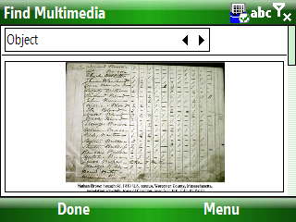

Select “Info” from the “Switch List” to see information about the multimedia object such as Caption, Date, Description, etc. (Information depends on what is available in your desktop genealogy program)

Note: If the image is smaller than what can be displayed on the screen, you can select the “Stretch” option from “Menu” to display it larger. “Stretch” is a “sticky” option. Once you select or deselect it, that value will be used as the default for the display of subsequent images.

Displaying all To Do’s
You can display all the To Do’s in the database either from the Master List or by doing a “Tools”, “Find”, “by To Do Task” and selecting “All” from the Find screen.

Setting the display Language
You can change the display language for Pocket Genealogist from the “Language” screen found from “File”, “Language”. Select the language in the list and press “OK”. If you use “System Default”, the current regional settings will be used for the display if a match can be found.

Note: The calendar and date calculator use the value in “Regional Settings” to determine the text strings (such as month names) and cannot use the selection from the Pocket Genealogist language version. Dates entered directly still work properly.

The Master Genealogist Flags
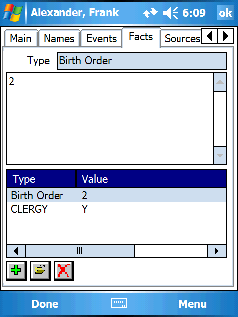
The flags in The Master Genealogist can be found under the “Facts” screen for the Individual. Since TMG does not support the flag data in GEDCOM files, you cannot edit this information on the device.

Note: Other desktop genealogy programs support similar features. If those programs support GEDCOM processing of that data, you will be able to add/edit the information on the “Facts” screen. If it’s a Y/N flag, adding the flag to the list assumes “Y”, and deleting the flag from the list assumes “N”.

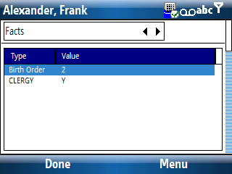

Turning off “View Only”
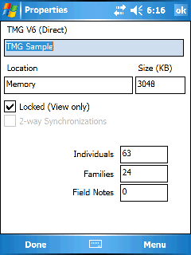
If you have synchronized your database as “View Only” and decide later you wish to enter data, you can turn off “View Only” on the device. Go to “File”, “Properties”.

Note: You cannot turn “View Only” back on once you turn it off without re-importing your database.
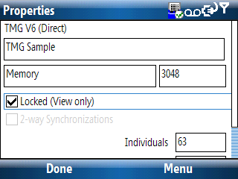

Turning off 2-way synchronizing
You can turn off the 2-way synchronization feature of Legacy Family Tree databases on the device. Go to “File”, “Properties” and uncheck the “2-way Synchronizations’ button.

Note: You cannot turn this back on once you turn it off without re-importing your database.

Change to a different View
You can change the “View” from the “Edit”, “View” menu or you can use the icons on the views that have them.
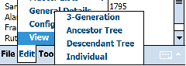
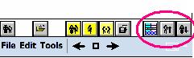

Configure use of a GPS
Pocket Genealogist supports GPS coordinate retrieval from GPS devices that support the intermediary driver with Windows Mobile 5 and newer (which allows you to share the GPS with other programs simultaneously). You may also use a GPS device with any version of Windows Mobile by directly communicating using the “COM” port but cannot share the device with another program.

It is assumed that you currently have the GPS device working with the GPS software that came with your device.

GPS intermediary driver
- Go to your GPS software and look up the COM port that is being used to communicate with the device.
- From the Windows “Start” menu, select “Settings”
- Select the “System” tab.
- Select the GPS icon.
- On the “Hardware” tab, set the “GPS hardware port” to the COM port you verified above. The Baud rate is generally 4800 or less. (Your GPS device should have documentation that will tell you the maximum speed that is supported, but 4800 is a good starting point.)
- On the “Programs” tab, set “GPS program port” to any port other than COM 0 or the port you just entered under the hardware tab.
- On the “Access” tab, check the “Manage GPS automatically”.
- Change your GPS software to use the new port specified on the “Programs” tab.
- Verify that your GPS software still works.
- Go to the “GPS” tab found from “Edit”, “Configuration” in Pocket Genealogist on the device. Select “Shared” as the Port.
- Test Pocket Genealogist to see if the GPS support works. Go to “Tools”, “Calculators”, “Coordinates” and press the globe icon or use the menu item to retrieve the coordinates from the GPS device.

The intermediary driver will allow both your GPS software and Pocket Genealogist access to the GPS device concurrently.

Using Serial Communications (COM)
If you have a device not running Windows Mobile 5 or have problems with the Intermediary Driver in Windows Mobile 5, you can also directly communicate with the GPS device using the appropriate COM port.

- Go to your GPS software and look up the COM port that is being used to communicate with the device.
- Go to the “GPS” tab found from “Edit”, “Configuration” in Pocket Genealogist on the device. Select the port found under step 1.
- In most cases a Baud rate of 4800 is appropriate.
- Test Pocket Genealogist to see if the GPS support works. Go to “Tools”, “Calculators”, “Coordinates” and press the globe icon to retrieve the coordinates from the GPS device)

If you are using Windows Mobile 5 or newer, you may still need to set the values found under the “GPS” icon (“Start”, “Settings”, “System” tab).

Retrieve GPS Coordinates
If you have a GPS device you can retrieve the current GPS coordinates for use with locations, repositories, addresses and notes. (Use depends on the capabilities of your desktop genealogy program.) On the screen where you enter GPS coordinates, press the “Globe” icon to retrieve the current location. On the notes edit screen, use the “Globe” icon to retrieve the current GPS coordinates.

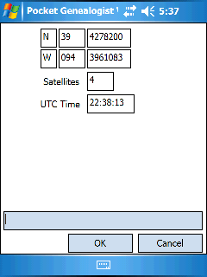
If a connection is successfully established to the GPS device, information about the current coordinates will be displayed. This information is refreshed every few seconds.

The “Satellites” value will indicate the number of satellites seen by the device. UTC Time is “Coordinated Universal Time” which is the base point for time zones around the globe.

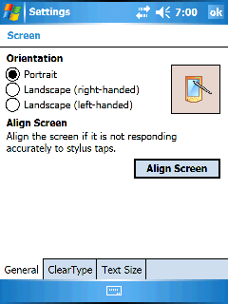
Switch to Landscape Orientation
For devices that support both Portrait and Landscape orientation, you can switch from the control panel in Windows Mobile, or from within Pocket Genealogist.

In Windows Mobile you can find it with the “Screen” icon under “Start”, “Settings”, “System” tab.

In Pocket Genealogist use “Tools”, “Device”, “Orientation”.

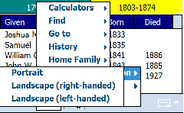

An example of the 3-gen screen with Landscape orientation.

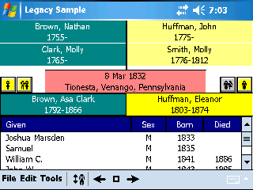

Displaying Multimedia
If your desktop program supports multimedia and you have the “Advanced” version of Pocket Genealogist, you can synchronize images to the device. (Only Images are supported, video and other multimedia objects are not) Depending on the capabilities of your desktop program, you can have multimedia objects attached to Individuals, Families, Events, LDS Ordinances, Sources, Citations, Repositories, Addresses, Locations, LDS Temples and “General”.

You will find a “Multimedia” button on the screens associated with each type above (Events for example) or as a separate “tab” for items such as Sources or Citations.
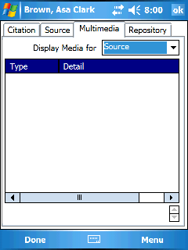
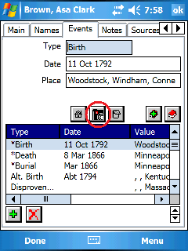

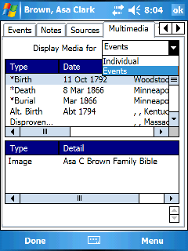

For Individuals, Families, Events or LDS Ordinances, you can use the “Multimedia” tab associated with the Individual or Family set of tabs for displaying those objects.

Smartphones work in a similar manner although there will be no “multimedia” buttons. You will find a “Multimedia” item on the menu which can be used to invoke the display of the objects.

Configuring the Device
Note: All configuration options are found from the “Edit”, “Configuration” menu.

Database to open at Program Start
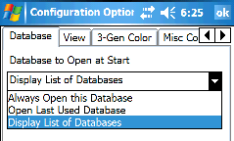
By default, the list of databases on the device will be displayed at program start. You can configure the program to either open a specific database or to open the last database you were working with. This option is found on the “Database” tab under “Edit”, “Configuration”.

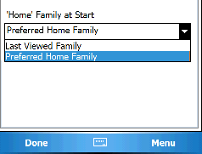
Home Family at Program Start
By default, the “Preferred” home family is displayed when you open a database. See “Set Home Family” for more information on how to change the home family. You can also set Pocket Genealogist to open the last family viewed before last closing the database. This option is found on the “Database” tab under “Edit”, “Configuration”.

Set Default View
The 3-generation view is the default view for Pocket Genealogist. You can change the view that is shown by default at program start from the “View” tab found under “Edit”, “Configuration”.

3 Generation
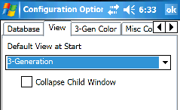
The “Collapse Child Window” option will display the icon bar at the bottom of the screen or you can use the collapse icon on the menu bar to raise and lower it.

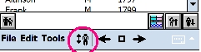

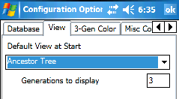
Tree Views
You can set the number of generations to include when you select a tree view. The “Basic” level of Pocket Genealogist supports up to 3 generations and the “Advanced” up to 255.

Set 3-Gen Colors
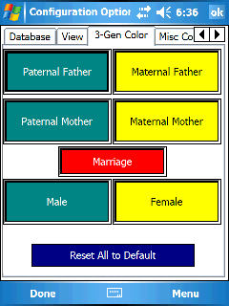
By default the 3-gen screen has no colors set. You can change the background and text colors for the selection boxes on the “3-Gen Color” tab found under “Edit”, “Configuration”.

Tap on the “Box” you wish to change and you will be presented with a color selection screen.

The color selection screen shows the 16 standard colors available with all Windows handheld devices. With some devices, you can also tap on either of the two “Custom” color boxes to display up to 64 different colors to choose from. (You get the same colors when you tap on either of the “custom color” boxes, the first one shows the selection for “Text” and the second for “Background”)
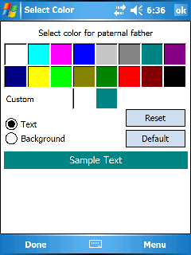
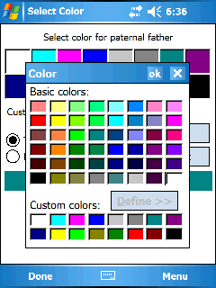

Set Miscellaneous Colors
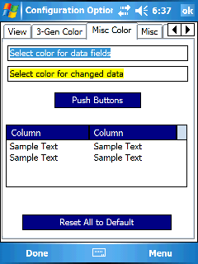
The Misc. Color options allow you to set the color of data fields and data fields that have changed on the device. You can also set the background and text color for push buttons, List columns and text within the list.

Tap on the item to set the color.

The color selection screen shows the 16 standard colors available with all Windows handheld devices. With some devices, you can also tap on either of the two “Custom” color boxes to display up to 64 different colors to choose from. (You get the same colors when you tap on either of the “custom color” boxes, the first one shows the selection for “Text” and the second for “Background”.)
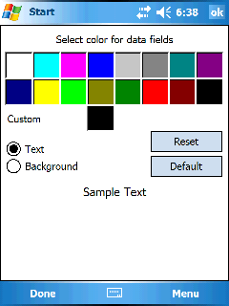
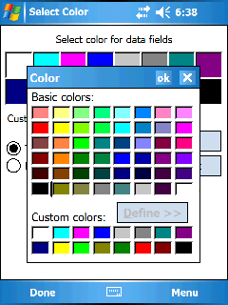

Misc

Uppercase Surnames
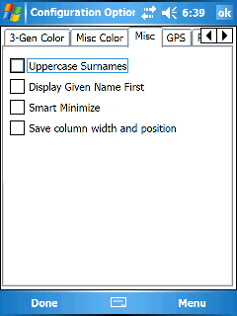
This option will cause all surnames to be displayed in uppercase.

Display Given Name First
This controls how names are displayed in lists, trees and the 3-gen screen.

Smart Minimize
With Pocket PC 2002 and newer devices, this controls the display of the “X” button found on the main Pocket Genealogist screens. (3-gen for example.) This button does not close the program but merely minimizes (hides) the program when pressed.

Save Column width and position
You can resize and change the order of the column headings for the lists in Pocket Genealogist. To resize the columns, tap and hold the separator between the column headings and slide it. To move a column, tap and hold on any column heading and move it to the desired location. This option will automatically save changes as you make them.

Note: “Smart Minimize” and “Save column width and position” is not available on smartphones. (non-touch screen devices)

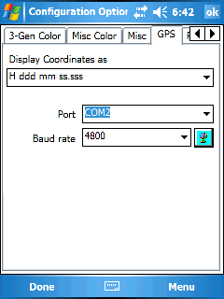
GPS
This changes the default display format for latitude and longitude in Pocket Genealogist. Also, if you have a built-in GPS or one connected via bluetooth or other method, you can configure Pocket Genealogist to use the GPS for retrieving coordinates. Use the globe icon to test your GPS after you set the port and baud rate.

Prompts
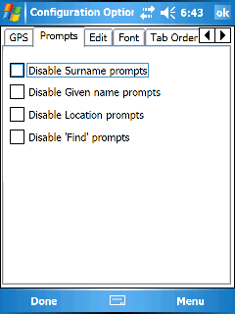
These options control some of the prompts that can occur in Pocket Genealogist. Selecting these items turns them off.

Disable Surname Prompts
Turning this on will disable the prompt that occurs when you add a new surname to the database.

Disable Given name Prompts
Turning this on will disable the prompt that occurs when you add a new given name to the database.

Disable Location Prompts
Turning this on will disable the prompt that occurs when you add a new location to the database.

Disable Find Prompts
During especially longs searches in the database, you will be prompted every 50,000 records to allow termination of the search. Turning this on will disable the search prompt.

Edit

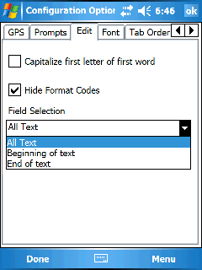
Capitalize first letter of first word
When entering text into a field, this controls whether the first letter of the first word is automatically capitalized.

Hide Format Codes
For some imports, this will hide the format codes in the note fields. If selected the note field will also be marked “read only” and format codes will be hidden.

Field Selection
Determines the location of the “cursor” and how the text is selected when a note field is displayed for editing.

Change Font size
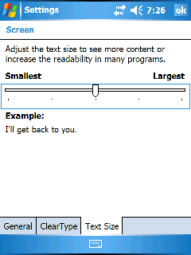
You can change the font size of the 3-gen view, the tree views, the lists and the edit fields within Pocket Genealogist. (Each can have a different size if desired.) With Windows Mobile 2003 Second Edition and newer devices, you can change font sizes globally on the device. With Pocket Genealogist, you can use the size as defined in the system or set your own.

With Windows Mobile, go to “Start”, “Settings”, “System” tab, “Screen” icon, “Text Size” tab. Adjust the slider to increase or decrease the size of the fonts on a global basis.

Pocket Genealogist can be set to use custom sizes within Pocket Genealogist or to use the System setting. Use the “Font” tab from “Edit”, “Configuration” to set the value you wish to use. The drop down list allows you to set it for each of the items that support a custom size. The example shows the 3-gen screen and lists with the smallest size available on a VGA device. (The quality of the text on the actual device is very good, much better than what is shown in the screen print.)
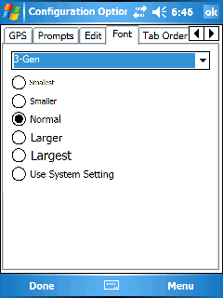
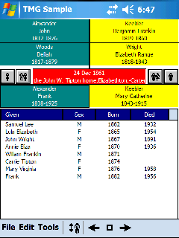

Tab order (Individual or Family)
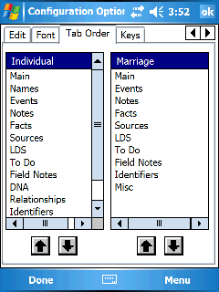
You can change the order of the “tabs” for the Individual and Family screens. Use the “Tab Order” screen from “Edit”, “Configuration”.

Each list shows the order that the tabs will be displayed for the Individual and Family screens.

Select the item in the list to move and press the up or down arrow to change its order.

Note: Tab order is not available for smartphones. (non-touch screen devices)

Keys
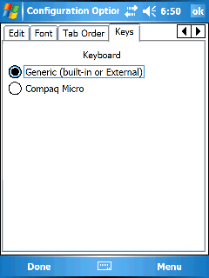
The Keys option allows you to set which type of keyboard you are using with your device. The default is “Generic (built-in or External)” which should work with the majority of keyboards. You can get to the “Keys” screen from “Edit”, “Configuration”.

Note: Keys is not available for smartphones. (non-touch screen devices)

Databases List
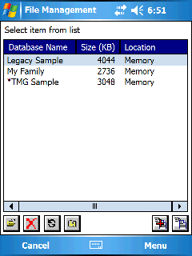
The databases list can be displayed from “File”, “Databases”. You can open, close, delete and do backups of the databases. The database that is currently open on the device will have an “*” next to it. For each database you will be shown the name, the amount of space it uses and where it is stored.

Memory databases can be either “Mounted” or “Object Store”. A memory database must be “Mounted” to be eligible for the backup feature. “Object Store” databases however are faster and take less space on the device.

Note: Windows Mobile 5 and newer doesn’t support “Object Store” databases so all databases are “Mounted” and the display will simply say “Memory”.

Used to open a database. If another database is already open, it will be closed automatically.
Used to delete a database. Deleting a database on the device does not delete the same database on the desktop, they must be done separately.
Used to Refresh the list of databases. Useful when you change storage cards with this screen displayed.
Closes the current open database, if any. You do not need to select the open database in the list first, just press this button to close the current open database.
Used to create a new backup of the database selected in the list. “Object Store” databases are not eligible for backup.
Used to restore using one of the backup sets you’ve already created. Restoring a database will overwrite the original if it still exists on the device.

Deleting a database
You can delete a database from the “File”, “Databases” menu. Select the database in the list to delete and press the “Delete” button or use the “Delete” menu item. You do not need to close the database first, and you will always be prompted to confirm your choice of deletion.

Opening a database
To open a database in Pocket Genealogist, go to the list of databases from the “File”, “Databases” menu. Select the database in the list and press the D-Pad “Enter” button, or press the “Open” button or use the “Open” menu item. You do not need to close the current open database first.

Backup/Restore of your database
The Backup/Restore feature requires the “Advanced” level of Pocket Genealogist. You cannot do backups on “Object Store” databases.

Backup
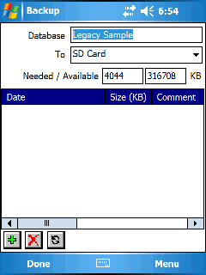
Select the database in the database list and press the “Backup” button to create a new backup. Any open databases will first be closed. The Backup screen allows you to pick the location where you would like to put the backup using the “To” drop down list. The amount of free space at that location will be displayed and if there is not enough for the backup you won’t be able to use that location. If you remove a storage card and put in another, press the “Refresh” button to make sure the space information is updated.

You can also delete backups from this list, select the backup in the list (this example doesn’t show any) and press the “Delete” button.

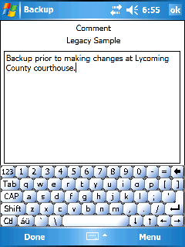
Create a new backup
Delete a backup
Refresh display

Press the “Add” button to create a new backup at the “To” location. You can enter a comment for the backup if you wish.

Note: If your database contains images, you will be prompted if you wish to include multimedia as part of the backup. If you say “No”, when you restore that database all multimedia objects will be “lost” until you re-import the database.

Restore
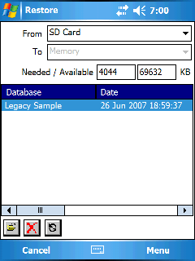
Press the “Restore” button to display a list of backups. The “From” drop down list allows you to select the location of the backups. Select the backup you wish to restore from the list and you will then be able to pick the “To” location where you wish to put the restored database. Any databases by that same name will automatically be deleted as part of the restore.

If you change a storage card while you are on this screen, you must press the “Refresh” button to retrieve information stored on that card.

Restore the database using the selected backup.
Delete a backup
Refresh display

Note: Scroll to the right to see the comment associated with the backup.

Warning: Restoring a backup will totally replace the database with the same name on the device.

Closing Pocket Genealogist
To close Pocket Genealogist on the device, do a “File”, “Exit”. You should always close Pocket Genealogist before a database synchronization.

View/Edit Master Lists
You can view the “Master lists” in your database from “Edit”, “Master lists”. This includes Name Prefix, Suffix, Given names, Surnames, Locations, Sources, Address/Repositories, Source Types, To Do Categories, Parent Relationships, Marriage Statuses and Child Statuses. When you change an item in these lists, it changes ALL references to that item. This is a handy way to change the spelling or capitalization of an item. You can also add new items to some of the lists but you can’t delete.

Note: You can view all TMG Research Log entries (To Do’s) for a Repository by viewing a repository from the Master List.

Relationship list
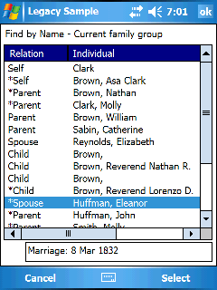
You will find the relationship button (or menu item) at various locations within the program. It is used to display a list of people who are directly related to the person in question. The current example was invoked from the 3-gen screen using the button found on the menu bar. (PocketPC) Shown, from top to bottom, are the current person and all aliases, followed by the parents. Next follows the spouse, the spouse’s parents and the children of the couple. If there are additional spouses, they will follow using the same order (spouse, parents of spouse and the children of the couple). In most cases, selecting a person in the list and pressing OK makes that person and the associated spouse the “current couple” on the 3-gen screen. However, in the case of the relationship display invoked from the 3-gen screen, this would not be that useful since you can easily “navigate” to that person directly from that screen. In this situation, selecting a person from the list and pressing OK will take you to the “Find by Surname” display with that person selected. This allows quick access to the “Find” function for that surname for easy selection of other relatives of that person.

For those imports that support “preferred” spouses, parents, and children, the “relation” column will put an * next to the preferred item. For the “Self” entries, the primary name will have an * next to it.

Status Area
Additionally, there is a status display at the bottom of the screen. When selecting the “Self” items, you get an indication if the name is a primary name or a secondary name (Alias). For Parents, the status area displays the child status of the “Self” person to the Parent. For Spouses, the status area displays the marriage date. (Or date associated with the “union” between the “Self” person and the spouse.) For Children, the status area will display the child status to the “Self” person.

The above is only available for those imports that support these relationship statuses. If data entry is enabled, you can “tap” on that the status field and change the value.

Date Calculator

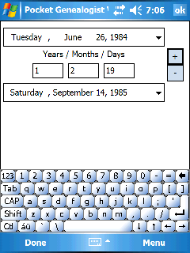
PocketPC
The date calculator can be used to calculate a second date using a start date and years, months and days from that date (either in the past or the future). Select the 1st date, then enter the years, months and days, then press the add or subtract button to calculate the second date.

The date calculate can also be used to enter a start and an end date and it will automatically calculate the number of years, months and days between the two. The date calculator is found from the “Tools”, “Calculators” menu.

Smartphone
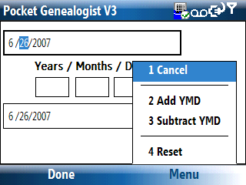
The smartphone version of the date calculator has some differences compared to the PocketPC version. It does support calculation of a second date from a first plus Y/M/D, or calculation of Y/M/D between two dates.

- You have to enter the dates “manually”, there is no “calendar” display to select the date.
- The date is a “Short” date, the day of the week is not shown and the month is shown as a numeric value.
- Calculation of the number of years, months and days between two dates is automatically calculate as you change either the first or second date.
- You can enter a first date, then values in the Years, Months, Days field, then use the “Add YMD” or “Subtract YMD” menu item to set the second date.

Soundex Calculator
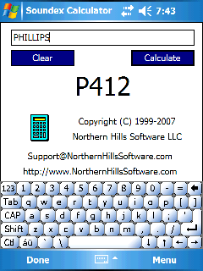
The Soundex calculator is used to calculate the Soundex code for a name. The calculator is found under “Tools”, “Calculators”.

Type in the surname and press the calculate button to display the soundex value. For certain names, you may get two values as the result. (Due to a little known “rule” regarding H’s and W’s.)
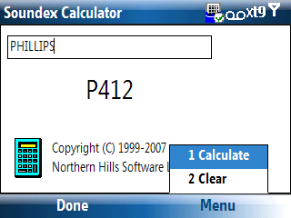

Coordinates Calculator
The coordinates calculator is not really a calculator but a convertor. It allows you to enter a latitude and longitude value and then convert it to a different format. You can find it from the “Calculator” menu found under “Tools”. The Coordinates button will retrieve the current GPS setting.

Using the Relationship Calculator
Found on the menu under “Tools”, “Calculators”, “Relationships”

PocketPC
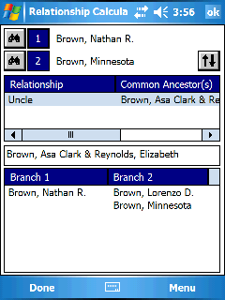
The relationship calculator is used to determine the relationship between two individuals. The relationship(s) shown in the list is always in reference to how the first person relates to the second person. As you change person 1 or person 2 the relationships shown in the list will automatically calculate.

The “Branch 1” and “Branch 2” list shows the individuals that are common between the two ancestors. “Branch 1” relates to person 1 and “Branch 2” relates to person 2. (The list is always shown with the oldest generation at the top of the list and the youngest at the bottom)

Invokes a “Find” screen to select the individual by name.
Invokes a “Go To” screen for selecting person 1.
Invokes a “Go To” screen for selecting person 2.
Used to swap person 1 and person 2.

Smartphone
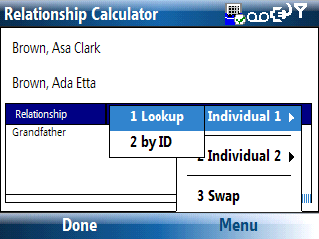
The relationship calculator is used to determine the relationship between two individuals. The relationship(s) shown in the list is always in reference to how the first person relates to the second person. As you change person 1 or person 2 the relationships shown in the list will automatically calculate.

Lookup | Invokes a “Find” screen to select Individual 1 or 2
By ID | Invokes a “Go To” screen for selecting Individual 1 or 2
Swap | Used to swap Individual 1 and 2.

History List

PocketPC
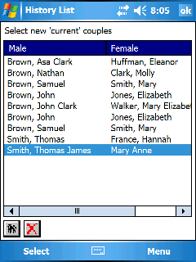
Pocket Genealogist keeps track of the individuals viewed during a Pocket Genealogist session. (Information is not retained when you close the database or exit the program.) You can use the History buttons on the menu bar or use the menu items “Back”, “List”, or “Forward” to traverse the history list. When you select the “List” function, you will see the individuals in the order that they were selected. The list is a “circular” list that displays a maximum of 100 individuals/family sets. The last viewed set is highlighted when the list is first displayed.

Displays the immediate relations to the person selected in the list.
Deletes the item in the list but does NOT delete the individual.

Smartphone
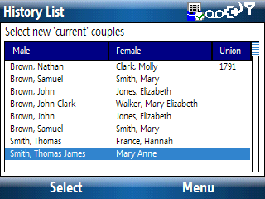
Pocket Genealogist keeps track of the individuals viewed during a Pocket Genealogist session. (Information is not retained when you close the database or exit the program.) You can display the list from the “Tools”, “History”, “List” menu item. A list of the individuals in the order that they were selected will be displayed. The list is a “circular” list that displays a maximum of 100 individuals/family sets. The last viewed set is highlighted when the list is first displayed.

If you select an item in the list, you can use the menu to view relationships to that person or to delete an item from the list. (It will not delete the individual from the database, just the item from the history list)

Soft Reset Device
Windows Mobile devices have a feature called a “Soft Reset”. A soft reset is like a reboot. Refer to your device manufacturers documentation on how to perform a soft reset, which is usually done by pressing a recessed button with the stylus. There are times when a soft reset will clear up problems that may be occurring on the device.

The “Advanced” level of Pocket Genealogist also has the ability to perform a soft reset. You do not need to close your Pocket Genealogist database as it will be done for you. However, you should close any other programs before doing the reset.
You can find the soft reset under “Tools”, “Device”, “Reset”.

Note: The soft reset function may not work with all devices as it depends on how the device manufacturer implemented Windows Mobile.

Hard Reset Device
Windows Mobile devices have a feature called a “Hard Reset”. A hard reset is MUCH more “extreme” than a soft reset since it resets the device to the factory installed state. All programs and data that you have put on the device will be removed during a hard reset. This would be similar to formatting a hard drive and re-installing the operating system. Refer to your device manufacturers documentation on how to perform a hard reset.

The “Advanced” level of Pocket Genealogist also has the ability to perform a hard reset. You will be prompted twice though since it’s such a drastic step. Pocket Genealogist and all databases will be lost if you do a hard reset. You can find the hard reset under “Tools”, “Device”, “Reset”.

Note: The hard reset function may not work with all devices as it depends on how the device manufacturer implemented Windows Mobile.

Format a Storage Card
On rare occasions you may need to format your storage card. The “Advanced” level of Pocket Genealogist has this ability, which can be found from “Tools”, “Device”, “Format”. All data on the storage card will be lost if you do a format.

Working with Dates
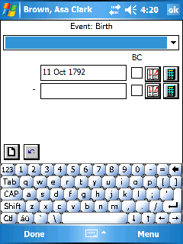
When you edit a date field in Pocket Genealogist, the date view/edit screen will be displayed. Dates are another area in Pocket Genealogist that can work quite differently depending on the capabilities of your desktop genealogy program. You can either enter a date with or without a “qualifier” such as “before”, a stand-alone date qualifier such as “Dead”, or any value you wish if you select “freeform”.
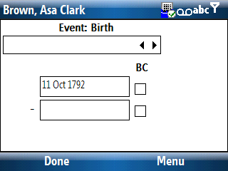

Date Qualifier
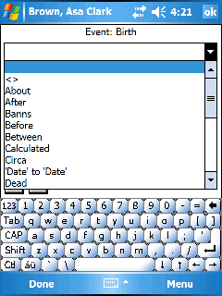
Use this date qualifier list to modify the type of date you are using. This includes things such as “Before” or standalone items such as “Dead”. Stand-alone items make up the entire date value and no actual date is allowed.

If you select “freeform”, you can enter any value you wish. This is generally used when you do not have a valid date to enter in the date field or have other special needs. Not all desktop programs support a freeform date.

Depending on what you select, the other fields on the screen will be shown or hidden.

Date Entry
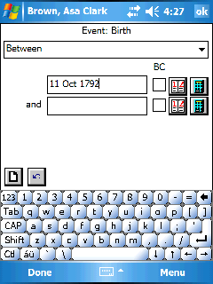
You can enter the date in the date entry field as shown. If the date qualifier is one that expects two dates, for example “Between”, use the second date entry field for the second date.

Depending on your desktop program, you may also have a BC (Before Christ) and DD (Double Date) checkbox available.

Calendar
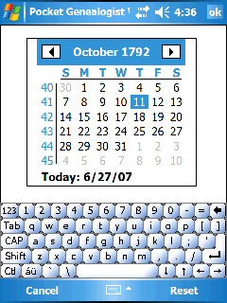
Use the calendar button or menu item to display a calendar that can be used to select the date for the date field. The oldest date available using the calendar is September 14, 1752.

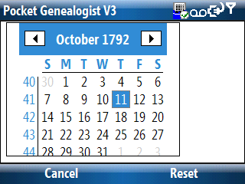

Calculator
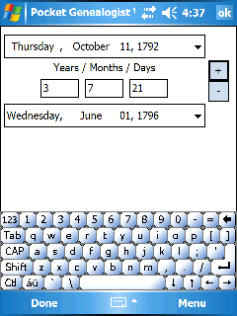
Use the calculator button to calculate a date to be entered into this field. You can start with a date and add or subtract years, months and days for example. The oldest date available using the calculator is September 14, 1752.

Note: The second date is the one that is always returned to the date field.

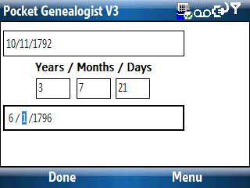

2-Way Synchronizing
Chapter
6

Overview
With direct Legacy Family Tree imports, if you enable the “2-way Synchronizing” option at import time, you can make changes to data on the device OR data in Legacy then synchronize those changes to the “other side”. (Legacy changes to the device or device changes back to Legacy) In order for this to work, you must only change one side at a time. If you make changes on the device, you cannot change anything in Legacy until you synchronize. If you make changes in Legacy, you can’t make changes on the device until you synchronize. After you synchronize, either side can then be changed but only one side at a time between synchronizations.

Before the initial Import
Pocket Genealogist is very “strict” with regards to doing updates into Legacy. To make sure that your Legacy Database is in good shape before you do the initial import, it is recommended that you do the following:

1. Backup your database
Since the following will make changes to your database, it’s always a good idea to first make a backup. This is done from the “File” menu, then select “Backup Family File”. Then select the name and location for your backup. (Backing up to your hard disk is fine. The intent is to provide a way to restore your data in case problems occur during the next few steps.)

2. Check/Repair
Over time, things can occur in your database that could interfere with the 2-way synchronization by Pocket Genealogist. The Legacy “Check/Repair” function can be used to find and fix some of these issues in the database. This is done from the “File” menu, then select “File Maintenance”, then “Check/Repair”. Depending on the size of your database, it may take a few seconds to much longer to perform this function. After it is complete, if any problems were found you will be given the choice to view a problem log.

3. Master Lists Cleanup
This is a handy location to combine duplicates that can cause problems for the 2-way Pocket Genealogist synchronization. This is done from the “File” menu, then select “File Maintenance”, then “Master Lists Cleanup”.

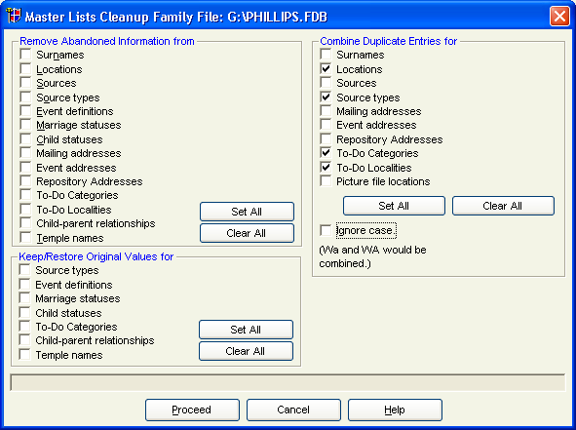

In the above screen print, the items that are important for the 2-way Pocket Genealogist synchronization are shown “checked”. You may wish to do other items for your own benefit.

After the initial Import
To verify that there are no problems in your Pocket Genealogist database that will prevent you from doing an update back into Legacy, it is recommended that you make a small change to your database on the device after the initial import to test the process. For example, you could change the “Ancestor Interest” value for one of the individuals in your database. (This is found on the “Main” tab for the individual.) After making the change and closing Pocket Genealogist on the device, go to Pocket Genealogist on the desktop and do a synchronize for the database. It should determine that a change was made and prompt you to do the update into Legacy. (More details in the following sections.) If the update is unsuccessful, please send a copy of your database (FDB file) to Northern Hills Software so we can evaluate the situation.

Updating Legacy with changes from the device
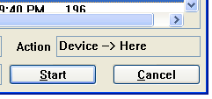
After you’ve made changes on the device, close the program and go to Pocket Genealogist on the desktop. Use the “Synchronize” button to retrieve the changes. On the synchronization screen, before you press start, you’ll notice that the “Action” listed at the bottom right indicates that changes on the device will be retrieved and placed in the Pocket Genealogist database on the desktop. (“Here”) No changes will be made to the Legacy database yet. After synchronization is complete, if changes were found you will be given the choice to update the Legacy database.

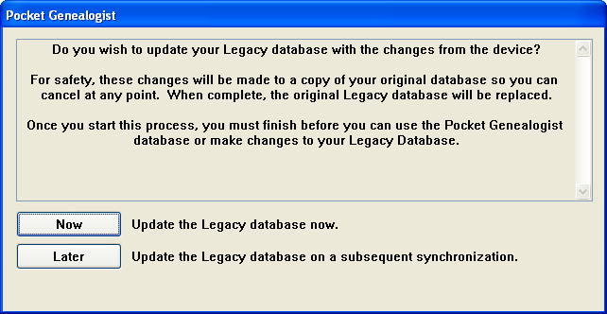

You can select “Later” if you wish to perform the updates at another time, but you must not make any changes to the Legacy database until you complete the update process. Even if you select “later”, you can continue to make more changes on the device. The additional changes will be retrieved when you do the synchronization at a later time. If you select “Now” and the database is open in Legacy, you will receive the following. You must close the database or shut down Legacy before you can continue.

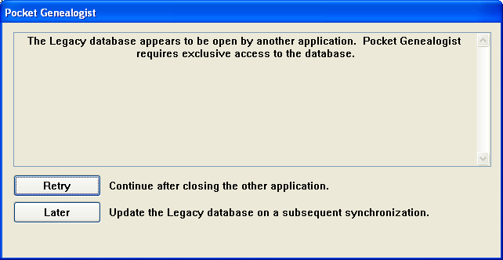

Selecting “Later” is the same as selecting it from the previous screen. Nothing has been applied to your original Legacy database. If you make changes to the Legacy database before you process the updates, a subsequent synchronization will determine this and won’t allow the updates. At that point, you’ll have to export a GEDCOM file in order to do the updates. (And 2-way synchronization will be turned off and will remain off unless you do a new import of the Legacy data.)

If you close the database or shut down Legacy, you can then press “Retry” to continue. When the updates are complete and if successful, you will be given one last chance before committing the changes to your original Legacy database.

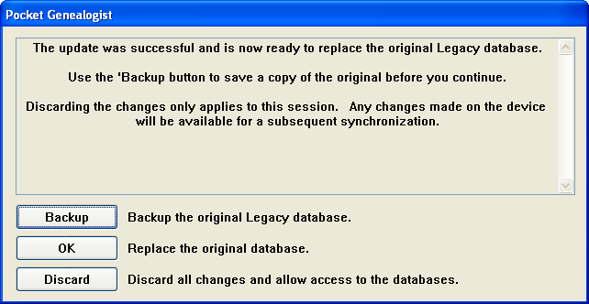

It is highly recommended that you use the “Backup” function to create a backup of your Legacy database before you replace it with the changes. The backup is functionally equivalent to one done by Legacy. (You can restore it using the Legacy “Restore Family File” function.)

When you press the “Backup” button, you then select the name and location where you wish to store the backup. Pressing “OK” starts the backup. You will see a progress window during the backup and a status when complete.

If you choose to discard the updates and do the process at a later time, the original Legacy database will not be touched, which is the same as selecting “Later” at the beginning of the update process. As before, you must finish the update process before you make any changes to the Legacy database.

Otherwise, if you are ready to commit your changes, press the “OK” button. The original Legacy database will be replaced with the copy with the changes. If any updates need to be synced back to the device, that will occur next. At the end of processing, it is then safe to make changes in Legacy or on the device.

Updating the device with changes in Legacy
After you’ve made changes in Legacy and want to update the database on the device, use the “Synchronize” button in Pocket Genealogist on the desktop. It will first check to see if any changes occurred on the device. If none have occurred, you will then be given the chance to “refresh” the data on the device from your Legacy database.

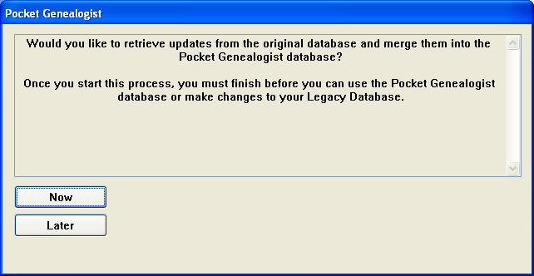

You can select “Later” if you wish, but if you have changed the Legacy database you must complete the update before you can make changes on the device. Pressing “Later” does not prevent you from making more changes in Legacy.

If you select “Now”, the Legacy database is examined for any changes that have occurred since the initial import or last synchronization, and if any are found they will be synchronized to the device. At the end of processing, it is then safe to make changes in Legacy or on the device.

Changes in both Legacy and Device
You may not make changes in both Legacy and on the device for a database and then do a 2-way synchronization. When you do this, the sync process will determine that changes have occurred in both places and will abort the update. No changes will be applied to the original Legacy database and the 2-way synchronization will be turned off for that database. You will have to use the GEDCOM export feature to retrieve and apply updates back to your Legacy database.

In order to turn the 2-way synchronization back on, you have to do a new import of your Legacy database. (Either replacing the database on the device or creating a new one.)

(This page intentionally left blank)

Field Notes
Chapter
7

Overview
Field notes do not transfer via GEDCOM file. You must either print a copy of the notes or “cut and paste” to your desktop genealogy program. Field Notes are the only data entry that can occur with the “Trial” version of Pocket Genealogist.

Adding note on Device

PocketPC
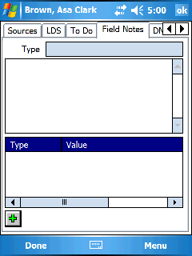
The Field Notes display on the device is almost identical to Notes, but you are limited to roughly 30,000 characters per note.

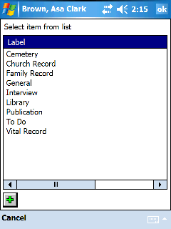

To add a new note, press the “Add” button or the “New” menu item. A list of field note types will be displayed and you can either select one from the list and press “OK” or press the “Add” button to add a new Field Note type. Once you’ve selected the Field Note type, the edit screen will be displayed for entering the note.

Smartphone
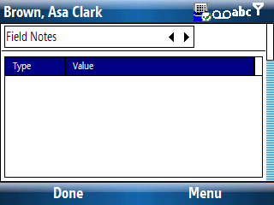
The Field Notes display on the device is almost identical to Notes, but you are limited to roughly 30,000 characters per note.

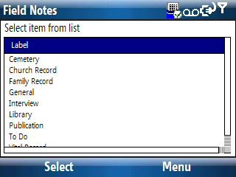

To add a new note, select “New” from the menu. A list of field note types will be displayed and you can either select one from the list and press “Select” or select “New” from the menu to add a new Field Note type. Once you’ve selected the Field Note type, the edit screen will be displayed for entering the note.

Field Notes list (Reports)
First you must retrieve the notes from your device using the “Synchronize” function in Pocket Genealogist. Select the database you wish to synchronize and press the “Synchronize” button. After the synchronization is complete, your Field Notes will now be in the corresponding desktop Pocket Genealogist database.
 Now press the “Reports” button and select “Field Notes” from the prompt. The Field Notes screen will automatically select all notes that are new or changed since the last time you did a synchronize.
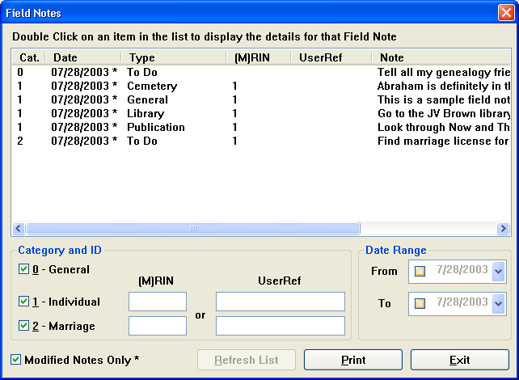
You can also customize your selection criteria. You must select at least one note category. (If you select ONLY individual or marriage, you can also specify a Record Identification Number (RIN) or Marriage Record Identification Number (MRIN) or User Reference.) You can also specify a date range for the notes. If you only want notes that have been added or changed, select the “Modified Notes Only” check box. After you pick the options that you want, press the “Refresh List” button. If the results are not what you want, change your options and press “Refresh List” again.
The asterisk next to the date in the list indicates that the note has been modified. You can view any of the notes by double clicking the item in the list that interests you. After you view a note, you may want to turn off the “modified flag” so that the note will no longer be considered “modified” the next time you query the list.
If you press the “Print” button, all notes shown in the list will be selected for printing.

Field Note Display
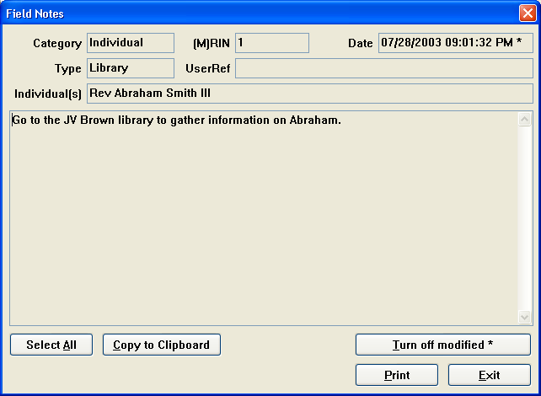
When you “double click” on one of the items in the Field Notes list, you will be shown more detail about that note. You can “copy” the note from the window to “paste” into your genealogy program. You can use your mouse to select any or all of the note or use the “Select All” button to select the entire note. Then press the “Copy to Clipboard” so you can then “paste” it into your desktop genealogy program (or any text editor).
If this note has been modified since the last time you synchronized notes, the “Turn off modified” button will be enabled. If you press that button the note will not show up in the list the next time you do a query for modified notes.
If you press the “Print” button only this one note will be selected for printing.

Field Note Print
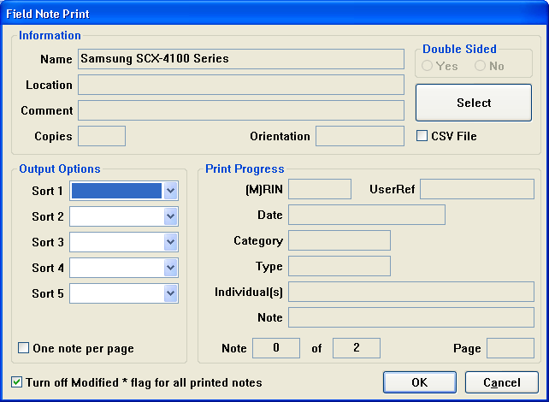
The Print dialog allows you to either print the field notes to a printer, or to export the notes to a CSV file. (CSV files are text files generally used with a spreadsheet program)
The “Select” button is used to either select the printer for output, or to select the name of the CSV file if you have “CSV File” checked. By default, the CSV file will be given a name and location although you can override to any value you wish. If you use the default location that is provided, the CSV files will show up on the “Logs” screen using the “Logs” button found on the main Pocket Genealogist screen.
The output options section allows you to pick the order in which the Field Notes will be printed or exported to CSV. If you have selected only one Field Note, the sort boxes will be disabled. If you do not pick any sort options, the Field Notes will be printed in the order that they are shown in the list prior to selecting the “Print” button. If you want only one Field Note per output page, select the “One note per page” check box. Otherwise, more than one Field Note may be printed on a single page.
Some options aren’t applicable when exporting to a CSV file, and they will be disabled or hidden when that option is selected.
When you press the OK button, the Field Notes will be printed. As each note is sent to the printer or CSV file, details for that note will be displayed in the Print Progress section.

(This page intentionally left blank)

Research Lists
Chapter
8

Overview
Research Lists are a way to group Individuals, Families, Sources and Repositories into lists of your choosing. You can create as many research lists as you like and assign any of the above items to the list for further research while you are “in the field” using Pocket Genealogist. With the exception of Family Historian, Research Lists do not transfer via GEDCOM or direct import. There is a simple export to CSV file feature for the Research Lists in Pocket Genealogist on the desktop so you can access the information you create on the device.

Note: Family Historian Named Lists are converted to Research Lists when imported into Pocket Genealogist.

Adding an item to a Research List
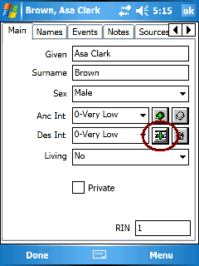
The “Add item to Research List” icon will be found on the screens applicable to items that can be added to a Research List (or on menus). Adding an item to a research list does not show you other Research List items that have already been added, it is only used to add a new item to a list.

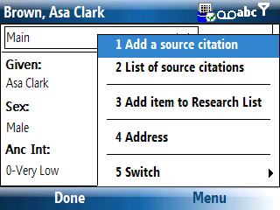
By default there are no Research Lists created on the device when you import a new database.

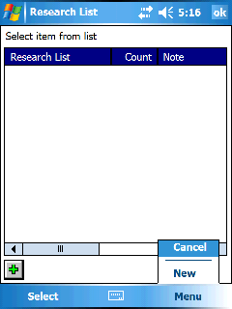
Here is an example of what you might see the first time you try and add an individual to a Research List. Since there is no lists yet in existance, the first step is to create a new list. (Use the “Add” button or the “New” menu item)
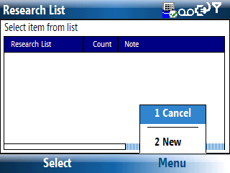

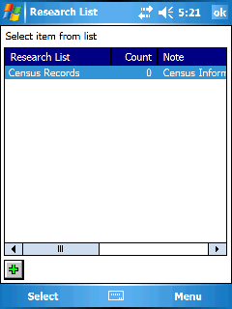
After pressing “New” or the “Add” button, we’ll enter the value “Census Records” to create a research list by that name. After the list has been created, a Note display will be shown where you can enter a note to describe the Research List. We are then taken back to the Research List selection screen, you can create more Research Lists now or when you first need them.

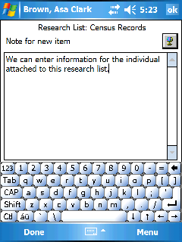

Select the Research List for which to add the individual and press “Select”. You will then be given a change to enter a note to attach to the person (or item) you are adding to the research list.

Viewing Research List
All Research Lists and the items attached to them can be found on the “Edit”, “General Details” screen. You will see a complete list of all Research Lists you have defined and an indication of the number of items attached to the list.

PocketPC
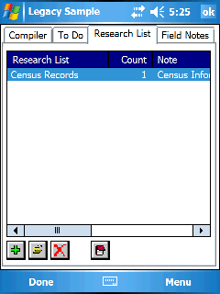
Add a new Research List
Edit (View) the items on the Research List.
Delete a Research List and all items attached to it.
View/Edit the note that describes the Research List.

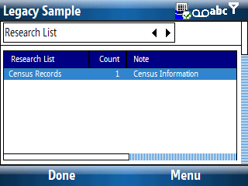
Smartphone
Same as for PocketPC but the items to manage the list will be found under “Menu”.

Working with items in a List
Select an item in the Research List and press the “Edit” button or the “Edit” menu item. You will be shown a list of items attached to the Research List.

PocketPC
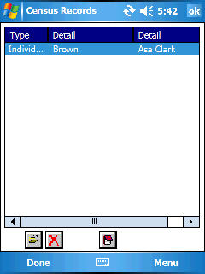
Used to view/edit the item on the list. (individual, family, source or repository)
Used to delete a Research List item. This does not delete the actual item attached to the list. For example, it won’t delete an individual attached to the list, just the Research List record.
Used to view/edit the note for the item attached to the Research List.

Smartphone
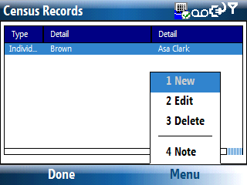
Use the menu to edit the item on the list (which takes you to the individual, family, source or repository) or the “Note” button to view/edit the note you attached to the item when you added it to the list.

Research List Report
First you must retrieve the Research Lists from your device using the “Synchronize” function in Pocket Genealogist. Select the database you wish to synchronize and press the “Synchronize” button. After the synchronization is complete, your Research Lists will now be in the corresponding desktop Pocket Genealogist database.
Now press the “Reports” button and select “Research List” from the prompt. The Research List screen will show a display similar to what is on the device.
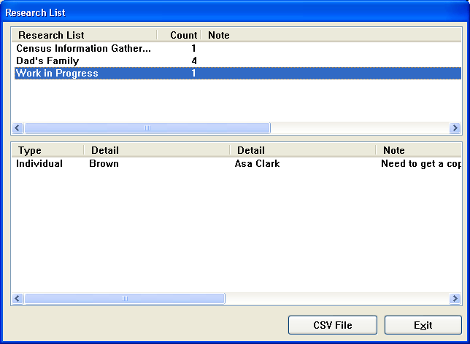

Select an item from the top list will show the details of the items attached to that list. Pressing the “CSV File” will create a CSV file just for that Research List. Repeat that process to create a CSV File for the other lists.

By default, the CSV file will be given a name and location although you can override to any value you wish. If you use the default location that is provided, the CSV files will show up on the “Logs” screen using the “Logs” button found on the main Pocket Genealogist screen.

(This page intentionally left blank)

Uninstalling Pocket Genealogist
Appendix
A

Desktop uninstall

- Start Pocket Genealogist on the desktop and press the “Tools” button.
- Select all items under “Data created by Pocket Genealogist” and then press the “Delete” button. Pocket Genealogist will automatically exit.

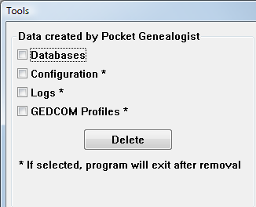

- Go to the Windows Control Panel from “Start”, “Settings”, “Control Panel”.

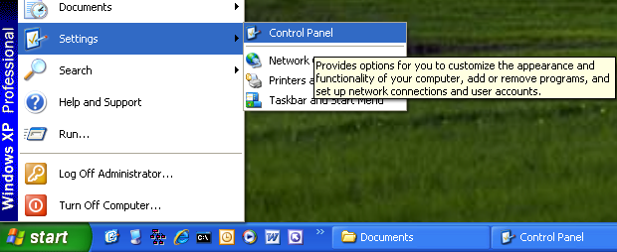

- Select “Add or Remove Programs”.


- Select the version of Pocket Genealogist from the list you wish to remove and press ‘Change/Remove”.

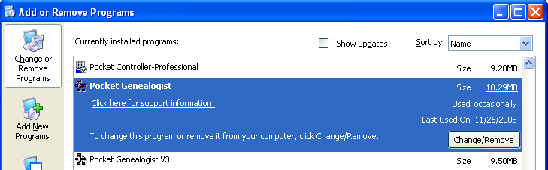

- The “Removal Wizard” will be displayed, follow the instructions to remove Pocket Genealogist.

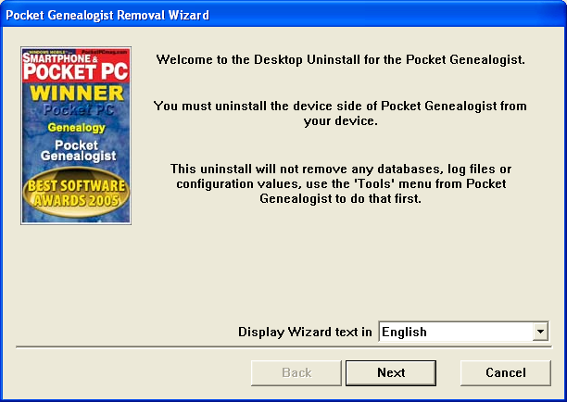

Device Uninstall
- Make sure Pocket Genealogist is not running on the device.
- From the “Start” menu select “Settings”.
- Select the “System” tab.
- Select the item in the list you wish to uninstall and press “Remove”.

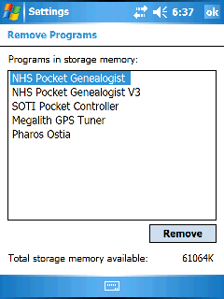

- Select “Yes” to the uninstall prompt.

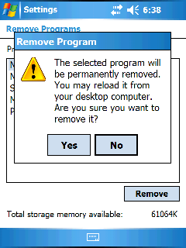

- If you are totally removing Pocket Genealogist, say “Yes”. This will remove all customization values including your registration code. If you have installed Version 3 and are removing Version 2, “Yes” is the correct answer.

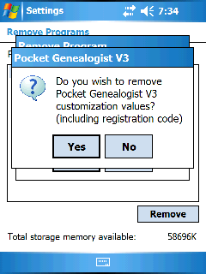

- If you are totally removing Pocket Genealogist say “Yes”. This will remove all databases on the device. If you have installed Version 3 and are removing Version 2, “Yes” is the correct answer.

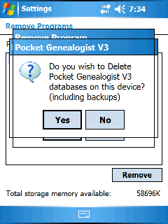

- If you have storage cards that may have databases on it, insert the card now and say “Yes”. Do that for every storage card that contains databases. When you are ready to continue say “No”.

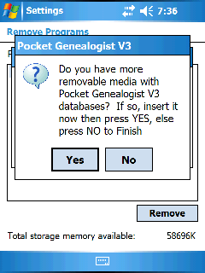

- The program has been uninstalled. If you have any languages installed you can remove them now as well.

(This page intentionally left blank)

GEDCOM creation
Appendix
B

The following are some specific examples for creating GEDCOM files. Even if your program is not listed, you may find some helpful hints that may be applicable to your situation. It is assumed, in all cases below, that your database is “open” before you start any of these processes.

Family Origins v10
- “File” menu.
- “GEDCOM” menu item.
- “Export GEDCOM…” menu item.
- Enter the name and location where you want to put the GEDCOM file. GEDCOM files should have a file extension of “ged”.
- Select “entire database” if you want all individuals or “Select people” if you want to be presented with the ability to select only certain individuals.
- Use the “General” destination type.
- “Correspondence log” and “Multimedia links” aren’t supported but won’t harm anything if included.
- Press OK to create the GEDCOM file. (If you selected “Select people”, you will be given the chance to pick who you want in the GEDCOM file).
Note: RootsMagic is similar.

Family Tree Maker v11

For all individuals in the Database
- “File” menu.
- “Copy/Export Family File” menu item.
- Change the “Save as type” to “GEDCOM (*.GED)”.
- Enter the name and location where you want to put the GEDCOM file. GEDCOM files should have a file extension of “ged”. (FTM version 11 automatically “fills in” the name while older versions do not)
- If the file already exists, it won’t let you overwrite it. However, you can select the file in the list and press the delete button, then create the new file.
- Destination is generally set to “FTW”.
- GEDCOM is generally set to “Version 5.5”.
- Character set is generally set to “ANSI”.
- Indent is generally not selected.
- Abbreviate is generally selected.

For some individuals in the Database
- Create either a Report, Ancestor tree, Descendant tree, or Outline Descendant tree.
- Using the right mouse button to pick options or the menu. (“Contents”)
- Select the individuals you want in the report or tree. (“Individuals to include”)
- “File” menu
- “Copy/Export Individuals in …..”
- Follow the same steps as above starting with step #3.

Generations v8.5
- “File” menu.
- “Import/Export” menu item.
- “Export GEDCOM…” menu item.
- Select “Who” you want to export.
- Destination is generally “GEDCOM 5.5”.
- Character set is generally “Windows”.
- Select “Optional Fields” and make sure that the data you want to include is “checked”.
- Press “Export” and you will be given a chance to pick the name and location of the GEDCOM file. GEDCOM files should have a file extension of “ged”.

Personal Ancestral File v5
- “File” menu.
- “Export…” menu item.
- Set “Export To” to “Other GEDCOM 5.5”.
- UTF-8 or ANSI is recommended as the Char Set.
- Select what you want to “include”. (Multimedia links are not supported but won’t cause any harm if included.)
- If you select “Partial” under “Filter”, you can choose which individuals are included in the GEDCOM file.
- Press “Export” and you will be given a chance to pick the name and location of the GEDCOM file. GEDCOM files should have a file extension of “ged”.

Ultimate Family Tree v3
- “File” menu.
- “Save As…” menu item.
- Change “Save file as type” to “GEDCOM”.
- Enter the name and location of the GEDCOM file.
- “Family 5.5” is generally used as the GEDCOM Format.

Import Limitations
Appendix
C

This section discusses limitations with the various imports. This information may change with each release as new imports are added or enhancements made to imports.

GEDCOM
Every desktop genealogy program creates GEDCOM files different from each other. The Pocket Genealogist “Profiles” provide a means to control the import and export of these GEDCOM files to provide a superior transfer of data and to make sure only data that is acceptable to the originating program is entered on the device.

Every attempt is made to support all the features in a GEDCOM file. There are still some data types that are not supported, such as multimedia objects. (Multimedia objects are not supported by any import.)

GenBridge PAF imports
- Problems will occur if you use the | character in notes.

GenBridge FTM imports (Prior to FTM 2008)
- The marriage reference # is not currently available.
- Under some circumstances, the order of children may not be correct.
- Multimedia is not supported.

GenBridge FTM 2008 imports
- Fact and Name notes are not imported.
- Spouses without a “family” fact or children will not be imported.
- Not all multimedia data associated with an image is imported.

Note: The above two limitations are as of September 24, 2008. Check the Northern Hills Software website to see if these items have been fixed.

Legacy Version 5 through 7 “Direct” imports
- All data is supported except for non-image multimedia object (Sound and Text files for example)

TMG “Direct” imports
- Templates are not supported.
- Location “elements” are not supported. (Locations are stored as one value in Pocket Genealogist.)
- Research Log is transferred but cannot be modified on the device.
- Most source elements cannot be modified on the device.

Ancestral Quest “Direct” imports
- The order of Parents is not currently supported.
- Page of Testimony is not supported (although the individual components will transfer).
- The “To Do” order is not currently supported.
- The source field “Abbreviated Author” is not currently supported.

RootsMagic “Direct” imports
- Correspondence List is not supported
- Primary/Secondary addresses are not supported. (The first address found in the database will be imported.)
- No distinction between primary and secondary repositories for sources.
- The reference to a family for an adopted event is not supported.
- Dates on Alternate names are not supported.
- The “preferred” flag for individuals are transferred but cannot be changed on the device.

Genbox “Direct” imports
- Too numerous to mention. This import is best when used with the “View Only” option.

PocketPC VGA Support
Appendix
D

If you have a Windows Mobile 2003 Second Edition or newer device with VGA support, you have a couple options. You can use the “native” support and increase the amount of data displayed by changing the text size using the “Screen” icon found in “Settings”, or you can use “Real VGA” by using a program such as SE_VGA.

Note: The following screen prints are not as clear as the actual display.

“Real VGA”

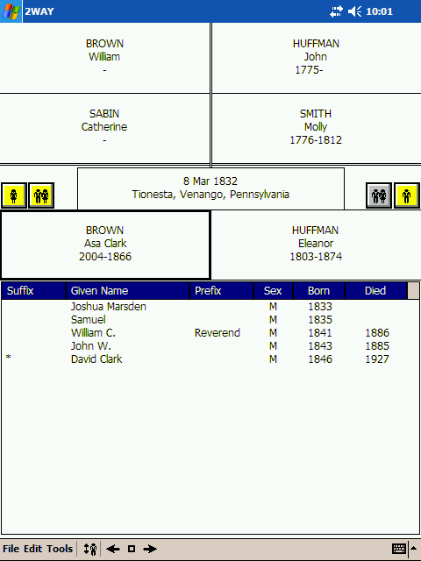
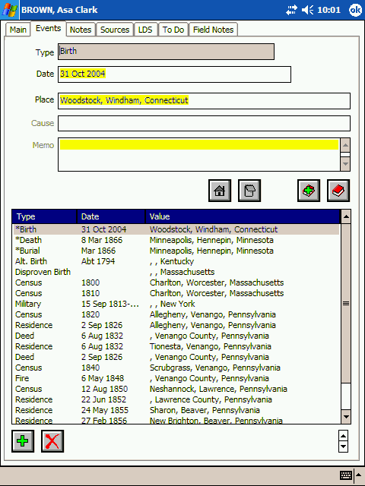

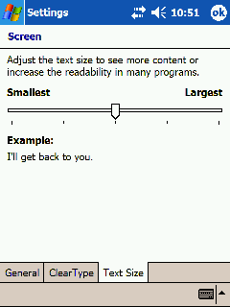
“Native” VGA
Windows Mobile devices with VGA screens have the ability to change the text size on the screen so that more information can be displayed. The text size can be changed from the “Screen” icon found on the “System” tab under “Settings”.

Pocket Genealogist uses the font size on the “3-gen” screen, the tree views, the lists and on some of the text fields such as Notes.

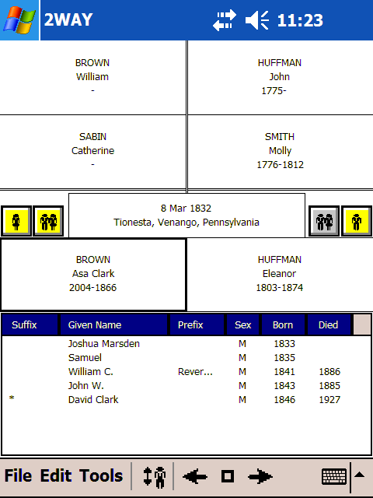
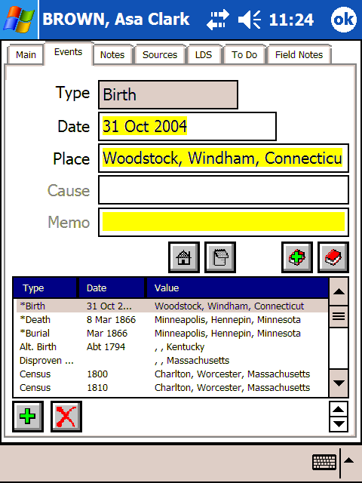
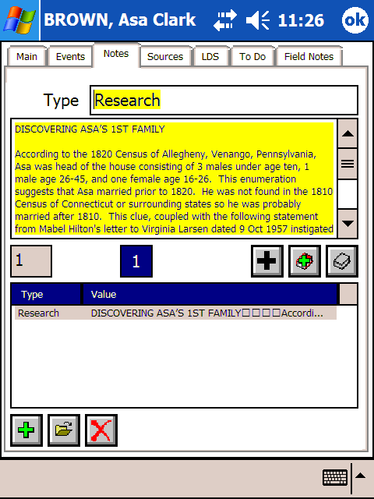
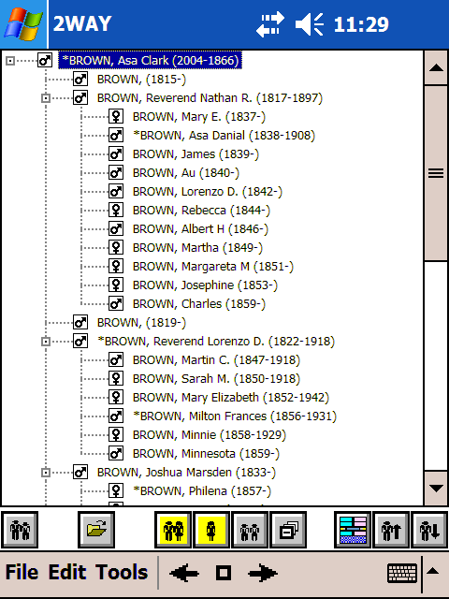
The following examples show Pocket Genealogist using the “smallest” font setting.

FreeImage License
Appendix
E
The Pocket Genealogist image import was developed using the FreeImage image conversion library which is used to ‘scale’ the size of desktop images to work better on the smaller device screens. The license for the use of this library is included below.

FreeImage Public License - Version 1.0
---------------------------------------------

1. Definitions.

1.1. "Contributor" means each entity that creates or contributes to the creation of Modifications.

1.2. "Contributor Version" means the combination of the Original Code, prior Modifications used by a Contributor, and the Modifications made by that particular Contributor.

1.3. "Covered Code" means the Original Code or Modifications or the combination of the Original Code and Modifications, in each case including portions thereof.

1.4. "Electronic Distribution Mechanism" means a mechanism generally accepted in the software development community for the electronic transfer of data.

1.5. "Executable" means Covered Code in any form other than Source Code.

1.6. "Initial Developer" means the individual or entity identified as the Initial Developer in the Source Code notice required by Exhibit A.

1.7. "Larger Work" means a work which combines Covered Code or portions thereof with code not governed by the terms of this License.

1.8. "License" means this document.

1.9. "Modifications" means any addition to or deletion from the substance or structure of either the Original Code or any previous Modifications. When Covered Code is released as a series of files, a
Modification is:

A. Any addition to or deletion from the contents of a file containing Original Code or previous Modifications.

B. Any new file that contains any part of the Original Code or previous Modifications.

1.10. "Original Code" means Source Code of computer software code which is described in the Source Code notice required by Exhibit A as Original Code, and which, at the time of its release under this License is not already Covered Code governed by this License.

1.11. "Source Code" means the preferred form of the Covered Code for making modifications to it, including all modules it contains, plus any associated interface definition files, scripts used to control
compilation and installation of an Executable, or a list of source code differential comparisons against either the Original Code or another well known, available Covered Code of the Contributor's choice. The Source Code can be in a compressed or archival form, provided the appropriate decompression or de-archiving software is widely available for no charge.

1.12. "You" means an individual or a legal entity exercising rights under, and complying with all of the terms of, this License or a future version of this License issued under Section 6.1. For legal entities, "You" includes any entity which controls, is controlled by, or is under common control with You. For purposes of this definition, "control" means (a) the power, direct or indirect, to cause the
direction or management of such entity, whether by contract or otherwise, or (b) ownership of fifty percent (50%) or more of the outstanding shares or beneficial ownership of such entity.

2. Source Code License.

2.1. The Initial Developer Grant.
The Initial Developer hereby grants You a world-wide, royalty-free, non-exclusive license, subject to third party intellectual property claims:

(a) to use, reproduce, modify, display, perform, sublicense and distribute the Original Code (or portions thereof) with or without Modifications, or as part of a Larger Work; and

(b) under patents now or hereafter owned or controlled by Initial Developer, to make, have made, use and sell ("Utilize") the Original Code (or portions thereof), but solely to the extent that
any such patent is reasonably necessary to enable You to Utilize the Original Code (or portions thereof) and not to any greater extent that may be necessary to Utilize further Modifications or
combinations.

2.2. Contributor Grant.
Each Contributor hereby grants You a world-wide, royalty-free, non-exclusive license, subject to third party intellectual property claims:

(a) to use, reproduce, modify, display, perform, sublicense and distribute the Modifications created by such Contributor (or portions thereof) either on an unmodified basis, with other Modifications, as Covered Code or as part of a Larger Work; and

(b) under patents now or hereafter owned or controlled by Contributor, to Utilize the Contributor Version (or portions thereof), but solely to the extent that any such patent is reasonably necessary to enable You to Utilize the Contributor Version (or portions thereof), and not to any greater extent that
may be necessary to Utilize further Modifications or combinations.

3. Distribution Obligations.

3.1. Application of License.
The Modifications which You create or to which You contribute are governed by the terms of this License, including without limitation Section 2.2. The Source Code version of Covered Code may be distributed only under the terms of this License or a future version of this License released under Section 6.1, and You must include a copy of this License with every copy of the Source Code You distribute. You may not offer or impose any terms on any Source Code version that alters or
restricts the applicable version of this License or the recipients' rights hereunder. However, You may include an additional document offering the additional rights described in Section 3.5.

3.2. Availability of Source Code.
Any Modification which You create or to which You contribute must be made available in Source Code form under the terms of this License either on the same media as an Executable version or via an accepted Electronic Distribution Mechanism to anyone to whom you made an Executable version available; and if made available via Electronic Distribution Mechanism, must remain available for at least twelve (12) months after the date it initially became available, or at least six (6) months after a subsequent version of that particular Modification has been made available to such recipients. You are responsible for ensuring that the Source Code version remains available even if the Electronic Distribution Mechanism is maintained by a third party.

3.3. Description of Modifications.
You must cause all Covered Code to which you contribute to contain a file documenting the changes You made to create that Covered Code and the date of any change. You must include a prominent statement that the Modification is derived, directly or indirectly, from Original Code provided by the Initial Developer and including the name of the Initial Developer in (a) the Source Code, and (b) in any notice in an Executable version or related documentation in which You describe the origin or ownership of the Covered Code.

3.4. Intellectual Property Matters

(a) Third Party Claims.
If You have knowledge that a party claims an intellectual property right in particular functionality or code (or its utilization under this License), you must include a text file with the source code distribution titled "LEGAL" which describes the claim and the party making the claim in sufficient detail that a recipient will know whom to contact. If you obtain such knowledge after You make Your Modification available as described in Section 3.2, You shall promptly modify the LEGAL file in all copies You make
available thereafter and shall take other steps (such as notifying appropriate mailing lists or newsgroups) reasonably calculated to inform those who received the Covered Code that new knowledge has been obtained.

(b) Contributor APIs.
If Your Modification is an application programming interface and You own or control patents which are reasonably necessary to implement that API, you must also include this information in the LEGAL file.

3.5. Required Notices.
You must duplicate the notice in Exhibit A in each file of the Source Code, and this License in any documentation for the Source Code, where You describe recipients' rights relating to Covered Code. If You created one or more Modification(s), You may add your name as a Contributor to the notice described in Exhibit A. If it is not possible to put such notice in a particular Source Code file due to its
structure, then you must include such notice in a location (such as a relevant directory file) where a user would be likely to look for such a notice. You may choose to offer, and to charge a fee for, warranty, support, indemnity or liability obligations to one or more recipients of Covered Code. However, You may do so only on Your own behalf, and not on behalf of the Initial Developer or any Contributor. You must make it absolutely clear than any such warranty, support, indemnity or
liability obligation is offered by You alone, and You hereby agree to indemnify the Initial Developer and every Contributor for any liability incurred by the Initial Developer or such Contributor as a result of
warranty, support, indemnity or liability terms You offer.

3.6. Distribution of Executable Versions.
You may distribute Covered Code in Executable form only if the requirements of Section 3.1-3.5 have been met for that Covered Code, and if You include a notice stating that the Source Code version of the Covered Code is available under the terms of this License, including a description of how and where You have fulfilled the obligations of Section 3.2. The notice must be conspicuously included in any notice in an Executable version, related documentation or collateral in which You
describe recipients' rights relating to the Covered Code. You may distribute the Executable version of Covered Code under a license of Your choice, which may contain terms different from this License,
provided that You are in compliance with the terms of this License and that the license for the Executable version does not attempt to limit or alter the recipient's rights in the Source Code version from the rights set forth in this License. If You distribute the Executable version under a different license You must make it absolutely clear that any terms which differ from this License are offered by You alone, not by the Initial Developer or any Contributor. You hereby agree to indemnify the Initial Developer and every Contributor for any liability incurred by the Initial Developer or such Contributor as a result of any such terms You offer.

3.7. Larger Works.
You may create a Larger Work by combining Covered Code with other code not governed by the terms of this License and distribute the Larger Work as a single product. In such a case, You must make sure the requirements of this License are fulfilled for the Covered Code.

4. Inability to Comply Due to Statute or Regulation.

If it is impossible for You to comply with any of the terms of this License with respect to some or all of the Covered Code due to statute or regulation then You must: (a) comply with the terms of this License to the maximum extent possible; and (b) describe the limitations and the code they affect. Such description must be included in the LEGAL file described in Section 3.4 and must be included with all distributions of the Source Code. Except to the extent prohibited by statute or regulation, such description must be sufficiently detailed for a recipient of ordinary skill to be able to understand it.

5. Application of this License.

This License applies to code to which the Initial Developer has attached the notice in Exhibit A, and to related Covered Code.

6. Versions of the License.

6.1. New Versions.
Floris van den Berg may publish revised and/or new versions of the License from time to time. Each version will be given a distinguishing version number.

6.2. Effect of New Versions.
Once Covered Code has been published under a particular version of the License, You may always continue to use it under the terms of that version. You may also choose to use such Covered Code under the terms of any subsequent version of the License published by Floris van den Berg
No one other than Floris van den Berg has the right to modify the terms applicable to Covered Code created under this License.

6.3. Derivative Works.
If you create or use a modified version of this License (which you may only do in order to apply it to code which is not already Covered Code governed by this License), you must (a) rename Your license so that the phrases "FreeImage", `FreeImage Public License", "FIPL", or any confusingly similar phrase do not appear anywhere in your license and (b) otherwise make it clear that your version of the license contains terms which differ from the FreeImage Public License. (Filling in the name of the Initial Developer, Original Code or Contributor in the notice described in Exhibit A shall not of themselves be deemed to be modifications of this License.)

7. DISCLAIMER OF WARRANTY.

COVERED CODE IS PROVIDED UNDER THIS LICENSE ON AN "AS IS" BASIS, WITHOUT WARRANTY OF ANY KIND, EITHER EXPRESSED OR IMPLIED, INCLUDING, WITHOUT LIMITATION, WARRANTIES THAT THE COVERED CODE IS FREE OF DEFECTS, MERCHANTABLE, FIT FOR A PARTICULAR PURPOSE OR NON-INFRINGING. THE ENTIRE RISK AS TO THE QUALITY AND PERFORMANCE OF THE COVERED CODE IS WITH YOU. SHOULD ANY COVERED CODE PROVE DEFECTIVE IN ANY RESPECT, YOU (NOT THE INITIAL DEVELOPER OR ANY OTHER CONTRIBUTOR) ASSUME THE COST OF ANY NECESSARY SERVICING, REPAIR OR CORRECTION. THIS DISCLAIMER OF WARRANTY CONSTITUTES AN ESSENTIAL PART OF THIS LICENSE. NO USE OF ANY COVERED CODE IS AUTHORIZED HEREUNDER EXCEPT UNDER THIS DISCLAIMER.

8. TERMINATION.

This License and the rights granted hereunder will terminate automatically if You fail to comply with terms herein and fail to cure such breach within 30 days of becoming aware of the breach. All sublicenses to the Covered Code which are properly granted shall survive any termination of this License. Provisions which, by their nature, must remain in effect beyond the termination of this License shall survive.

9. LIMITATION OF LIABILITY.

UNDER NO CIRCUMSTANCES AND UNDER NO LEGAL THEORY, WHETHER TORT (INCLUDING NEGLIGENCE), CONTRACT, OR OTHERWISE, SHALL THE INITIAL DEVELOPER, ANY OTHER CONTRIBUTOR, OR ANY DISTRIBUTOR OF COVERED CODE, OR ANY SUPPLIER OF ANY OF SUCH PARTIES, BE LIABLE TO YOU OR ANY OTHER PERSON FOR ANY INDIRECT, SPECIAL, INCIDENTAL, OR CONSEQUENTIAL DAMAGES OF ANY CHARACTER INCLUDING, WITHOUT LIMITATION, DAMAGES FOR LOSS OF GOODWILL, WORK STOPPAGE, COMPUTER FAILURE OR MALFUNCTION, OR ANY AND ALL OTHER COMMERCIAL DAMAGES OR LOSSES, EVEN IF SUCH PARTY SHALL HAVE BEEN INFORMED OF THE POSSIBILITY OF SUCH DAMAGES. THIS LIMITATION OF LIABILITY SHALL NOT APPLY TO LIABILITY FOR DEATH OR PERSONAL INJURY RESULTING FROM SUCH PARTY'S NEGLIGENCE TO THE EXTENT APPLICABLE LAW PROHIBITS SUCH LIMITATION. SOME JURISDICTIONS DO NOT ALLOW THE
EXCLUSION OR LIMITATION OF INCIDENTAL OR CONSEQUENTIAL DAMAGES, SO THAT EXCLUSION AND LIMITATION MAY NOT APPLY TO YOU.

10. U.S. GOVERNMENT END USERS.

The Covered Code is a "commercial item," as that term is defined in 48 C.F.R. 2.101 (Oct. 1995), consisting of "commercial computer software" and "commercial computer software documentation," as such terms are used in 48 C.F.R. 12.212 (Sept. 1995). Consistent with 48 C.F.R. 12.212 and 48 C.F.R. 227.7202-1 through 227.7202-4 (June 1995), all U.S. Government End Users acquire Covered Code with only those rights set forth herein.

11. MISCELLANEOUS.

This License represents the complete agreement concerning subject matter hereof. If any provision of this License is held to be unenforceable, such provision shall be reformed only to the extent necessary to make it enforceable. This License shall be governed by Dutch law provisions (except to the extent applicable law, if any, provides otherwise), excluding its conflict-of-law provisions. With respect to disputes in which at least one party is a citizen of, or an entity chartered or registered to do business in, the The Netherlands: (a) unless otherwise agreed in writing, all disputes relating to this License (excepting any dispute relating to intellectual property rights) shall be subject to final and binding arbitration, with the losing party paying all costs of arbitration; (b) any arbitration relating to this Agreement shall be held in Almelo, The Netherlands; and (c) any litigation relating to this Agreement shall be subject to the jurisdiction of the court of Almelo, The Netherlands with the losing party responsible for costs, including without limitation, court costs and reasonable attorneys fees and expenses. Any law or regulation which provides that the language of a contract shall be construed against the drafter shall not apply to this License.

12. RESPONSIBILITY FOR CLAIMS.

Except in cases where another Contributor has failed to comply with Section 3.4, You are responsible for damages arising, directly or indirectly, out of Your utilization of rights under this License, based
on the number of copies of Covered Code you made available, the revenues you received from utilizing such rights, and other relevant factors. You agree to work with affected parties to distribute
responsibility on an equitable basis.

EXHIBIT A.

"The contents of this file are subject to the FreeImage Public License Version 1.0 (the "License"); you may not use this file except in compliance with the License. You may obtain a copy of the License at http://home.wxs.nl/~flvdberg/freeimage-license.txt

Software distributed under the License is distributed on an "AS IS" basis, WITHOUT WARRANTY OF ANY KIND, either express or implied. See the License for the specific language governing rights and limitations under the License.

Index

2-way Synchronizing 33, 48, 49, 165
3-Generation View 57
ActiveSync 11, 15, 18, 53, 76, 77, 79
Add a new Person 92
Adding
Address 98
AKA 101
Brother 92
Child 92
Daughter 92
DNA 103
Event 93
Field Note 100
Location 104
Note 97
Parent 92
Research List item 100
Secondary Name 101
Sister 92
Son 92
Source 95, 96
Source Citation 95
Spouse 92
Suffix 107
Surname 106
To Do 99
Unrelated Individual 92
Address 62, 98, 155
Adding 98
Administrator privileges 11
Advanced Options
Desktop 31
AFN 122
AKA 61
Ancestor Interest 123
Ancestor Tree View 59, 60, 63
Expanding nodes 60, 63
Generations to display 146
Ancestral Quest 33, 45, 51, 192
Customizing the Import 45
Import Location 29
ANSEL 33, 78
ANSI 33, 78, 189, 190
Applies To 127
Asterisk 66
Auto-Capitalization 150
Backup 63, 154, 165, 168
Birth Event 40, 42, 44, 45, 46, 66, 125
Burial Event 40, 42, 44, 45, 46, 66, 123
Calculator
Coordinates 158
Date 157
Relationship 159
Soundex 158
Cause of Death 126, 127
Child
Adding 92
Deleting 111, 114
Linking 109
Preferred 117
Unlinking 111, 114
Child Relationship 121
Child Status 121, 127, 155
Children List 109, 111, 114, 115, 117, 121
Christening Event 40, 42, 44, 45, 46, 66
Citation (Source) 40, 62, 95, 126, 127
Applies To 127
Code Page
Setting 31
Color
3-Generation View 147
Miscellaneous on Device 148
Configuration 55, 58, 59, 71, 83, 146, 147, 151, 152
Contact Information 2
Coordinates
Calculator 158
Latitude 42, 63, 104
Longitude 42, 63, 104
CSV File 175, 181
Current Couple 57, 73, 110, 129
Customizing the Import 39
Database
Backup (Device) 154
Creating 75
Creation 36
Deleting (Desktop) 75
Deleting (Device) 153
Import 33, 34, 47, 48, 50, 51, 52, 76, 79, 83, 84, 86, 165, 166, 190, 191
List (Device) 153
Locking 30, 40, 64, 77, 84, 85, 129, 141, 192
Memory (Mounted) 85
Open (Device) 56, 146, 154
Orphans 79
Read Only 30, 40, 64, 77, 84, 85, 129, 141, 192
Re-importing 76
Restore (Device) 154
Synchronization 34, 48, 53, 54, 77, 79, 165, 167, 169, 173, 181
View Only 30, 40, 64, 77, 84, 85, 129, 141, 192
Databases
Object Store 31
Dates
Calculator 157, 164
Calendar 163
Double 40
Ending or Status 63
Working with 93, 162
Death Event 40, 42, 44, 45, 46, 66, 123, 126
Deleting
Child 111, 114
Parent 110
Spouse 110, 112
Descendant Interest 123
Descendant Tree View 59, 60, 63
Expanding nodes 60, 63
Generations to display 146
Desktop Setup of Pocket Genealogist 26
Device
Configuring 146
Font size 151
Format a Storage Card 161
Hard Reset 161
Orientation switching 144
Soft Reset 54, 161
DNA 70, 103
Adding 103
Double Dates 40
Dual Surname 40, 41
Events
Adding 93
Birth 40, 42, 44, 45, 46, 66, 125
Burial 40, 42, 44, 45, 46, 66, 123
Christening 40, 42, 44, 45, 46, 66
Death 40, 42, 44, 45, 46, 66, 123, 126
Marriage 40, 42, 44, 45, 46, 49, 57, 66, 73, 155, 173
Order 125
Preferred 124
Primary 40, 42, 45, 46, 66
Primary Only 40, 42, 44, 46
Swapping Primary 125
Exiting Pocket Genealogist (Device) 155
Exporting to GEDCOM 77
Family Historian 78, 127, 177
Family Origins 189
Family Tree Maker 33, 40, 46, 66, 189, 191
Customizing the PAF/FTM add-on Import 46
Field Notes 70, 81, 90, 100, 122, 171, 172, 173, 174, 175
Adding 100
Find 60, 62, 108, 109, 129, 130, 131, 132, 133, 134, 135, 136, 137, 140, 156, 159
By Location 132
By Name 130
Prompt (disabling) 150
To Do 134, 136
Find Multimedia
PocketPC 138
Smartphone 139
First time you run Pocket Genealogist
Desktop Setup 26
Flags
Custom 43
The Master Genealogist 140
Font size 151
Format a Storage Card 161
Format Codes
Removing 42
GEDCOM 33, 36, 39, 40, 41, 43, 47, 69, 76, 77, 78, 79, 83, 86, 100, 103, 140, 168, 169, 171, 177, 189, 190, 191
Customizing the Import 39
Exporting 77
Import Location 29
Unsupported Tags 40
Genbox 33, 51, 127, 192
Customizing the Import 44
Import Location 29
GenBridge 191
Import Location 29
Getting Started
Desktop 33, 75
Device 55
Given Name 61, 155
Display first 149
Prompt (disabling) 150
Go To 128, 129, 159
GPS 142, 143, 149, 158
Hard Reset 161
History List 160
How to
Desktop 75
Device 87
Husband Phrase 120
Identifiers 71, 122
Images
BMP Option 32
Displaying 145
Import 33, 34, 47, 48, 50, 51, 52, 76, 79, 83, 84, 86, 165, 166, 190, 191
Comment / Location options 40, 46
Customizing 39
Customizing Ancestral Quest imports 45
Customizing Family Tree Maker (PAF/FTM add-on) imports 46
Customizing GEDCOM imports 39
Customizing Genbox imports 44
Customizing Legacy imports 41
Customizing PAF (PAF/FTM add-on) imports 46
Customizing RootsMagic imports 43, 45
Customizing The Master Genealogist imports 42
Multimedia, Ancestral Quest 45
Multimedia, GEDCOM 40
Multimedia, Genbox 44
Multimedia, Legacy Family Tree 41
Multimedia, PAF/FTM Add-on 46
Multimedia, RootsMagic 45
Multimedia, The Master Genealogist 43
Primary Events First 40
Unsupported Tags 40
Import Location
Ancestral Quest 29
GEDCOM 29
Genbox 29
GenBridge 29
Legacy 29
RootsMagic 29
The Master Genealogist 29
Importing 39
Individual View 61
Install
Administrator Privileges 11
Before Installation 11
Desktop shortcut 14
Installation location for Windows Mobile 5 devices 22
Installation location on desktop computer 14
Microsoft database drivers 16
Pocket Genealogist 11
Programs shortcut (Desktop) 14
RAPI Security Policy (Windows Mobile 5 Devices) 22
Re-installing 11
Start menu shortcut 14
Storage Card (Windows Mobile 5 devices) 22
Unknown Publisher (device) 21
Windows Mobile 5 devices 20
Keyboard 58, 93, 152
Keypad 130, 132, 134, 136
Landscape
Device switching 144
Language
Changing 80
Latitude (Coordinates) 42, 63, 104
LDS 69
Legacy
Customizing the Import 41
Legacy Family Tree 2, 33, 41, 48, 49, 62, 69, 75, 76, 77, 78, 79, 85, 90, 120, 127, 141, 165, 166, 167, 168, 169, 191
Import Location 29
Legacy Installation 41
Limiting
Size of Citation Notes 40
Size of Event Notes 40
Linking
Child 109
Parents 110
Spouse 108
Lists
Column Position 30, 84
Column Width 30, 84
Living 59, 64, 123
Location
Adding 104
Commas when missing 42
Finding 132
Place 46, 69, 104
Prompt (disabling) 150
Reversing Order 42
Locking the database 30, 40, 64, 77, 84, 85, 129, 141, 192
Logs
Pocket Genealogist 86
Longitude (Coordinates) 42, 63, 104
Lookup 62, 104, 105, 106
Marriage Event 40, 42, 44, 45, 46, 49, 57, 66, 73, 155, 173
Master Lists 155, 166
Microsoft database drivers 16
Multimedia
Displaying 145
Find (PocketPC) 138
Find (Smartphone) 139
Icon 64
Import, Ancestral Quest 45
Import, GEDCOM 40
Import, Genbox 44
Import, Legacy Family Tree 41
Import, PAF/FTM Add-on 46
Import, RootsMagic 45
Import, The Master Genealogist 43
Name
Adding an AKA 101
Adding secondary 101
Finding 130
Swapping 102
Never Married 120, 127
Not Married 120
Notes
Adding 97
Auto-Capitalization 150
Field Selection 150
Format Code (hiding) 150
Format Code removal 42
Opening a device database 56
Options
Comment / Location Import Options 40, 46
Customizing the Import 39
Import Location on desktop 29
Sounds 29
View Only databases 30, 40, 64, 77, 84, 85, 129, 141, 192
Orphan (databases) 79
PAF/FTM add-on 33, 36, 52
Customizing the import 46
Parents
Adding 92
Deleting 110
Linking 110
List 110
Preferred 118
Unlinking 110, 113
Personal Ancestral File 33, 46, 52, 190, 191
Customizing the PAF/FTM add-on Import 46
Photos
Displaying 145
Place 46, 69, 104
Preferred 62, 66, 102, 116, 117, 118, 124, 125, 129, 146
Primary Events 40, 42, 45, 46, 66
Primary Events First 40
Primary Events Only 40, 42, 44, 46
Primary name 61, 101
Private 123
RAPI Security Policy 22
Read only database 30, 40, 64, 77, 84, 85, 129, 141, 192
Refresh 38, 63, 76, 153, 154, 155, 173
Regional Settings
Use of 12, 140
Registration (unlock) code 27, 55
Re-installing Pocket Genealogist 11
Relationship Calculator 159
Relationship List 60
Relationships 71, 72, 119, 155
Remove Customization Values
Desktop 26
Remove Format Codes 42
Repository 64, 136, 137, 155
Research List 64, 77, 82, 90, 100, 177, 178, 179, 180, 181
Adding 100
Research Log (See also To Do) 43, 155, 192
Restore 64, 154, 155, 168
RFN 122
RIN 61, 128, 173
Roles and Witnesses 43
RootsMagic 16, 33, 45, 51, 189, 192
Customizing the Import 45
Import Location 29
Sex 59, 64, 123
Shortcut
Desktop 14
Program (Desktop) 14
Start Menu (Desktop) 14
Size Limits 40
Smart Minimize 149
Soft Reset 54, 161
Sort 61, 62, 124, 175
Soundex
Calculator 158
Sounds
At completion of an event 29, 79
Export complete 29
Import complete 29
Synchronization complete 29
Source Citation 62, 95, 96, 127
Adding 95
Sources 44, 45, 68, 99, 100, 155, 177
Adding 95, 96
Spouse
Adding 92
Deleting 110, 112
Linking 108
Preferred 116
Unlinking 112, 113
Spouse List 60, 108, 110, 112, 116
Storage Card 54, 153, 187
Formatting 161
Suffix
Adding 107
Surname 61, 106, 156
Adding 106
Dual 40, 41
Prompt (disabling) 150
Uppercase 40, 44, 45, 149
Synchronization
2-way 33, 48, 49, 165
Database 34, 48, 53, 54, 77, 79, 165, 167, 169, 173, 181
Device Configuration 32
Location with most space 32
Tab Order 152
Tap and Hold
Tips 92
TCP/IP 85
Temple 69
The Master Genealogist 2, 16, 33, 43, 50, 62, 69, 71, 78, 99, 119, 155, 192
Customizing the Import 42
Flags 140
Import Location 29
Tips 34, 35, 58, 59, 71, 84, 92, 98, 135
Icon 92
To Do 43, 63, 69, 90, 99, 100, 134, 135, 136, 137, 140, 155, 192
Adding 99
Finding 134, 136
Research Log 43, 155, 192
Ultimate Family Tree 190
Unicode 33
Uninstalling 183
Unknown Publisher
Device Install 21
Unlink
Child 111, 114
Parent 110, 113
Spouse 112, 113
Unsupported GEDCOM Tags 40
Uppercase Surnames 40, 44, 45, 149
User Reference 122, 173
UTF-8 33, 78, 190
VGA 151, 193, 194
View
3-Generation 57
3-Generation Colors 147
Ancestor Tree 59, 60, 63
Ancestor Tree (Expanding node) 60, 63
Changing 141
Default 146
Descendant Tree 59, 60, 63
Descendant Tree (Expanding node) 60, 63
Individual 61
Tree generations to display 146
View Only database 30, 40, 64, 77, 84, 85, 129, 141, 192
Wife Phrase 120
Windows 98 26
Windows ME 26
Windows Mobile 5 20, 54, 85, 142, 153
Working with Dates 93, 162

Copyright and Terms of Use
Pocket Genealogist™ is the copyrighted work of Northern Hills Software LLC. Use of the Software is governed by the terms of the end user license agreement, if any, which accompanies or is included with the Software ("License Agreement"). An end user who is willing to use the Software agrees to the License Agreement terms. The copyright is owned by Northern Hills Software LLC. In no event shall Northern Hills Software LLC be liable for any special, indirect or consequential damages or any damages whatsoever resulting from loss of use, data or profits arising out of or in connection with the use or performance of the Software.
Any rights not expressly granted herein are reserved.
(C) 1999-2008 Northern Hills Software LLC. All rights reserved.

Changes to this Document
This information can be used to determine which pages to print to update your documentation without printing out the complete document.

Version 3.00 (July 1, 2006)
Baseline

Version 3.00 (July 2, 2006)
Indexing

Version 3.02 (August 2nd, 2006)
Install screen changes (page 11), new GPS Options explained (pages 105-106)

Version 3.10 (July 1st, 2007)
Revisions for new features and smartphone support. (Entire document)

Version 3.20 (June 4th, 2008)
Revisions for new and changed features. (Entire document)

Version 3.30 (September 24th, 2008)
Note: Page numbers can change because of additions to the text, the number listed is the new page number and subsequent pages therefore may not match the version of the user guide you have printed.

- Page 31 – Advanced Options changes
- Page 39–46 – Updated Customize screens to include “Multimedia” references and addition of new Genbox Customization screen.
- Page 64 – addition of Multimedia icon to list.
- Page 86 – addition of “Synchronize Images as ‘BMP’ files” option.
- Page 138 – added Find Multimedia
- Page 145 – added Display Multimedia
- Page 186-187 – Changed screen prints for Device Uninstall
- Added Appendix E – FreeImage License
- Miscellaneous minor changes to the text and updates to screen prints throughout the document.
- Updates in text to improve Index

